

Requirement & Design Specification
Quiz Practice System (QPS)
Version: 1.0

– Hanoi, May 2025 –

Record of Changes
Version | Date | A*  M, D | In charge | Change Description
V1.1 | 25/05/2025 | A | HoanTX | Add code package, ERD
V1.2 | 26/05/2025 | A | HoanTX | Add Use case specification, Screen design, code package, ERD
V1.3 | 27/05/2025 | A | TuanKD | Add model class, Add CF2-User Login, Modify screen description for CF2 - User Login
V1.4 | 27/05/2025 | A | ThuanHD | Add classes for screen editUserProfile
V1.5 | 28/05/2025 | M | HuongNI | Update ERB, DB script
V1.6 | 29/05/2025 | A, M | HoanTX | Modify screen description for CF2-Practices List, Add CF2-Practices List use case specification
V1.7 | 29/5/2025 | M | HuongNI | Modify screen home description PL-1 Home
V1.8 | 29/5/2025 | A | ThuanHD | Add and finalize implementation of quizzList feature
V2.0 | 9/6/2025 | A | HuongNI | Add Blog List, Blog Details, Post Details
V2.1 | 12/06/2025 | A | HoanTX | Add Use case specifications for Reset Password, Sliders List and Slider Details
V2.2 | 12/6/2025 | M | HuongNI | Modified Post Details
V2.3 | 12/6/2025 | A | ThuanHD | Add classes for screen Quiz Details and Registrations List
V2.4 | 13/6/2025 | M | HoanTX | Update Design Specification for Sliders List screen
V2.5 | 15/6/2025 | M | ThuanHD | Edit the extension for the Registrations List screen
V3.1 | 17/6/2025 | A | HuongNI | Add Design Marketing Dashboard
V3.2 | 20/6/2025 | M | HuongNI | Modified Use Case Marketing Dashboard
V3.3 | 20/6/2025 | M | ThuanHD | Modified Use Case Question Details
V3.4 | 24/06/2025 | A | HoanTX | Add use case specification and design specification for Subjects List (Public) screen
V3.5 | 26/06/2025 | M | HoanTX | Modified use case specification of Subjects List screen
V3.6 | 27/06/2025 | M | HuongNI | Modified use case Marketing Dashboard
V3.7 | 01/07/2025 | M | HoanTX | Modified use case PL-4 Subjects List, CF-4 Reset Password, MF-2 Sliders List, CSF-1 My Registration, CSF-2 Practices List
V3.8 | 08/07/2025 | M | HoanTX | Modified use case PL-4 Subjects List
V3.9 | 10/08/2025 | M | HoanTX | Modified screen design of public subjects list screen
V4.1 | 18/07/2025 | A | HuongNI | Add use case CF-3 Simulation List
V4.2 | 19/7/2025 | M | ThuanHD | Modified Design and logic Question Details
V4.3 | 20/7/2025 | A | ThuanHD | Add classes for screen QuestionList
V4.4 | 21/07/2025 | A | HoanTX | Add use case PL-5 Subject Register and design specification
V4.5 | 22/07/2025 | A | TuanKD | Add use case CF-7 Subject Detail and design specification
V4.6 | 22/07/2025 | A | TuanKD | Add use case PL-7 Lesson Subject and Lesson Detail design specification
V4.7 | 25/07/2025 | M | HoanTX | Modify query in Practices List screen design and Slider Details screen
*

A - Added M - Modified D - Deleted

Contents
Record of Changes 2
I. Overview 7
1. User Requirements 7
1.1 Actors 7
1.2 Use Cases 8
2. Overall Functionalities 17
2.1 Screens Flow 17
2.2 Screen Descriptions 17
2.3 Screen Authorization 19
2.4 Non-UI Functions 22
3. System High Level Design 24
3.1 Database Design 24
3.2 Code Packages 28
II. Requirement Specifications 30
1. Admin Function 30
1.1 AF-1_View User List 30
1.2 AF-2_View user details 31
1.3 AF-3_View Setting Lists 32
1.4 AF-4_View Setting Details 33
1.5 AF-5_View User Details 34
1.6 AF-6_Register User Account 35
1.7 AF-7_Question List 37
2. Common Functions 38
2.1 CF-1_User Login 38
2.2 CF-2_Change Password 42
2.3 CF-3_Reset Password 42
2.4 CF-4_UserProfile 44
2.5 CF-5_Authorization 45
3. Public 49
3.1 PL-1_Home 49
3.2 PL-2_Blogs List 55
3.3 PL-3_Blog Details 61
3.4 PL-4_Courses List 66
3.5 PL-5_Course Details 67
3.6 PL-6_Course Registration 69
3.7 PL-7_My Course 70
4. Marketing Feature 71
4.1 MF-1_Slider List 71
4.2 MF-2_Slider Detail 72
4.3 MF-3 View Dashboard New Course 73
4.4 MF-4 View Dashboard New Registrations 74
4.5 MF-4 View Dashboard Revenues 75
4.6 MF-4 View Dashboard New Customer 76
5. Customer Features 77
5.1 CF1-_Lesson View 77
5.2 CF2-_Quiz Handle 78
5.3 CF3-_Special Quiz Handle 79
5.4 CF4-_Quiz Lesson 80
6. Sale Features 81
6.1 SF1-_Registration View 81
6.2 SF2-_Registration Detail 82
6.3 SF3-_Registration Adding 82
6.4 SF4-_Recommend course 83
7. Course Content 84
7.1 CC-1_Subject Lessons 84
7.2 CC-2_Lesson Details 86
7.1 CC-3_Subjects List 89
7.4 CC-4_New Subject 91
III. Design Specifications 93
1. Common 93
1.1 System Access 93
1.1 User Profile 97
1.1 Course List 100
3. Public 103
3.1 Course Detail 103
3.2 Course Register 105
3.2 Blogs List 108
3.3 Blog Detail 110
3.3 Home 112
4. Marketing 117
4.1 Marketing Dashboard 117
5. Customer 123
5.1 Lesson View 123
5.2 Quiz Handle 126
6. Admin 128
6.1 View user List 128
6.2 View user details 130
6.3 Add new user 132
7. Course Content 133
7.1 Subject Lesson 133
7.2 Lesson Details 135
7.3 Subject List 140
7.4 New Subject 145
8. Sale 147
8.1 View Registration List 147
8.2 View registration details 150
8.3 Recommend course 151
IV. Appendix 152
1. Assumptions & Dependencies 152
2. Limitations & Exclusions 153
3. Business Rules 153
4. Additional Notes 154

I. Overview

1. User Requirements

1.1 Actors
# | Actor | Description
1 | Admin | The organization leader/manager acting as the system administrator, responsible for overall system management, including managing users, settings, and content.
2 | Expert | Prepares and manages course content and tests as assigned by the Admin. They can only view and modify their assigned courses and relevant testing content.
3 | Marketing | Member of the organization’s marketing team, responsible for managing promotional content, such as posts, sliders, and accessing relevant system analytics.
4 | Sale | Manages customer registrations, checks user statuses, and updates registration details. Sales members also provide customer assistance for registration issues.
5 | Customer | Registered users who are actual or potential customers of the courses. They can register, access, and view courses, lessons, and take quizzes.
6 | Guest | Unregistered users who can browse course listings, blog posts, and access limited content but require registration to access courses.

1.2 Use Cases

a. Diagram(s)

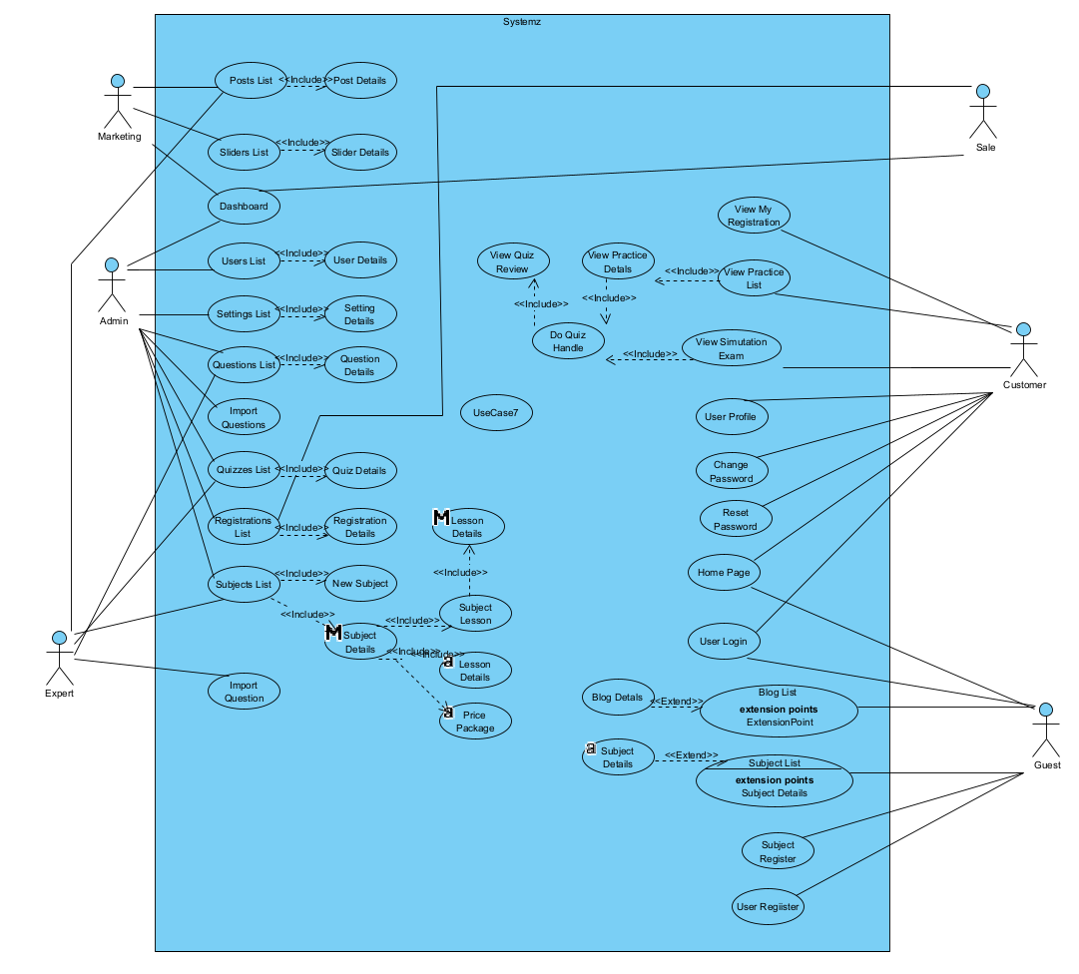

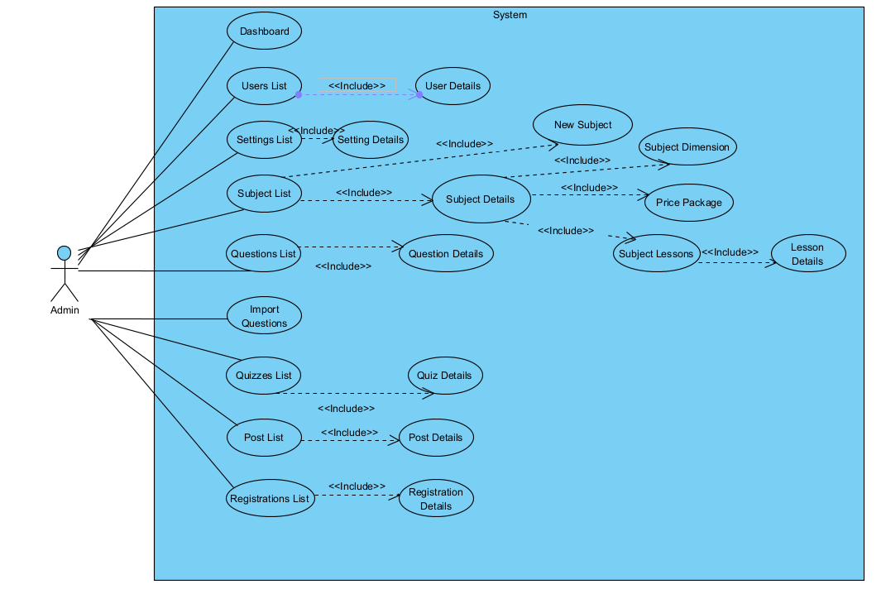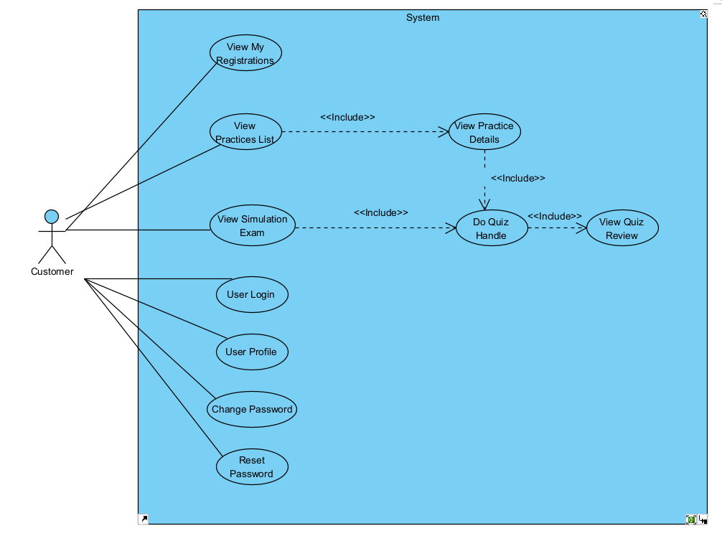
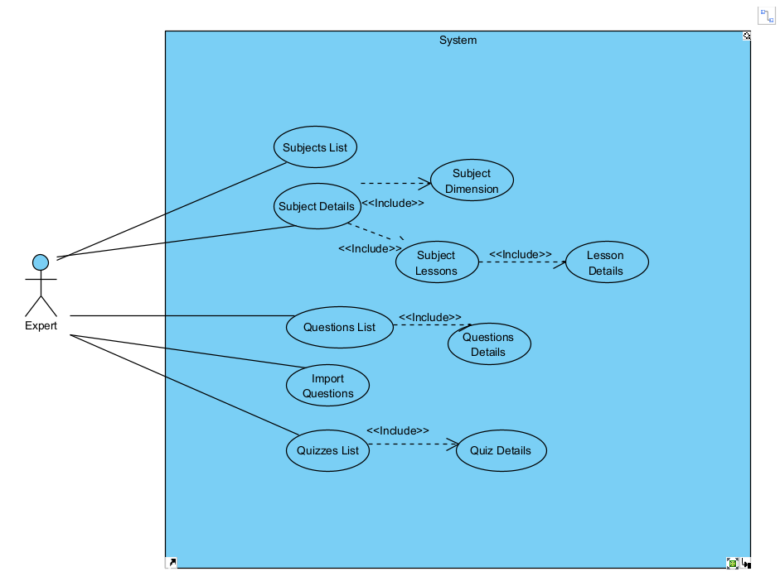
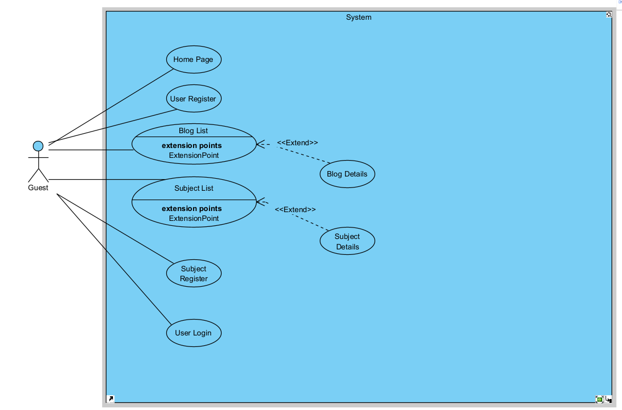
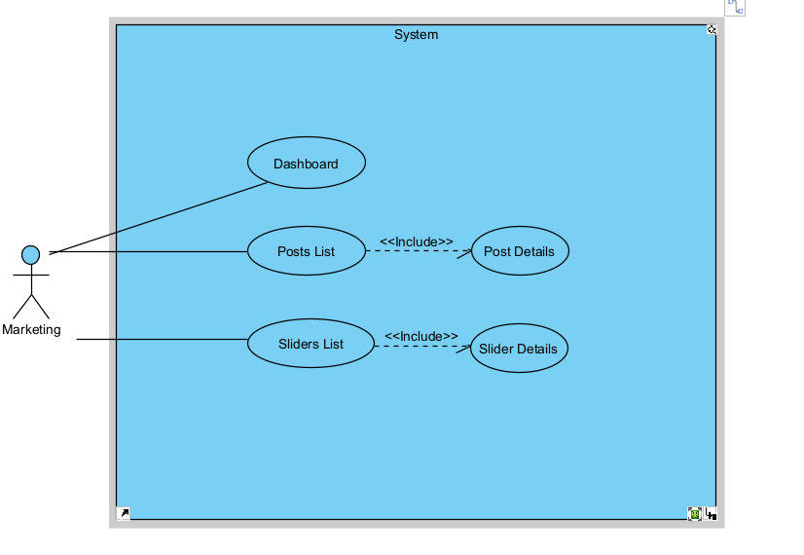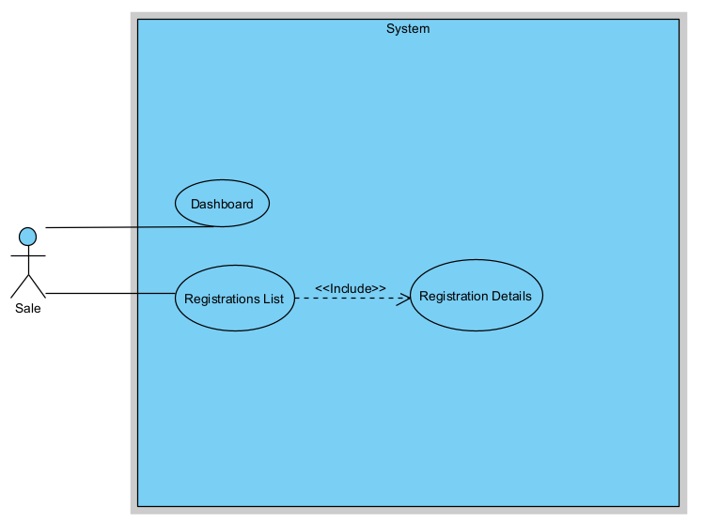

b. Descriptions

Admin Features:
ID | Feature | Use Case | Use Case Description
01 | Admin feature | Login | Allows the admin to log in to the system with valid information
02 | Admin Feature | View User List | Show the paginated list of registered users with filter/search/sort options.
03 | Admin Feature | Edit User | View or edit user details: role and status.Admin can view, add, edit, filter, and search users.
04 | Admin Feature | Add User | Add new user and send generated login password via email
05 | Admin Feature | View Settings | View the paginated list of settings with filter/search/sort options
06 | Admin Feature | Edit Setting | View or edit setting information.
07 | Admin Feature | Add Setting | Add a new system setting.

Sales Features

ID | Feature | Use Case | Use Case Description
01 | Sale Feature | View Registrations | Show the list of users’ registrations with filter/search/sort options.
02 | Sale Feature | Edit Registration | Add or change status of a registration with relevant notes.
03 | Sale Feature | Add Registration | Add new registration manually from the registration details screen.

Marketer Features

ID | Feature | Use Case | Use Case Description
01 | Marketing | View Dashboard | Show statistics on subjects, registrations, revenues, customers, and trends.
02 | Marketing | View Post Details | Show detailed post information and allow users to input, view or edit them.
03 | Marketing | View Sliders List | Show paginated list of sliders with filter and search.
04 | Marketing | View Slider Details | Show detailed slider information for view/edit.

User Features

ID | Feature | Use Case | Use Case Description
01 | User Profile | Edit Profile | Edit profile info except email
02 | Password | Change Password | Change password by entering current and new password
03 | Registration | View My Registrations | Show lists of user’s registrations; allow cancel/edit if still submitted.
04 | Practice | View Practices List | View list of quiz practices that user has taken
05 | Practice | View Practice Detail | View or input new practice information
06 | Simulation | View Simulation Exams | View available simulation exams and take them.

Guest Features

ID | Feature | Use Case | Use Case Description
01 | Authentication | User Login | Pop-up screen to login in with email and password. Includes register/reset links.
02 | Authentication | User Register | Pop-up screen to register with full name, gender,  email, mobile, and verify email.
03 | Authentication | Reset Password | Input email to receive reset link and reset password from the link
04 | Home | View Home Page | View sliders, hot posts, featured subjects.
05 | Blogs | View Blog List | View paginated posts with search/filter.
06 | Blogs | View Blog Details | View detailed blog content.
07 | Subjects | View Subjects List | View paginated list of subjects.
08 | Subjects | View Subject Details | View details of a selected subject.
09 | Subjects | Subject Register | Pop-up to register for a subject (with contact info for guests).

Course Features

ID | Feature | Use Case | Use Case Description
01 | Course Management | View Subjects List | View paginated list of courses with filters.
02 | Course Management | Add New Subject | Input new course information
03 | Course Management | View Subject Details | Admin/Expert manage subject general info, dimension, price packages.
04 | Course Management | Manage Dimensions | Input or edit subject dimension information.
05 | Course Management | Manage Price Packages | Input/edit subject price package info.
06 | Course Management | View Subject Lessons | Show lessons list; add/edit/activate/deactivate lessons.
07 | Course Management | Edit Lesson Details | Input/edit lesson information.

2. Overall Functionalities

2.1 Screens Flow
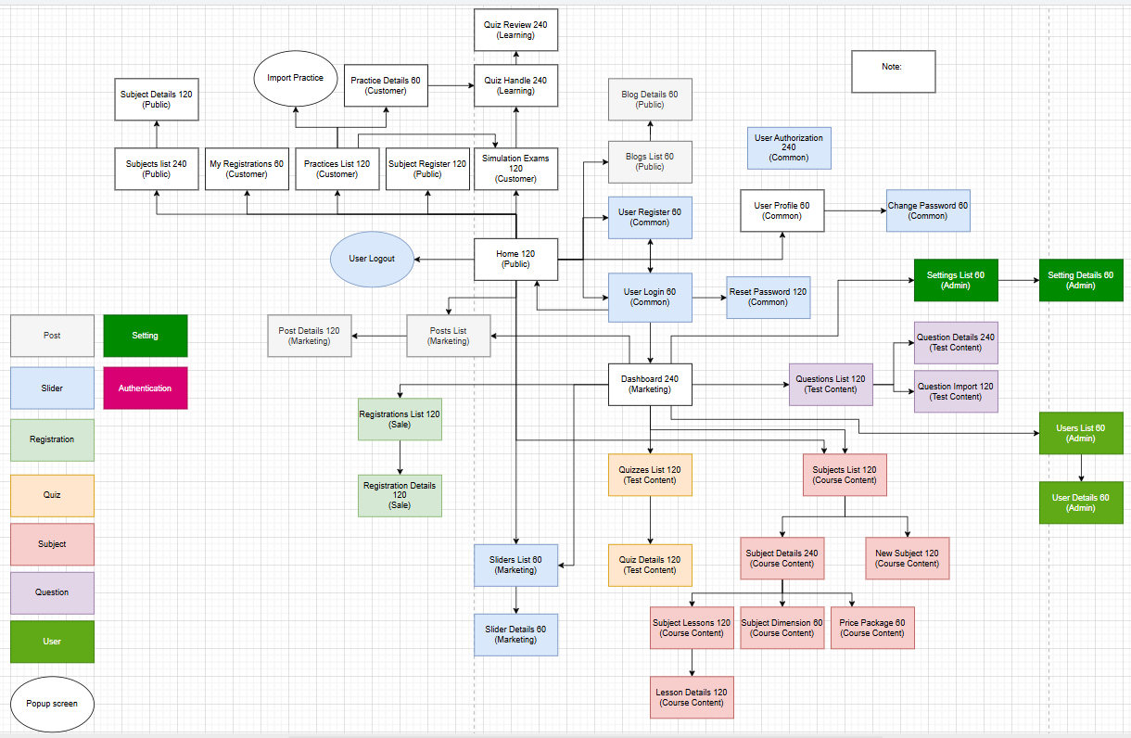

2.2 Screen Descriptions

# | Feature | Screen | Description
1 | Common | User Login | A pop-up screen allowing users to log in via email and password. Also provides options to reset forgotten passwords and navigate to the registration page for new users.
2 | Common | User Register | A pop-up screen for new users to sign up with full name, gender, email, and mobile. Requires email verification before login.
3 | Common | Reset Password | Users input email to receive a reset link. The link leads to a password reset form (input twice), valid only for a configured time.
4 | Common | User Authorization | Implements role-based access control by displaying role-specific menus and blocking unauthorized access to links.
5 | Common | User Profile | Pop-up for editing user profiles including avatar. Email is not editable.
6 | Common | Change Password | Pop-up where users can change password by entering current and new passwords (twice).
7 | Public | Home | Main landing page showing sliders, hot posts, and featured subjects. Clicking items redirects to detail pages.
8 | Public | Blogs List | Paginated blog list with thumbnails and categories. Sidebar includes search box and post categories.
9 | Public | Blog Details | Detailed view of a selected blog post including author, update date, and category.
10 | Public | Subjects List | Paginated list of subjects with thumbnails, taglines, and pricing. Allows registration.
11 | Public | Subject Details | Detailed view of a subject including title, description, pricing, and Register button.
12 | Public | Subject Register | Pop-up for course registration. Logged-in users have prefilled contact fields.
13 | Customer | My Registrations | Displays user's registration list. Allows editing or canceling if still in submitted status.
14 | Customer | Practices List | Lists user's quiz practices. Allows navigating to details or simulation exams.
15 | Customer | Practice Details | Input screen for new practice or review existing one.
16 | Customer | Simulation Exams | Lists simulation exams per subject. Filterable and searchable by name.
17 | Learning | Quiz Handle | Screen for taking quizzes. Includes navigation, answer review, timers, and result scoring.
18 | Learning | Quiz Review | Screen for reviewing quiz results, filtering by answered/marked/incorrect, and viewing explanations.
19 | Marketing | Dashboard | Admin/Marketing dashboard showing statistics on subjects, revenue, customers, and orders with date filters.
20 | Marketing | Post Details | Allows creation/editing of blog post content including thumbnails and brief info.
21 | Marketing | Sliders List | Paginated list of homepage sliders. Supports filtering, editing, and visibility toggling.
22 | Marketing | Slider Details | Detailed editing screen for slider info including image, title, and backlink.
23 | Course Content | Subject List | Paginated course list. Supports filtering and searching. Options to add or edit subjects.
24 | Course Content | New Subject | Screen to add new subjects with fields like name, category, image, owner, and description.
25 | Course Content | Subject Details | Edit subject info: overview, dimensions, and pricing. Only Admins can publish/unpublish or update pricing.
26 | Course Content | Subject Dimension | Admin/Expert input or edit subject dimensions including type, name, and description.
27 | Course Content | Price Package | Admin-only access to define subject pricing options. Experts can view only.
28 | Course Content | Subject Lessons | Displays lessons per package. Admin/Expert can activate/deactivate or edit lessons.
29 | Course Content | Lesson Details | Input/edit form for lesson information, media, and quiz associations.
30 | Test Content | Questions List | Paginated list of questions. Allows filtering by subject, dimension, lesson, level, and search by content.
31 | Test Content | Question Details | Input/edit question content, media, answer options, and explanations.
32 | Test Content | Question Import | Pop-up for importing questions from files and downloading sample templates.
33 | Test Content | Quizzes List | Paginated list of quizzes. Allows filtering/searching and links to Quiz Details for editing or deleting.
34 | Test Content | Quiz Details | Input/edit quiz configuration (metadata, structure).
35 | Sale | Registration List | Lists user registrations. Allows filtering, searching, and editing or adding new records.
36 | Sale | Registration Details | Shows registration details. Can create a user account if email is not registered and send login info.
37 | Admin | Users List | Paginated user list. Allows filtering, sorting, and searching. Add/Edit buttons available.
38 | Admin | User Details | Detailed user info including avatar, role, and status. Can only update role and status.
39 | Admin | Settings List | Paginated list of system settings. Allows search, filter, edit, and add new settings.
40 | Admin | Setting Details | Detailed view/edit screen for settings (type, value, order, status).

2.3 Screen Authorization

Screen | Guest | User | Admin | Expert | Marketer | Sale
Home | X | X |  | X | X | X
User Register | X
User Login | X
User Logout |  | X | X | X | X | X
Reset Password | X
Blogs List | X | X | X | X | X
Add Blogs |  |  | X |  | X
Update Blog |  |  |  |  | X
Delete Blog |  |  | X |  | X
Blog Details | X | X | X | X | X
Update Detail |  |  |  |  | X
User Profile |  | X | X | X | X | X
View Information |  | X | X | X | X | X
Change Information |  | X | X | X | X | X
Change Password |  | X | X | X | X | X
Slider Lists | X | X | X | X | X | X
Update Slider |  |  |  |  | X | X
Slider Details | X | X | X | X | X | X
Update Slider Detail |  |  |  |  | X | X
Add Slider Detail |  |  |  |  | X | X
Delete Slider Detail |  |  |  |  | X | X
Update Slider Detail |  |  |  |  | X | X
Setting List |  |  | X
Filter |  |  | X
View |  |  | X
Search |  |  | X
Hide |  |  | X
Add New Setting |  |  | X
Edit Existed Setting |  |  | X
Setting Details |  |  | X
View Specific System Setting |  |  | X
Edit Specific System Setting |  |  | X
Post Details | X | X | X | X | X | X
Update Post Detail |  |  |  |  | X | X
Add Post Detail |  |  |  |  | X | X
Delete Post Detail |  |  |  |  | X | X
Update Post Detail |  |  |  |  | X | X
Dashboard |  |  | X
Course List | X | X | X | X
Course Details | X | X | X | X
Update Course Detail |  |  | X
Delete Course Detail |  |  | X
Update Course Detail |  |  | X
Course Register |  | X | X
Delete Registered Course |  | X
My Course |  | X
Search (Course) |  | X
Start Course |  | X
Lesson View |  | X
Quiz Review |  | X
Review Results |  | X
Explanation |  | X
Quiz Handle |  | X
Score Exam |  | X
Peak at Answer |  | X
Mark for Review |  | X
Review Progress |  | X
Quiz Lesson |  | X
View Quiz Detail |  | X
View Quiz Result |  | X
Subject List |  |  | X
View All |  |  | X
View Assigned Courses |  |  |  | X
New Subject |  |  | X
Add Course |  |  | X
Assign The Expert |  |  | X
Subject Details |  |  | X | X
Subject Lesson |  |  | X
Overview |  |  | X | X
Subject Dimension |  |  | X | X
Price Package |  |  | X
Lesson Detail |  |  | X
Registration List |  |  |  |  | X | X
Filter The List |  |  |  |  | X | X
Sort List |  |  |  |  | X | X
Registration Details |  |  |  |  | X | X
Add Registration Details |  |  |  |  | X | X
View Information |  |  |  |  | X | X
Change Status |  |  |  |  | X | X
Question List |  | X | X
Filter |  |  | X |  | X
Search (Question) |  |  | X | X
Import Question |  | X | X |  | X
Quiz List |  | X | X |  | X
Filter By Subject |  | X
Search (Quiz) |  |  | X
Add New Quiz |  | X
Edit Quiz |  | X
Delete Quiz |  | X
Question Details |  |  | X |  | X
Input Question Information |  |  | X |  | X
Quiz Details |  | X | X
Overview |  | X
Setting |  | X
Question Import |  |  | X
Import File |  | X
Download File |  | X
Query All Data | X
Query Own Data |  |  | X
Query Managed Data |  |  | X
Add New Data |  |  | X
Update All Data |  |  | X
Update Own Data |  |  | X
Update Managed Data |  |  | X
Delete Data |  |  | X

2.4 Non-UI Functions
# | Feature | System Function | Description
1 | User Authentication | Role-Based Authorization | System will authorize users based on their roles, directing them to respective screens and functions according to permissions.
2 | User Notifications | Notification Service | Sends automated notifications (e.g., email or in-app) for events such as course enrollment, reminders, and new content.
3 | Content Recommendation | GPT API Integration | Uses GPT API to analyze user interactions and generate personalized course recommendations based on learning history.
4 | Content Summarization | GPT API for Summarization | Leverages GPT API to generate summaries for lengthy content or courses, providing quick insights to users.
5 | Data Backup | Scheduled Backup Job | Regularly backs up user and course data to ensure data security and facilitate recovery in case of data loss.
6 | Data Cleanup | Cleanup Batch Job | Periodically removes obsolete data, including expired sessions, outdated logs, and incomplete registrations.
7 | Usage Analytics | Analytics Service | Gathers and analyzes data on user engagement, course popularity, and system performance, generating reports for admin review.
8 | Course Content Import | Bulk Import Service | Facilitates batch import of course content, quizzes, and questions from external files into the system.
9 | Payment Processing | Payment Gateway Integration | Interfaces with third-party payment APIs to process user transactions for course purchases and subscriptions.
10 | Performance Monitoring | System Health Check Service | Periodically checks system health and alerts admins if any service or module is not performing optimally.
11 | Content Review Automation | AI Content Review API | Uses AI services to automatically review uploaded course content for quality, relevance, and adherence to platform guidelines.

3. System High Level Design

3.1 Database Design

a. Database Schema
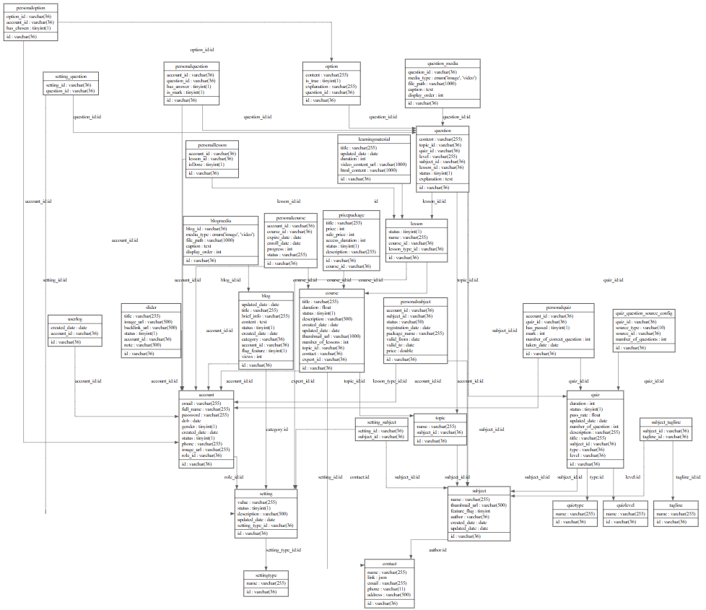

b. Table Descriptions
No | Table | Description
01 | Account | Stores account’s information such as email, password, full name, etc.  - Primary keys: id  - Foreign key: role references to Setting (id)
02 | Blog | Stores blog’s information such as id, updated_date, thumbnail_url, title, etc.  - Primary keys: id  - Foreign keys: account_id references to Account (id) category references to Setting (id)
03 | BlogMedia | Stores blog media such as image, video, caption, etc  - Primary keys: id  - Foreign key: blog_id references to Blog (id)
04 | Userlog | Logs user actions, tracking login/logout events for audit purposes.  - Primary keys: id  - Foreign keys: account_id references Account(id)
05 | Tagline | Stores various taglines that can be associated with courses for categorization or search optimization.  - Primary keys: id
06 | Slider | Stores information for website sliders, including image and link details.  - Primary keys: id  - Foreign keys: account_id references Account(id)
07 | Course | Contains course details such as title, description, category, and assigned expert.  - Primary keys: id  - Foreign keys: topic_id references Topic(id), expert_id references Account(id), contact references Contact (id)
08 | QuizLevel | Stores the information about quiz’s level  - Primary key: id  - Foreign key: None
09 | QuizType | Stores the information about quiz’s type  - Primary key: id  - Foreign key: None
10 | PricePackage | Defines price packages for courses, including base price, sale price, and duration.  - Primary keys: id  - Foreign keys: course_id references Course(id)
11 | Setting | Contains values for each setting type, such as user roles (admin, customer, etc.), course categories, and question levels.  - Primary keys: id  - Foreign keys: setting_type_id references SettingType(id)
12 | SettingQuestion | Contains foreign keys of Setting and Question
13 | SettingSubject | Contains foreign keys of Setting and Subject
14 | PersonalCourse | Manages personal enrollment in courses, tracking enrollment date, progress.  - Primary key: id  - Foreign keys: account_id references Account (id), course_id references Course (id)
15 | SettingType | Stores types of settings for various categories (e.g., user roles, course categories, lesson types, question levels).  - Primary keys: id
16 | Subject | Stores subject’s information such as name and thumbnail url  - Primary key: id  - Foreign key: None
17 | Lesson | Stores information about lessons, including lesson type, name, status.  - Primary keys: id  - Foreign keys: lesson_type_id references Setting(id), course_id references Course(id)
18 | PersonalLesson | Tracks individual user progress through lessons.  - Primary keys: account_id, course_id, lesson_id  - Foreign keys: account_id, course_id references PersonalCourse(account_id, course_id), lesson_id references Lesson(lesson_id)
19 | LearningMaterial | Stores details of learning materials, including title, upload date, and duration.  - Primary keys: id  - Foreign keys: id references Lesson(id)
20 | Quiz | Stores quiz details for a lesson, including title, duration, and pass rate.  - Primary keys: id  - Foreign keys: id references Lesson(id), topic_id Topic(id), type references Setting(id), level references Setting(id)
21 | PersonalQuiz | Tracks individual user progress through quizzes, including score and pass status.  - Primary keys: account_id, course_id, lesson_id  - Foreign keys: account_id, course_id, lesson_id references PersonalLesson(account_id, course_id, lesson_id)
22 | SubjectTagline | Contains foreign keys of Subject and Tagline
23 | Question | Stores quiz questions, with details like content, difficulty level, and question type.  - Primary keys: id  - Foreign keys: quiz_id references Quiz(lesson_id), topic_id references Topic(id)
24 | Option | Stores answer options for quiz questions.  - Primary keys: id  - Foreign keys: question_id references Question(id)
25 | PersonalQuestion | Tracks individual user interactions with quiz questions.  - Primary keys: account_id, course_id, lesson_id, question_id  - Foreign keys: account_id, course_id, lesson_id, question_id references PersonalQuiz(account_id, course_id, question_id)
26 | PersonalOption | Tracks individual user responses to answer options in quizzes.  - Primary keys: course_id, account_id, option_id, lesson_id, question_id  - Foreign keys: course_id, account_id, lesson_id, question_id references PersonalQuestion(course_id, account_id, lesson_id, question_id), option_id references Option(id)
27 | Topic | Stores topic’s name  - Primary key: id  - Foreign key: subject_id references Subject (id)
28 | Contact | Stores organization’s information, who owns the courses  - Primary key: id  - Foreign key: None
29 | QuizQuestion SourceConfig | Displays the list containing the number of questions of the quiz you want to get.  - Primary key: id  - Foreign key: quiz_id references to Quiz(id)
30 | Personal Subject | Stores information about subjects that users have registered such as status, registration_date, package_name, valid_from, valid_to, price  - Primary key: account_id, subject_id  - Foreign key: account_id references to Account(id)  and subject_id references to Subject(id)
31 | QuestionMedia | Stores media content information such as type, path, etc,..  - Primary key: id  - Foreign key: question_id references to Question(id)

c. Script Database
-- Table structure for table `account`
CREATE TABLE `account`
(
`id` varchar(36) NOT NULL,
`email` varchar(255) NOT NULL,
`full_name` varchar(255) NOT NULL,
`password` varchar(255) NOT NULL,
`dob` date DEFAULT NULL,
`gender` tinyint(1) DEFAULT NULL,
`created_date` date NOT NULL,
`status` tinyint(1) NOT NULL,
`phone` varchar(255) NOT NULL,
`image_url` varchar(255) DEFAULT NULL,
`role_id` varchar(36) NOT NULL,
PRIMARY KEY (`id`),
UNIQUE KEY `email` (`email`),
KEY `role` (`role_id`),
CONSTRAINT `role` FOREIGN KEY (`role_id`) REFERENCES `setting` (`id`),
CONSTRAINT `account_chk_1` CHECK ((`gender` in (0, 1, 2))),
CONSTRAINT `account_chk_2` CHECK (regexp_like(`email`,
_utf8mb4'^[A-Za-z0-9._%+-]+@[A-Za-z0-9.-]+\\.[A-Za-z]{2,}$')),
CONSTRAINT `account_chk_3` CHECK (regexp_like(`password`,
_utf8mb4'^(?=.*[a-z])(?=.*[A-Z])(?=.*\\d)(?=.*[!@#$%^&*()_+\\-={}\\[\\]:;"\'<>,.?/]).{8,}$')),
CONSTRAINT `account_chk_4` CHECK (regexp_like(`phone`, _utf8mb4'^\\+?[0-9]{10,15}$'))
);
-- Table structure for table `blog`
CREATE TABLE `blog`
(
`id` varchar(36) NOT NULL,
`updated_date` date DEFAULT NULL,
`title` varchar(255) NOT NULL,
`brief_info` varchar(255) NOT NULL,
`content` text,
`status` tinyint(1) NOT NULL DEFAULT '1',
`created_date` date NOT NULL,
`category` varchar(36) NOT NULL,
`account_id` varchar(36) NOT NULL,
`flag_feature` tinyint(1) DEFAULT '1',
`views` int NOT NULL DEFAULT '0',
PRIMARY KEY (`id`),
KEY `FKBlog922018` (`account_id`),
KEY `post categories` (`category`),
CONSTRAINT `FKBlog922018` FOREIGN KEY (`account_id`) REFERENCES `account` (`id`),
CONSTRAINT `post categories` FOREIGN KEY (`category`) REFERENCES `setting` (`id`)
);
-- Table structure for table `blogmedia`
CREATE TABLE `blogmedia`
(
`id` varchar(36) NOT NULL,
`blog_id` varchar(36) NOT NULL,
`media_type` enum ('image','video') NOT NULL,
`file_path` varchar(1000) NOT NULL,
`caption` text,
`display_order` int DEFAULT '0',
PRIMARY KEY (`id`),
KEY `FK_BlogMedia_Blog` (`blog_id`),
CONSTRAINT `FK_BlogMedia_Blog` FOREIGN KEY (`blog_id`) REFERENCES `blog` (`id`) ON DELETE CASCADE
);
-- Table structure for table `contact`
CREATE TABLE `contact`
(
`id` varchar(36) NOT NULL,
`name` varchar(255) NOT NULL,
`link` json NOT NULL,
`email` varchar(255) NOT NULL,
`phone` varchar(11) NOT NULL,
`address` varchar(500) NOT NULL,
PRIMARY KEY (`id`),
UNIQUE KEY `email` (`email`),
CONSTRAINT `contact_chk_2` CHECK (regexp_like(`email`,
_utf8mb4'^[A-Za-z0-9._%+-]+@[A-Za-z0-9.-]+\\.[A-Za-z]{2,}$')),
CONSTRAINT `contact_chk_4` CHECK (regexp_like(`phone`, _utf8mb4'^\\+?[0-9]{10,15}$'))
);
-- Table structure for table `course`
CREATE TABLE `course`
(
`id` varchar(36) NOT NULL,
`title` varchar(255) NOT NULL,
`duration` float NOT NULL,
`status` tinyint(1) NOT NULL DEFAULT '1',
`description` varchar(500) NOT NULL,
`created_date` date NOT NULL,
`updated_date` date DEFAULT NULL,
`thumbnail_url` varchar(1000) DEFAULT NULL,
`number_of_lessons` int NOT NULL,
`topic_id` varchar(36) NOT NULL,
`contact` varchar(36) NOT NULL,
`expert_id` varchar(36) NOT NULL,
PRIMARY KEY (`id`),
KEY `FKCourse6215` (`contact`),
KEY `FKCourse968779` (`topic_id`),
KEY `fk_course_expert` (`expert_id`),
CONSTRAINT `fk_course_expert` FOREIGN KEY (`expert_id`) REFERENCES `account` (`id`),
CONSTRAINT `FKCourse6215` FOREIGN KEY (`contact`) REFERENCES `contact` (`id`),
CONSTRAINT `FKCourse968779` FOREIGN KEY (`topic_id`) REFERENCES `topic` (`id`)
);
-- Table structure for table `learningmaterial`
CREATE TABLE `learningmaterial`
(
`id` varchar(36) NOT NULL,
`title` varchar(255) NOT NULL,
`updated_date` date DEFAULT NULL,
`duration` int NOT NULL,
`video_content_url` varchar(1000) DEFAULT NULL,
`html_content` varchar(1000) NOT NULL,
PRIMARY KEY (`id`),
CONSTRAINT `FKLearningMa384166` FOREIGN KEY (`id`) REFERENCES `lesson` (`id`)
);
-- Table structure for table `lesson`
CREATE TABLE `lesson`
(
`id` varchar(36) NOT NULL,
`status` tinyint(1) NOT NULL DEFAULT '1',
`name` varchar(255) NOT NULL,
`course_id` varchar(36) NOT NULL,
`lesson_type_id` varchar(36) NOT NULL,
PRIMARY KEY (`id`),
KEY `FKLesson764776` (`course_id`),
KEY `lesson types` (`lesson_type_id`),
CONSTRAINT `FKLesson764776` FOREIGN KEY (`course_id`) REFERENCES `course` (`id`),
CONSTRAINT `lesson types` FOREIGN KEY (`lesson_type_id`) REFERENCES `setting` (`id`)
);
-- Table structure for table `option`
CREATE TABLE `option`
(
`id` varchar(36) NOT NULL,
`content` varchar(255) NOT NULL,
`is_true` tinyint(1) NOT NULL DEFAULT '0',
`explanation` varchar(255) NOT NULL,
`question_id` varchar(36) NOT NULL,
PRIMARY KEY (`id`),
KEY `FKOption204933` (`question_id`),
CONSTRAINT `FKOption204933` FOREIGN KEY (`question_id`) REFERENCES `question` (`id`)
);
-- Table structure for table `personalcourse`
CREATE TABLE `personalcourse`
(
`id` varchar(36) NOT NULL,
`account_id` varchar(36) NOT NULL,
`course_id` varchar(36) NOT NULL,
`expire_date` date DEFAULT NULL,
`enroll_date` date NOT NULL,
`progress` int NOT NULL DEFAULT '0',
`status` varchar(255) DEFAULT 'SENT',
PRIMARY KEY (`id`),
KEY `FKPersonalCo602046` (`course_id`),
KEY `FKPersonalCo728981` (`account_id`),
CONSTRAINT `FKPersonalCo602046` FOREIGN KEY (`course_id`) REFERENCES `course` (`id`),
CONSTRAINT `FKPersonalCo728981` FOREIGN KEY (`account_id`) REFERENCES `account` (`id`),
CONSTRAINT `personalcourse_chk_1` CHECK ((`status` in
(_utf8mb4'PAID', _utf8mb4'SENT', _utf8mb4'ACCEPTED', _utf8mb4'DECLINED')))
);
-- Table structure for table `personallesson`
CREATE TABLE `personallesson`
(
`id` varchar(36) NOT NULL,
`account_id` varchar(36) NOT NULL,
`lesson_id` varchar(36) NOT NULL,
`isDone` tinyint(1) NOT NULL DEFAULT '0',
PRIMARY KEY (`id`),
KEY `FKPersonalLe846456` (`lesson_id`),
KEY `FKPersonalLe96067` (`account_id`),
CONSTRAINT `FKPersonalLe846456` FOREIGN KEY (`lesson_id`) REFERENCES `lesson` (`id`),
CONSTRAINT `FKPersonalLe96067` FOREIGN KEY (`account_id`) REFERENCES `account` (`id`)
);
-- Table structure for table `personaloption`
CREATE TABLE `personaloption`
(
`id` varchar(36) NOT NULL,
`option_id` varchar(36) NOT NULL,
`account_id` varchar(36) NOT NULL,
`has_chosen` tinyint(1) NOT NULL DEFAULT '0',
PRIMARY KEY (`id`),
KEY `FKPersonalOp32617` (`account_id`),
KEY `FKPersonalOp130168` (`option_id`),
CONSTRAINT `FKPersonalOp130168` FOREIGN KEY (`option_id`) REFERENCES `option` (`id`),
CONSTRAINT `FKPersonalOp32617` FOREIGN KEY (`account_id`) REFERENCES `account` (`id`)
);
-- Table structure for table `personalquestion`
CREATE TABLE `personalquestion`
(
`id` varchar(36) NOT NULL,
`account_id` varchar(36) NOT NULL,
`question_id` varchar(36) NOT NULL,
`has_answer` tinyint(1) NOT NULL DEFAULT '0',
`is_mark` tinyint(1) NOT NULL DEFAULT '0',
PRIMARY KEY (`id`),
KEY `FKPersonalQu428012` (`question_id`),
KEY `FKPersonalQu214880` (`account_id`),
CONSTRAINT `FKPersonalQu214880` FOREIGN KEY (`account_id`) REFERENCES `account` (`id`),
CONSTRAINT `FKPersonalQu428012` FOREIGN KEY (`question_id`) REFERENCES `question` (`id`)
);
-- Table structure for table `personalquiz`
CREATE TABLE `personalquiz`
(
`id` varchar(36) NOT NULL,
`account_id` varchar(36) NOT NULL,
`quiz_id` varchar(36) NOT NULL,
`has_passed` tinyint(1) NOT NULL DEFAULT '0',
`mark` int DEFAULT NULL,
`number_of_correct_question` int DEFAULT NULL,
`taken_date` date NOT NULL,
PRIMARY KEY (`id`),
KEY `FKPersonalQu344927` (`account_id`),
KEY `FKPersonalQu344926` (`quiz_id`),
CONSTRAINT `FKPersonalQu344926` FOREIGN KEY (`quiz_id`) REFERENCES `quiz` (`id`),
CONSTRAINT `FKPersonalQu344927` FOREIGN KEY (`account_id`) REFERENCES `account` (`id`)
);
-- Table structure for table `personalsubject`
CREATE TABLE `personalsubject`
(
`account_id` varchar(36) NOT NULL,
`subject_id` varchar(36) NOT NULL,
`status` varchar(50) NOT NULL DEFAULT 'sent',
`registration_date` date NOT NULL,
`package_name` varchar(255) DEFAULT NULL,
`valid_from` date DEFAULT NULL,
`valid_to` date DEFAULT NULL,
`price` double DEFAULT NULL,
PRIMARY KEY (`account_id`, `subject_id`),
KEY `account_id` (`account_id`),
KEY `subject_id` (`subject_id`),
CONSTRAINT `personalsubject_ibfk_1` FOREIGN KEY (`account_id`) REFERENCES `account` (`id`),
CONSTRAINT `personalsubject_ibfk_2` FOREIGN KEY (`subject_id`) REFERENCES `subject` (`id`)
);
-- Table structure for table `pricepackage`
CREATE TABLE `pricepackage`
(
`id` varchar(36) NOT NULL,
`course_id` varchar(36) NOT NULL,
`title` varchar(255) NOT NULL,
`price` int NOT NULL,
`sale_price` int NOT NULL,
`access_duration` int NOT NULL,
`status` tinyint(1) NOT NULL DEFAULT '0',
`description` varchar(255) DEFAULT NULL,
PRIMARY KEY (`id`, `course_id`),
KEY `FKPricePacka152688` (`course_id`),
CONSTRAINT `FKPricePacka152688` FOREIGN KEY (`course_id`) REFERENCES `course` (`id`),
CONSTRAINT `pricepackage_chk_1` CHECK ((`sale_price` <= 100))
);
-- Table structure for table `question`
CREATE TABLE `question`
(
`id` varchar(36) NOT NULL,
`content` varchar(255) NOT NULL,
`topic_id` varchar(36) DEFAULT NULL,
`quiz_id` varchar(36) DEFAULT NULL,
`level` varchar(255) NOT NULL,
`subject_id` varchar(36) DEFAULT NULL,
`lesson_id` varchar(36) DEFAULT NULL,
`status` tinyint(1) NOT NULL DEFAULT '1',
`explanation` text,
PRIMARY KEY (`id`),
KEY `FKQuestion523038` (`topic_id`),
KEY `FKQuestion112697` (`quiz_id`),
KEY `FK_Question_Subject` (`subject_id`),
KEY `FK_Question_Lesson` (`lesson_id`),
CONSTRAINT `FK_Question_Lesson` FOREIGN KEY (`lesson_id`) REFERENCES `lesson` (`id`),
CONSTRAINT `FK_Question_Subject` FOREIGN KEY (`subject_id`) REFERENCES `subject` (`id`),
CONSTRAINT `FKQuestion112697` FOREIGN KEY (`quiz_id`) REFERENCES `quiz` (`id`),
CONSTRAINT `FKQuestion523038` FOREIGN KEY (`topic_id`) REFERENCES `topic` (`id`)
);
-- Table structure for table `question_media`
CREATE TABLE `question_media`
(
`id` varchar(36) NOT NULL,
`question_id` varchar(36) NOT NULL,
`media_type` enum ('image','video') NOT NULL,
`file_path` varchar(1000) NOT NULL,
`caption` text,
`display_order` int DEFAULT '0',
PRIMARY KEY (`id`),
KEY `FK_QuestionMedia_Question` (`question_id`),
CONSTRAINT `FK_QuestionMedia_Question` FOREIGN KEY (`question_id`) REFERENCES `question` (`id`) ON DELETE CASCADE
);
-- Table structure for table `quiz`
CREATE TABLE `quiz`
(
`id` varchar(36) NOT NULL,
`duration` int NOT NULL,
`status` tinyint(1) NOT NULL DEFAULT '0',
`pass_rate` float DEFAULT NULL,
`updated_date` date NOT NULL,
`number_of_question` int NOT NULL DEFAULT '0',
`description` varchar(255) NOT NULL,
`title` varchar(255) NOT NULL,
`subject_id` varchar(36) NOT NULL,
`type` varchar(36) NOT NULL,
`level` varchar(36) NOT NULL,
PRIMARY KEY (`id`),
KEY `FKQuiz471131` (`level`),
KEY `FKQuiz75766` (`type`),
KEY `FKQuiz767071` (`subject_id`),
CONSTRAINT `FKQuiz471131` FOREIGN KEY (`level`) REFERENCES `quizlevel` (`id`),
CONSTRAINT `FKQuiz75766` FOREIGN KEY (`type`) REFERENCES `quiztype` (`id`),
CONSTRAINT `FKQuiz767071` FOREIGN KEY (`subject_id`) REFERENCES `subject` (`id`)
);
-- Table structure for table `quiz_question_source_config`
CREATE TABLE `quiz_question_source_config`
(
`id` varchar(36) NOT NULL,
`quiz_id` varchar(36) NOT NULL,
`source_type` varchar(10) NOT NULL,
`source_id` varchar(36) NOT NULL,
`number_of_questions` int NOT NULL,
PRIMARY KEY (`id`),
KEY `FK_QuizQuestionSourceConfig_Quiz` (`quiz_id`),
CONSTRAINT `FK_QuizQuestionSourceConfig_Quiz` FOREIGN KEY (`quiz_id`) REFERENCES `quiz` (`id`)
);
-- Table structure for table `quizlevel`
CREATE TABLE `quizlevel`
(
`id` varchar(36) NOT NULL,
`name` varchar(255) DEFAULT NULL,
PRIMARY KEY (`id`)
);
-- Table structure for table `quiztype`
CREATE TABLE `quiztype`
(
`id` varchar(36) NOT NULL,
`name` varchar(255) DEFAULT NULL,
PRIMARY KEY (`id`)
);
-- Table structure for table `setting`
CREATE TABLE `setting`
(
`id` varchar(36) NOT NULL,
`value` varchar(255) NOT NULL,
`status` tinyint(1) NOT NULL,
`description` varchar(500) DEFAULT NULL,
`updated_date` date DEFAULT NULL,
`setting_type_id` varchar(36) NOT NULL,
PRIMARY KEY (`id`),
KEY `FKSetting908739` (`setting_type_id`),
CONSTRAINT `FKSetting908739` FOREIGN KEY (`setting_type_id`) REFERENCES `settingtype` (`id`)
);
-- Table structure for table `setting_question`
CREATE TABLE `setting_question`
(
`setting_id` varchar(36) NOT NULL,
`question_id` varchar(36) NOT NULL,
PRIMARY KEY (`setting_id`, `question_id`),
KEY `question level` (`question_id`),
CONSTRAINT `question level` FOREIGN KEY (`question_id`) REFERENCES `question` (`id`),
CONSTRAINT `test type` FOREIGN KEY (`setting_id`) REFERENCES `setting` (`id`)
);
-- Table structure for table `setting_subject`
CREATE TABLE `setting_subject`
(
`setting_id` varchar(36) NOT NULL,
`subject_id` varchar(36) NOT NULL,
PRIMARY KEY (`setting_id`, `subject_id`),
KEY `FKSetting_Su420121` (`subject_id`),
CONSTRAINT `FKSetting_Su420121` FOREIGN KEY (`subject_id`) REFERENCES `subject` (`id`),
CONSTRAINT `Subject dimension` FOREIGN KEY (`setting_id`) REFERENCES `setting` (`id`)
);
-- Table structure for table `settingtype`
CREATE TABLE `settingtype`
(
`id` varchar(36) NOT NULL,
`name` varchar(255) NOT NULL,
PRIMARY KEY (`id`)
);
-- Table structure for table `slider`
CREATE TABLE `slider`
(
`id` varchar(36) NOT NULL,
`title` varchar(255) NOT NULL,
`image_url` varchar(500) NOT NULL,
`backlink_url` varchar(500) DEFAULT NULL,
`status` tinyint(1) NOT NULL DEFAULT '1',
`account_id` varchar(36) NOT NULL,
`note` varchar(500) DEFAULT NULL,
PRIMARY KEY (`id`),
KEY `FKSlider777469` (`account_id`),
CONSTRAINT `FKSlider777469` FOREIGN KEY (`account_id`) REFERENCES `account` (`id`)
);
-- Table structure for table `subject`
CREATE TABLE `subject`
(
`id` varchar(36) NOT NULL,
`name` varchar(255) NOT NULL,
`thumbnail_url` varchar(500) DEFAULT NULL,
`feature_flag` tinyint DEFAULT '0',
`author` varchar(36) NOT NULL,
`created_date` date DEFAULT NULL,
`updated_date` date DEFAULT NULL,
PRIMARY KEY (`id`),
KEY `FKSubject873139` (`author`),
CONSTRAINT `FKSubject873139` FOREIGN KEY (`author`) REFERENCES `contact` (`id`)
);
-- Table structure for table `subject_tagline`
CREATE TABLE `subject_tagline`
(
`subject_id` varchar(36) NOT NULL,
`tagline_id` varchar(36) NOT NULL,
PRIMARY KEY (`subject_id`, `tagline_id`),
KEY `FKSubject_Ta221833` (`tagline_id`),
CONSTRAINT `FKSubject_Ta221833` FOREIGN KEY (`tagline_id`) REFERENCES `tagline` (`id`),
CONSTRAINT `FKSubject_Ta283943` FOREIGN KEY (`subject_id`) REFERENCES `subject` (`id`)
);
-- Table structure for table `tagline`
CREATE TABLE `tagline`
(
`id` varchar(36) NOT NULL,
`name` varchar(255) NOT NULL,
PRIMARY KEY (`id`)
);
-- Table structure for table `topic`
CREATE TABLE `topic`
(
`id` varchar(36) NOT NULL,
`name` varchar(255) NOT NULL,
`subject_id` varchar(36) NOT NULL,
PRIMARY KEY (`id`),
KEY `FKTopic873139` (`subject_id`),
CONSTRAINT `FKTopic873139` FOREIGN KEY (`subject_id`) REFERENCES `subject` (`id`)
);
-- Table structure for table `userlog`
CREATE TABLE `userlog`
(
`id` varchar(36) NOT NULL,
`created_date` date NOT NULL,
`account_id` varchar(36) NOT NULL,
PRIMARY KEY (`id`),
KEY `FKUserLog508255` (`account_id`),
CONSTRAINT `FKUserLog508255` FOREIGN KEY (`account_id`) REFERENCES `account` (`id`)
);

3.2 Code Packages

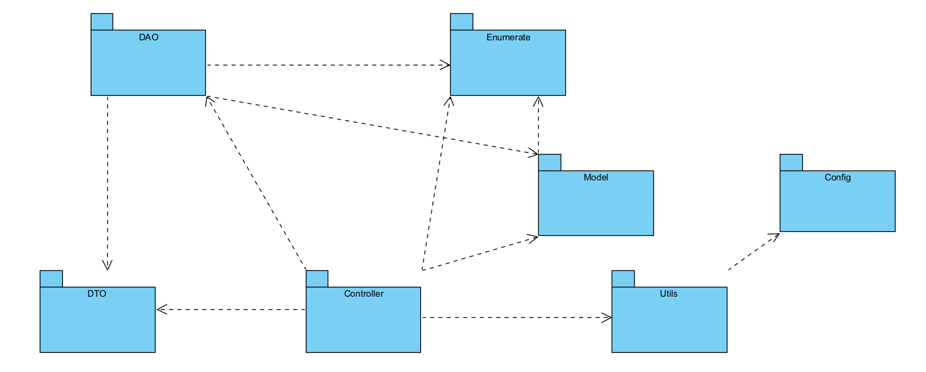
Package descriptions
No | Package | Description
01 | Model | This package contains the business logic and entities. It defines the structure of the data and interacts with the DAO package for data storage and retrieval.
02 | DAO | The Data Access Object (DAO) package provides an interface to interact with the database. It includes methods for querying, updating, and manipulating data.
03 | Controller | This package is responsible for handling HTTP requests, coordinating between the model and view, and returning the appropriate responses to the user interface.
04 | Config | This package contains configuration classes
05 | Enumerate | This package stores the constants of models
06 | Utils | This package stores the utility classes
07 | DTO | This package used to wrap response data

4. Other Resources

4.1 External Library (.jar)
- Commons-codec-1.18.9
- Core-3.5.3
- Dotenv-java-2.2.0
- Googleauth-1.4.0
- Gson-2.13.1
- Jackson-annotation-2.18.4
- Jackson-core-2.18.4
- Jackson-databind-2.15.0
- Jackson-datatype-jsr310-2.19.1
- Jakarta.activation-2.0.1
- Jakarta.mail-2.0.1
- Jakarta.servlet-api-6.1.0
- Jakarta.servlet.jsp.jstl-2.0.0
- Jakarta.servlet.jsp.jstl.api-2.0.0
- Jakarta.websocket-api-2.1.0
- Javase-3.5.3
- Jaxb-api-2.1
- Lombok
- Mysql-connector-j-9.3.0
- Tyrus-standalone-client-2.2.0

4.2 Internal Components
- back_to_top.html
- footer.html
- header.jsp
- navbar.html
- notification.html
- spinner.html

II. Requirement Specifications

1. Admin Function

2. Common Features

2.1 CMF-1_User Login
a. Functional Description
ID and Name: | CMF-1 My Registration
Created By: | TuanKD | Date Created: | 26/05/2025
Primary Actor: | Common | Secondary Actors: | N/A
Description: | This is a pop-up screen which allows the user to enter email & password to login; on this page, there are also options for user to register new information or reset the password for the case s/he forget it
Trigger: | Customers click the “Login” button in the Home screen
Preconditions: | PRE-1: The user has already registered an account with a valid email and password.  PRE-2: The user accesses the login screen from the homepage or any unauthenticated page.
Postcondition: | POST-1: The user is authenticated and granted access based on their role (e.g., Customer, Admin, Expert).  POST-2: The user is redirected to the appropriate dashboard or homepage for their role.
Normal Flow: | - Users are on the login screen  - Users enter their email and password  - Users click the “Login” button  - System verifies credentials  - System redirects users to the appropriate dashboard
Alternative Flows: | AF-1: If the login fails, the system shows an error message and remains on the login page  AF-2: Users can click “Register” or “Forgot Password” to navigate to respective screens
Exceptions: | None
Priority: | High
Frequency of Use: | Customers can use this feature everyday
Business Rules: | None
Other Information: | None
Assumptions: | None

2.2 CMF-2_User Register
a. Functional Description
ID and Name: | CMF-2 Register
Created By: | HuongNI | Date Created: | 26/05/2025
Primary Actor: | Common | Secondary Actors: | N/A
Description: | This screen allows the user to register himself/herself to the system by inputting the following information: full name, gender, email, mobile; User then needs to verify by clicking the link sent via email to him/her before being able to access the system.
Trigger: | Customers click the “Register” button in the Home screen or click on the “Register” at the login page.
Preconditions: | PRE-1: The user is not logged in.  PRE-2: The user has not registered before.
Postcondition: | POST-1: A new user account is created in the system.  POST-2: A password is sent to the registered email address.
Normal Flow: | - - Users navigate to the Home screen.  - - Users click the “Register” button.  - - The system displays the registration form.  - - Users enter required information and submit.  - - The system validates the input and creates a new account.  - - The password is sent to the user’s email.
Alternative Flows: | None
Exceptions: | EX-1: If the email is already registered, the system displays an appropriate error message.
Priority: | High
Frequency of Use: | Customers use this when creating a new account (one-time use per user).
Business Rules: | BR-CMF-1, BR-CMF-2
Other Information: | None
Assumptions: | None

b. Business Rules
ID | Business Rule | Business Rule Description
BR-CMF-1 | Validate email format | The email address provided during registration must be in a valid email format.
BR-CMF-2 | Check email exists | The email address must not already exist in the system’s user database.

2.3 CMF-3_User Profile
a. Functional Description
ID and Name: | CMF-3 User Profile
Created By: | ThuanHD | Date Created: | 25/05/2025
Primary Actor: | Common | Secondary Actors: | N/A
Description: | This is a pop-up screen that allows users to edit their personal information.
Trigger: | User clicks on Save change button to save changes
Preconditions: | PRE-1: The user has filled in all the information fields and the information must be valid.  PRE-2: The user must access from the home screen to.
Postcondition: | POST-1: Users can update their personal information..  POST-2: The user is directed to the Update Successful screen to signal and press back to return..
Normal Flow: | 1. User access the home page by entering the url “localhost:8080/qps/jsp/common-features/edit_profile.jsp”  2. The user is on the edit Profile screen.  3. User enters the information fields to be changed  4. User clicks on save Change button to save the information to be changed  5. The system will update the information for the user and direct to the screen notifying you that the update was successful.
Alternative Flows: | AF-1: If the user enters incorrect information fields according to the rules, the system will return red command lines as reminders below each incorrect line.  AF-2: Users can click on the select photo on the side to update the photo.
Exceptions: | None
Priority: | High
Frequency of Use: | User can use this feature everyday
Business Rules: | None
Other Information: | None
Assumptions: | None

2.4 CMF-4_Reset Password
a. Functional Description
ID and Name: | CMF-4 Reset Password
Created By: | HoanTX | Date Created: | 10/06/2025
Primary Actor: | Admin, Expert, Sale, Marketing, Customer | Secondary Actors: | N/A
Description: | This is a screen that allows users to change their password if they forgot.
Trigger: | Users click on “Forgot password?” button in the bottom of Login screen
Preconditions: | PRE-1: Users must have unbanned accounts  PRE-2: Users access this screen by correct url
Postcondition: | POST-1: The labels, input fields and navigate links are ready to interact
Normal Flow: | - Users access Login screen by accessing the url “localhost:8080/qps/jsp/common-features/reset_password.jsp”  - Users click the “Forgot password” button in the bottom  - System navigates to Reset password screen  - Users enter their email  - System shows 3 authentication methods  - Users choose one of 3 methods and enter OTP code if needed  - Users enter new password and confirm password in the reset password part  - System confirms and changes users password
Alternative Flows: | AF-1: Users choose Google Authenticator method  - Users click “Google Authenticator” option  - System displays QR code  - Users scan QR code  - Users enter 6 digits code in Google Authenticator app in their mobile phone  - System navigates to reset password part  AF-2: Users choose Magic Link method  - Users click “Magic Link” option  - Users click link that sent to users’ email  - System opens success message in other tab and navigates to reset password part in current tab  AF-3: Users choose OTP method  - Users click “OTP” option  - Users enter 6 digits code that sent to users’ email  - System navigates to reset password part  AF-4: Users can go back to Login screen by clicking the “Back to login” button in the bottom of screen  AF-5: Users can send OTP again by clicking the “Resend code” button
Exceptions: | 2.4.E1 Users enter non-existent email  - Error notification will be displayed  - Users enter email again  2.4.E2 Users enter wrong OTP  - Error notification will be displayed  - Users enter OTP again
Priority: | High
Frequency of Use: | User can use this feature everyday
Business Rules: | BR-CMF-3, BR-CMF-4, BR-CMF-5, BR-CMF-6, BR-CMF-7, BR-CMF-8, BR-CMF-9, BR-CMF-10, BR-CMF-11
Other Information: | None
Assumptions: | None

b. Business Rules
ID | Business Rule | Business Rule Description
BR-CMF-3 | Expire date for magic link | Token used in magic link should be expired after 5 minutes
BR-CMF-4 | One-time-using magic link | Magic link can be only used for one time
BR-CMF-5 | Email contains magic link | Magic link should be stored in the email that sent to users
BR-CMF-6 | One-time-creating shared secret | Secret key is created only when users trigger TOTP
BR-CMF-7 | Expire date for TOTP | TOTP expires after 30 second
BR-CMF-8 | Unsaved TOTP | Each code is only used for one time
BR-CMF-9 | Size of OTP | Contains 6 digits
BR-CMF-10 | Email contains OTP | OTP should be stored in the email that sent to users
BR-CMF-11 | Expire date for OTP | OTP expires after 5 minutes

3. Public

3.1 PL-1_Home
a. Functional Description
ID and Name: | PL-1 Home Page
Created By: | HuongNI | Date Created: | 27/05/2025
Primary Actor: | Public | Secondary Actors: | N/A
Description: | The screen displays sliders, hot posts, featured subjects, features courses, a sidebar includes the latest posts.
Trigger: | The system loads the homepage when a user visits the root URL or clicks the “Home” link from the navigation menu.
Preconditions: | None
Postcondition: | Homepage is displayed with interactive content blocks: sliders, posts, subjects.
Normal Flow: | - User accesses the homepage with url “localhost:8080/qps/home”  - Sliders display with image and title (clickable to backlink)  - Courses display with image and title, price (clickable to course details)  - Hot posts display with thumbnail, title, post date (clickable to post detail)  - Featured subjects display with thumbnail, title, tag line (clickable to subject detail)  - Sidebar display with latest posts
Alternative Flows: | AF-1: If there are no sliders/posts/subjects available, the system hides the corresponding sections.
Exceptions: | None
Priority: | Medium
Frequency of Use: | Every time a user visits or returns to the homepage
Business Rules: | BR-PL-1, BR-PL-2, BR-PL-3
Other Information: | None
Assumptions: | None

b. Business Rules
ID | Business Rule | Business Rule Description
BR-PL-1 | Sliders constraint | Only active sliders are displayed.
BR-PL-2 | Blogs constraint | Only blogs with the status = true are displayed.
BR-PL-3 | Subjects constraint | Only subjects with the feature flag = true are displayed.

3.2 PL-2_Blog List
a. Functional Description
ID and Name: | PL-2 Blog List
Created By: | HuongNI | Date Created: | 09/06/2025
Primary Actor: | Public | Secondary Actors: | N/A
Description: | This screen displays a list of blog posts with pagination. A sidebar contains search, categories, latest posts, and static links.
Trigger: | The user clicks on “Blogs” from the site’s navigation menu.
Preconditions: | PRE-1: The user is on the homepage and clicks the "Blogs" navigation link.
Postcondition: | POST-1: A paginated list of blogs is displayed.  POST-2: Sidebar with search bar, categories, and latest blog details page.  POST-3: Clicking a blog navigates the user to the Blog Details page.
Normal Flow: | - The user can access blogs page by url “localhost:8080/qps/blog-list”  - The user opens the homepage and clicks on “Blogs” from the header menu.  - The Blogs page is displayed with a sidebar and a paginated list of blog posts.  - The user can navigate between pages by clicking on the corresponding page numbers  - The user can search for blog posts by title, brief information, or description.  - The user can filter blog posts by category to narrow down the results.  - When a user clicks on a blog post, the system redirects them to the corresponding blog details page.
Alternative Flows: | AF-1: The user enters a keyword in the search box (by title or description). The system filters and reloads the list based on the search query.  AF-2: The user clicks on a blog category from the sidebar. The system updates and displays only the blog posts belonging to that selected category.
Exceptions: | None
Priority: | Medium
Frequency of Use: | Frequently used by general users and customers to read blog posts
Business Rules: | BR-PL-2
Other Information: | None
Assumptions: | None

b. Business Rules
ID | Business Rule | Business Rule Description
BR-PL-4 | Search blog | Search includes title, brief, and description.

3.3 PL-3_Blog Details
a. Functional Description
ID and Name: | PL-3 Blog Details
Created By: | HuongNI | Date Created: | 09/06/2025
Primary Actor: | Public | Secondary Actors: | N/A
Description: | This screen displayed the details of a specific blog post including: title, author, updated date, category, post description, image. Sidebar containing: search box, post categories, latest posts, static contact information
Trigger: | The user clicks on a blog post from either the blog list or the sidebar.
Preconditions: | PRE-1: The selected blog post exists and is published.  PRE-2: The user accesses the blog via the blog list, homepage, or sidebar.
Postcondition: | POST-1: The blog details are rendered and displayed correctly, including title, author, update date, content, media (images/videos), and category.  POST-2: The sidebar content is fully loaded, displaying the search box, post categories, latest posts, and static contact information. Users can click on a category to view related posts.
Normal Flow: | - The user visits the Blog List page or clicks on the latest blog or hottest blog on the homepage.  - The user clicks on a blog title.  - The system navigates to the Blog Details screen.  - The blog content and sidebar are fully rendered and displayed.
Alternative Flows: | AF-1: Click on the latest blog or hottest blog on the homepage.
Exceptions: | None
Priority: | Medium
Frequency of Use: | Frequently used whenever users view blog content
Business Rules: | BR-PL-2
Other Information: | None
Assumptions: | None

3.4 PL-4_Subjects List
a. Functional Description
ID and Name: | PL-4 Subjects List
Created By: | HoanTX | Date Created: | 24/06/2025
Primary Actor: | Public | Secondary Actors: | N/A
Description: | This use case allows users to view the full list of subjects available on the platform, tailored to their customized learning goals. Users can filter subjects by category with assistant support and view the top 3 most popular subjects.
Trigger: | TRG: Users click the “Subjects List” button in the navbar of home page
Preconditions: | PRE-1: Users’ device is connected to the Internet  PRE-2: Gemma3:4b server is already running  PRE-3: Users access this screen with correct static url: “localhost:8080/qps/jsp/public-features/subjects_list.jsp” or clicks the “Subjects List” button
Postcondition: | POST-1: System saves the users’ customized learning goal information.  POST-2: The list of subjects that match the customization are generated and saved to the session.  POST-3: System determines the top 3 featured subjects; Search fields and options are prepared for further interaction.
Normal Flow: | - System navigates to the “Subjects list” screen, gets all topics with their attributes and displays the customized learning goal section.  + Step 1: Asks users for their learning goals. They can click 1 or more options.  + Step 2: Asks users for their jobs. There are 3 options: Pupil, Student, Working professional and they can only select one option.  + Step 3: Asks users for their education level. There are 3 options: secondary education or below, undergraduate level, postgraduate level. Users only select one option.  + Step 4: System displays all topics with their colors and icons. Users can choose one or more topics and search for topics that they want.  - Users press the “Start the experience” button.  - System analyzes the customized data and provides the list of the most relevant subjects.  - System presents the final subject list with pagination support and highlights top subjects in the sidebar.
Alternative Flows: | AF-1: Users clicks the “Edit your goal” button  - System hides the list and displays the customization section.  - Users configure their learning goal.  - System generates and renders the subjects list tailored to the customization.  AF-2: Users search for subjects  - Users enter their willing by natural language or keywords  - System analysis users’ prompt. There are 3 cases:  + Case 1 - prompt matches all categories: Gemma will respond to the keyword “all” and the system queries all subjects in the database, then displays them.  + Case 2 - prompt matches one of categories: Gemma will respond to the category’s name. After that, the system queries all subjects that belong to this category.  + Case 3 - prompt does not match any categories: Gemma will respond with the keyword “none”. Then it notifies and guides users to prompt again with the correct format.  AF-2: Users clicks “Details” button or one of features subjects in the left side-bar  - System navigates to “Subject Details” screen  AF-3: Users clicks the “Register” button  - System opens the register modal  - Users register for a subject (PL5-Subject Register)  AF-5: Users clicks the “About us” link  - System navigates to “About me” screen
Exceptions: | None
Priority: | High
Frequency of Use: | Frequently
Business Rules: | BR-PL-5, BR-PL-6, BR-PL-7
Other Information:
Assumptions: | Each category contains at least one subject

b. Business Rules
ID | Business Rule | Business Rule Description
BR-PL-5 | Prompt contains all categories | Prompt-based engines (Gemma 3 4b) must semantically compare prompt text with all available subject categories in the system and return the closest match.
BR-PL-6 | Gemma’s answer format | - If gemma deduces the category name, the name will be returned.  - If gemma does not find any categories, it will return “none”  - If gemma find all categories, it will return “all”
BR-PL-7 | Prompt language | Prompt language must be English

3.5 PL-5_Subject Registration
a. Functional Description
ID and Name: | PL- 4 Subject Registration
Created By: | HoanTX | Date Created: | 21/07/2025
Primary Actor: | Customer, Guest | Secondary Actors: | N/A
Description: | This use case allows users to register a subject in order to access all the courses and quizzes that it contains
Trigger: | TRG: Users click the “Details” button of one specific subject in the screen Subjects List
Preconditions: | PRE-1: Users’ device has an active Internet connection  PRE-2: Gemma3:4b backend server is up and running  PRE-3: Users access the Subjects List screen  PRE-4: The Subjects List has at least one record
Postcondition: | POST-1: System opens the register modal  POST-2: The labels, input fields and buttons are prepared for further interactions
Normal Flow: | - Users click the “Details” button in one specific record in the list  - System opens the register popup screen  - If users have been signing in, their details will be automatically filled in all the fields (except for price package selection). Otherwise, they must enter their information manually.  - Users press “Register confirmation” button  - System validates user details and sends an email.The email content has to have:  - If he/she is a new user, system will create a new account and the email contains the account's password.  - A link that navigates to the payment screen, allows users to pay for their subject  - Users check the register information and click the link in the email.  - Users are navigated to the payment screen.  - Users scans the QR, clicks the “I have transferred” button to complete the payment
Alternative Flows: | AF-1: Users click outside of the modal  - Popup modal will close  AF-2: Users do not fill all fields  - The required alert will be displayed below that fields  - System does not allow users to click the “Register confirm” button
Exceptions: | None
Priority: | High
Frequency of Use: | Frequently
Business Rules: | BR-PL-8
Other Information: | None
Assumptions: | - Users have set up their learning goal and system is rendering subjects  - Users transfer before click the “I have transferred” button

b. Business Rules
ID | Business Rule | Business Rule Description
BR-PL-8 | Customer details | If users do not sign in, they must fill in all fields manually. Otherwise, their information that gotten from their account details will be automatically rendered

4. Marketing Feature

4.1 MF-1_Post Details
a. Functional Description
ID and Name: | MF-1 Post Details
Created By: | HuongNI | Date Created: | 09/06/2025
Primary Actor: | Marketer | Secondary Actors: | N/A
Description: | This screen enables marketers to manage all post-related information. Users can view, search, filter, edit, delete, change the post status, mark posts as featured, and customize the visibility of table columns. The interface includes pagination and supports post creation with multimedia uploads.
Trigger: | The marketer accesses the “Post Details” screen via the marketing dashboard.
Preconditions: | PRE-1: Marketer has successfully logged into the system.
Postcondition: | POST-1: A table of all posts is displayed with key information and action buttons (View, Edit, Delete).  POST-2: The “Create New Post” button opens a form with media upload support.  POST-3: Search, pagination, and column visibility customization are available.
Normal Flow: | - The marketer logs into the system.  - Users access the website with static url “localhost:8080/qps/marketer/post-details”  - From the dashboard, the marketer navigates to the “Post Details” screen.  - The system displays a table listing all existing posts with key details.  - The marketer uses the search box to filter posts by title, description, or brief information.  - The marketer clicks View, Edit, or Delete to manage individual posts. Deletion requires confirmation.  - The marketer clicks Create New Post to add a new post, with support for uploading multiple images or videos.  - The marketer uses pagination, the show dropdown to control the number of rows per page, and the column settings menu to customize visible columns.
Alternative Flows: | None
Exceptions: | None
Priority: | High
Frequency of Use: | Daily
Business Rules: | BR-MF-1, BR-MF-2, BR-MF-3, BR-MF-4, BR-MF-5, BR-MF-6
Other Information: | None
Assumptions: | None

ID | Business Rule | Business Rule Description
BR-MF-1 | Media constraint | Media files (images/videos) must follow format and size restrictions defined by the system.
BR-MF-2 | Media format | Only media files with the following extensions are accepted:  Images: .jpg, .jpeg, .png, .gif, .webp  Videos: .mp4, .mov, .avi, .mkv
BR-MF-3 | File directory | Image files are saved to the /img/ directory; video files are saved to the /video/ directory.
BR-MF-4 | Limit size of file | Each uploaded file must not exceed 30MB in size.
BR-MF-5 | Page size | Pagination options include: 10, 20, 50 rows per page.
BR-MF-6 | Filter post | Search filters posts by title, description, or brief content using partial match.

4.2 MF-2_Sliders List
a. Functional Description
ID and Name: | MF-2 Sliders List
Created By: | HoanTX | Date Created: | 12/06/2025
Primary Actor: | Marketer | Secondary Actors: | N/A
Description: | This screen allows marketers to view all sliders stored in the database. Users can filter, edit, view details or change sliders’ status
Trigger: | Users select the “Slider” button in the marketer dashboard screen
Preconditions: | PRE-1: Users have an account that has permission to access the dashboard  PRE-2: Users’ account is not banned  PRE-3: Users’ device is connected to the Internet  PRE-4: Users access this screen with correct url
Postcondition: | POST-1: Paginated table with sliders’ information is displayed  POST-2: Buttons, switches and input fields are ready to interact
Normal Flow: | - Users access the website with static url “localhost:8080/qps/jsp/marketing-features/sliders_list.jsp”  - Users login to the system with role Marketer  - System navigates to Marketer dashboard  - Users click the “Slider” button  - System navigates to “Sliders list” screen
Alternative Flows: | AF-1: Users open “Add new” popup screen by clicking the “Add new” button in the top left of table  AF-2: Users open preview popup screen by clicking the “View” button in each cell of table  AF-3: Users go to the “Slider details” screen by clicking the “Edit” button in each cell of table  AF-4: Users change table’s size by entering the number of items per page  AF-5: Users show/hide status, author’s names and sliders’ images by clicking the switches in the left sidebar
Exceptions: | None
Priority: | High
Frequency of Use: | Daily
Business Rules: | None
Other Information: | The table should support pagination.
Assumptions: | None

4.3 MF-3_Slider Details
a. Functional Description
ID and Name: | MF-3 Slider Details
Created By: | HoanTX | Date Created: | 12/06/2025
Primary Actor: | Marketer | Secondary Actors: | N/A
Description: | This screen allows marketers to view all information of a specific slider. Users can preview, edit it or see who is it’s author
Trigger: | Users click the “Edit” button in the Sliders list screen
Preconditions: | PRE-1: Users have an account that has permission to access the dashboard  PRE-2: Users’ account is not banned  PRE-3: Users’ device is connected to the Internet  PRE-4: There is at least one slider is displayed in the Sliders list screen
Postcondition: | POST-1: Paginated table with slider’s information is displayed  POST-2: Buttons, switches and input fields are ready to interact
Normal Flow: | - Users login to the system with role Marketer  - System navigates to Marketer dashboard  - Users go to “Sliders list” screen by clicking the “Slider” button  - Users go to “Slider details” screen by clicking the “Edit” button
Alternative Flows: | AF-1: Users open preview popup screen by clicking the “View” button in each cell of table  AF-2: Users show/hide author’s name or image by clicking the switches in the left sidebar
Exceptions: | None
Priority: | High
Frequency of Use: | Daily
Business Rules: | None
Other Information: | None
Assumptions: | None

4.4 MF-4_Dashboard
a. Functional Description
ID and Name: | MF-4 Dashboard
Created By: | HuongNI | Date Created: | 17/06/2025
Primary Actor: | Marketer | Secondary Actors: | N/A
Description: | This screen provides marketers with an overview of key business statistics, including the number of new subjects, new registrations, total revenue, customer activity, and daily order trends. The dashboard supports filtering by date range (default: last 7 days) and integrates an AI assistant for generating marketing insights.
Trigger: | The marketer clicks the “Dashboard” link in the header menu after logging in.
Preconditions: | PRE-1: The user is logged in as a Marketer or Admin.
Postcondition: | POST-1: The dashboard displays statistical metrics: new subjects, new registrations, total revenue, customer count, and daily order trends based on the selected or default date range.  POST-2: A pie chart displays revenue distribution by subject category.  POST-3: An AI assistant (chatbot) is available for analyzing data insights using pre-suggested or custom queries.
Normal Flow: | - The user accesses the dashboard via “http://localhost:8080/qps/admin/dashboard”.  - After logging in with a marketer account, the user is redirected to the dashboard screen.  - The system displays metrics like new subjects, new registrations, revenue, customers, and daily order trends.  - The marketer may choose a different date range. Then the system refreshes all metrics and charts accordingly.  - The marketer clicks the AI chatbot icon to open the assistant.  - The marketer can click a suggested question to send it directly. Type a custom question in the chat popup.  - The system streams AI responses line-by-line in real-time.  - The user can continue chatting with the AI to analyze trends, understand anomalies, or gain marketing insights — all powered by real-time dashboard data.
Alternative Flows: | None
Exceptions: | EX-1: If the chatbot fails to fetch API data, an error message will appear: “Miss encountered an error while responding.”  EX-2: The selected date range is invalid (start date > end date or end date < start date). The system shows an error message: “Invalid date rage”.
Priority: | Medium
Frequency of Use: | Daily
Business Rules: | BR-MF-7, BR-MF-8, BR-MF-9, BR-MF-10
Other Information: | None
Assumptions: | None

ID | Business Rule | Business Rule Description
BR-MF-7 | AI Message | The chatbot only uses data visible on the dashboard (e.g., total revenue, order trend, new accounts) to provide insights.
BR-MF-8 | Date default | The default date range for all metrics and charts is the last 7 days upon dashboard load.
BR-MF-9 | Validate date range | The selected date range must be valid: startDate ≤ endDate. If not, an error is shown.
BR-MF-10 | Fetch data by date range | Each metric is calculated based on the currently selected date range.

5. Customer Features

5.1 CSF-1_My Registration
a. Functional Description
ID and Name: | CSF-1 My Registration
Created By: | HoanTX | Date Created: | 26/05/2025
Primary Actor: | Customers | Secondary Actors: | N/A
Description: | This screen allows users to view their registered courses by subjects, so that they can edit, delete or search for courses.
Trigger: | Customers click the “My Registration” button in the Home screen
Preconditions: | PRE-1: Customers have successfully logged into their account.  PRE-2: Customers must enroll in a course.  PRE-3: Customers access this screen with correct url
Postcondition: | POST-1: Table with information of registered courses will be displayed  POST-2: Filter with all subjects will be displayed and ready for interaction
Normal Flow: | - Users access the website with dynamic url “localhost:8080/qps/user/registration”  - Users are on the homepage after logging in  - Users click the “My Registration” button below the sliders  - System navigates to “My Registration” screen
Alternative Flows: | AF-1: Users can redirect to the “Subject Details” screen to edit a specific course by clicking the “Edit” button.  AF-2: Screen displays the contact’s information in the left sidebar after clicking a row in the tables.
Exceptions: | None
Priority: | High
Frequency of Use: | Customers can use this feature everyday
Business Rules: | None
Other Information: | The table should support pagination.
Assumptions: | Users, who will log in, must have registered courses already

b. Business Rules
None

5.2 CSF-2_Practices List
a. Functional Description
ID and Name: | CSF-2 Practices List
Created By: | HoanTX | Date Created: | 29/05/2025
Primary Actor: | Customers | Secondary Actors: | N/A
Description: | This screen allows users to view their sample exams and enrolled exams
Trigger: | Customers click the “Practices List” button in the Home screen
Preconditions: | PRE-1: Customers have successfully logged into their account.  PRE-2: Customers access this screen with correct url
Postcondition: | POST-1: Table with information of practices will be displayed  POST-2: Filter with all subjects will be displayed and ready for interaction  POST-3: “View”, “Add new”, “Simulation exam” buttons are ready for interaction
Normal Flow: | - Users access the website  - Users are on the homepage after logging in  - Users click the “Practices” button below the sliders  - System navigates to “Practices List” screen
Alternative Flows: | AF-1: Users can redirect to the “Practice Details” screen to view exam information by clicking the “View” button.  AF-2: System displays the “Add new” popup screen when users click the “Add new” button.  AF-3: System will redirect to “Simulation exam” screen when users click the “Simulation exam” button.
Exceptions: | None
Priority: | High
Frequency of Use: | Customers can use this feature everyday
Business Rules: | None
Other Information: | The table should support pagination.
Assumptions: | None

b. Business Rules
None

5.3 CSF-3_Simulation Exam
a. Functional Description
ID and Name: | CSF-3 Simulation Exam
Created By: | HuongNI | Date Created: | 17/7/2025
Primary Actor: | Customers | Secondary Actors: | N/A
Description: | This screen allows users to view and interact with available simulation exams. It supports filtering, searching, and provides actions to view details or start practicing a selected exam.
Trigger: | Customers click the “Simulation Exam” button from the Home screen.
Preconditions: | PRE-1: Customers have successfully logged into their account.  PRE-2: Customers access the screen via the correct URL.
Postcondition: | POST-1: A paginated table of available simulation exams is displayed, including columns such as: ID, Subject, Exam Name, Level, Duration, Pass Rate, and Actions.  POST-2: A subject filter dropdown is displayed and ready for interaction.  POST-3: Search functionality is available to find exams by name.
Normal Flow: | - The user clicks the “Simulation Exam” link located in the navbar on the homepage.  - The system navigates to the Simulation Exam screen: ‘localhost:8080/qps/simulation-exams’.  - A paginated table of simulation exams is displayed with columns: ID, Subject, Exam Name, Level, Duration, Pass Rate, and Action.  - The customer can filter exams by subject using the dropdown.  - The customer can search exams by name using the search box.  - The customer can click on actions, View Details or Practice for each exam.
Alternative Flows: | None
Exceptions: | None
Priority: | High
Frequency of Use: | Customers can use this feature everyday
Business Rules: | BR-CSF-1
Other Information: | The table should support pagination.
Assumptions: | None

ID | Business Rule | Business Rule Description
BR-CSF-1 | Quiz constraint | Only the quiz has status = true are displayed.

6. Sale Features

6.1 SF-1_Registration List

ID and Name: | SF-1 Registration List
Created By: | ThuanHD | Date Created: | 13/06/2025
Primary Actor: | Sale | Secondary Actors: | N/A
Description: | This is a screen that allows sellers to view a list of courses that have been posted by users. The list is paginated and supports filtering and searching.
Trigger: | The user accesses the List of Enrolled Courses screen from the navigation menu.
Preconditions: | PRE-1: User must be logged in with valid credentials and authorized as a salesperson.
Postcondition: | POST-1: List of courses registered by individual is displayed with data according to user role (salesperson).
Normal Flow: | - Saler access the home page by entering the url “localhost:8080/qps/resgistrationList”  - The system verifies the user's role and loads a list of courses that the registered user can access.  - The user sees a pagination of the subjects with the fields: Email Registration time, Subject, Package , Total cost, Status, Valid from Valid to  - Users can filter by Subject and Status using the drop-down list.  - Users can search for topics by Name by entering VALID DATE RANGE, EMAIL, REGISTRATIONS PER PAGE..  - User can click Add New to go to New Subject page.  - User can click a row to edit Registration Details.
Alternative Flows: | AF-1: When the user selects a title and the conditions are not displayed, it means there is no corresponding list.
Exceptions: | None
Priority: | High
Frequency of Use: | Saler can use this feature everyday
Business Rules: | None
Other Information: | None
Assumptions: | None

7. Course Features

7.1 CF-1_Subject List

ID and Name: | CF-1 Subject List
Created By: | TuanKD | Date Created: | 30/05/2025
Primary Actor: | Expert, Admin | Secondary Actors: | N/A
Description: | This screen allows the admin and expert to view the list of existing courses. The admin can see all courses, while the expert can only see the ones assigned to them. The list is displayed with pagination and shows key subject information: ID, name, category, number of lessons, owner, and status.
Trigger: | TRG-1: Expert logs in and selects "Subject List" from the navigation bar.  TRG-2: Admin logs in, accesses the dashboard, and then selects "Subject List" from the sidebar.
Preconditions: | PRE-1: User must be authenticated with valid credentials and authorized with the role of either Expert or Admin.
Postcondition: | POST-1: The Subject List is rendered and populated with data based on the user's role. Admin sees all existing subjects, Expert sees only subjects assigned to them.
Normal Flow: | - User navigates to the Subject List screen (via Dashboard or Navigation Bar, depending on role).  - System sends a request to the backend to retrieve the list of subjects assigned to the user.  - System renders a paginated table with subject information: ID, Name, Category, Lessons, Owner, Status.  - User enters a keyword into the search box and submits.  - System filters the list by course name and updates the result.  - User applies filters by category or status.  - System updates the list accordingly based on selected filters.  - User clicks the “Name” title of a course.  - System redirects the user to the Subject Details screen for the selected course.  - User clicks the “Add New” button.  - System redirects the user to the New Subject screen.
Alternative Flows: | AF-1: User enters a search keyword but no subjects match the query.  System displays “No subjects found.”  AF-2: User applies filter by category or status, and the result is empty. System shows an empty list with appropriate message.
Exceptions: | None
Priority: | High
Frequency of Use: | Expert users can use this feature daily to manage and update their assigned subjects.
Business Rules: | BR-CF-1 , BR-CF-2, BR-CF-3
Other Information: | None
Assumptions: | None

b. Business Rules
ID | Business Rule | Business Rule Description
BR-CF-1 | Customer Details | Admin can view all subjects, while experts can only view the subjects they own.
BR-CF-2 | Subject valid | Subjects must have a valid category assigned; otherwise, they will not be shown.
BR-CF-3 | Subject show | Subject list is paginated, showing 10 records per page.

7.2 CF-2_Subject Lesson .

ID and Name: | CF-2 Subject Lesson
Created By: | TuanKD | Date Created: | 09/06/2025
Primary Actor: | Expert / Admin | Secondary Actors: | N/A
Description: | This screen displays the list of lessons that belong to a selected price package within a subject.
Trigger: | The user clicks on the Package Name in the Price Package tab to view and manage lessons associated with that package.
Preconditions: | PRE-1: User is logged in as Admin or Expert  PRE-2: A subject and one of its price packages are selected  PRE-3: The user has permission to manage lessons for the subject
Postcondition: | POST-1: The list of lessons is displayed and updated after each operation  POST-2: Changes to lessons (add/edit/status) are updated and persisted
Normal Flow: | - The user clicks on the Package Name in the Price Package tab of the Subject Details screen.  - System displays existing lessons under the selected price package  - System displays the list of lessons belonging to that package.  - User clicks Add Lesson or selects an existing one to edit.  - System redirects to the Lesson Details screen.  - After saving, user is redirected back to Subject Lesson and the list is refreshed.  - User can toggle active/inactive status directly on the list.
Alternative Flows: | AF-1: If no lessons exist in the package, system shows an empty state with an "Lesson Not Found" button.
Exceptions: | None
Priority: | High
Frequency of Use: | Used frequently during course creation or update by Admin and Expert
Business Rules: | BR-CF-4, BR-CF-5, BR-CF-6
Other Information: | None
Assumptions: | None

b. Business Rules
ID | Business Rule | Business Rule Description
BR-CF-4 | Lesson Details | Each lesson must belong to a specific price package
BR-CF-5 | Customer Details | Only assigned users (Admin/Expert) can manage lessons
BR-CF-6 | Lesson Name | Lessons must have unique names within the same package

7.3 CF-3_Price Package.

ID and Name: | CF-3 Price Package
Created By: | TuanKD | Date Created: | 09/06/2025
Primary Actor: | Admin | Secondary Actors: | Expert (read-only)
Description: | This page allows the Admin to define and edit price package details including duration, list price, sale price, and status. The Expert can only view the existing price packages but cannot add or modify them.
Trigger: | The user navigates to the Price Package tab from the Subject Details screen.
Preconditions: | PRE-1: The user is logged in with Admin or Expert role.  PRE-2: A valid subject is selected in the Subject Details screen.  PRE-3: Price Package tab is available for the selected subject.
Postcondition: | POST-1: New or updated price packages are saved to the subject.  POST-2: Price packages are displayed in read-only mode for Expert users.  POST-3: The list of packages is available for rendering in the subject registration/payment flows.
Normal Flow: | - The user navigates to the PricePackage tab in the Subject Details screen.  - The system displays the list of existing price packages (if any).  - Admin clicks Add Package to open the input form.  - Admin fills in all fields: name, duration (months), list price, sale price, and description.  - Status is automatically displayed as "Active" by default.  - Admin clicks Save, the system validates the data and saves the package to the database.  - The list updates immediately to reflect the new/edited package.  - Expert users can view the same tab but all fields and buttons are disabled (read-only mode).
Alternative Flows: | AF-1: If required fields are missing or invalid (e.g., missing name or invalid price), the system shows validation errors and disables the Save button.  AF-2: If the Admin clicks Cancel, the form is cleared and closed without saving.  AF-3: If a duplicate package name is entered (within the same subject), the system prevents saving and shows an error.
Exceptions: | None
Priority: | High
Frequency of Use: | - Used whenever a subject is created or updated with new pricing models.  - Admins typically use it during subject setup or revision periods.
Business Rules: | BR-CF-7, BR-CF-8, BR-CF-9, BR-CF-10
Other Information: | This tab is only editable by Admin users. Expert access is strictly read-only.
Assumptions: | - A valid subject context exists.  - The pricing model is already defined by business.  - Currency is managed consistently across the platform (e.g., VND or USD).

b. Business Rules
ID | Business Rule | Business Rule Description
BR-CF-7 | Price Package Details | Each subject can have one or more price packages.
BR-CF-8 | Price Package Name | Price package name must be unique within the same subject.
BR-CF-9 | Customer Details | Only Admin users can add or edit price packages; Experts have view-only access.
BR-CF-10 | Sale Details | Final payable amount = Sale Price (if available), otherwise List Price.

7.6 CF-6_Subject Dimension.

ID and Name: | CF-6 Subject Dimension
Created By: | TuanKD | Date Created: | 09/06/2025
Primary Actor: | Expert / Amin | Secondary Actors: | N/A
Description: | This screen allows the expert or admin to edit or input the dimension details of a subject, including type, name, and description.
Trigger: | The user navigates to the Dimensions tab of the Subject Details screen.
Preconditions: | PRE-1: User is logged in with Admin or Expert role.  PRE-2: A subject is already selected and loaded in the Subject Details screen.
Postcondition: | POST-1: New dimensions are saved to the subject.  POST-2: Saved dimensions are reflected immediately in the Dimensions tab.
Normal Flow: | - The user navigates to the Dimensions tab in the Subject Details screen.  - The system displays the list of existing dimensions (if any).  - The user clicks “Add Dimension” to input a new dimension.  - A form appears where the user fills in the type, name, and description of the dimension.  - The user clicks “Save” to confirm.  - The system validates the input, adds the new dimension to the list, and stores it in the database.
Alternative Flows: | AF-1: If the user submits the form with missing or invalid fields (e.g., empty name or description), the system displays validation messages and does not save the data.  AF-2: If the user clicks “Cancel” while adding or editing a dimension, the form is closed and no changes are saved.
Exceptions: | None
Priority: | Medium
Frequency of Use: | Used occasionally when editing or preparing subject content.
Business Rules: | BR-CF-11, BR-CF-12.
Other Information: | None
Assumptions: | None

b. Business Rules
ID | Business Rule | Business Rule Description
BR-CF-11 | Dimension Details | Each dimension must have a type, name, and description.
BR-CF-12 | Customer Details | Only Admin or assigned Expert of the subject can add/edit dimensions.

7.7 CF-7_Lesson Detail.

ID and Name: | CF-7 Lesson Detail
Created By: | TuanKD | Date Created: | 19/06/2025
Primary Actor: | Expert / Amin | Secondary Actors: | N/A
Description: | This screen allows the expert or admin to input or edit lesson details for a selected subject and package. The fields shown depend on the lesson type (Subject Topic, Lesson, Quiz).
Trigger: | The user clicks “Add Lesson” or selects an existing lesson to edit from the Subject Lesson screen.
Preconditions: | PRE-1: User is logged in as Admin or Expert  PRE-2: A valid price package and subject context is active
Postcondition: | POST-1: The lesson is saved or updated successfully  POST-2: User is redirected back to the Subject Lesson screen with the updated data
Normal Flow: | - User clicks “Add New Lesson” or selects an existing lesson to edit.  - System opens the Lesson Details screen.  - User fills in or updates lesson information and clicks Save.  - System validates and saves the lesson.  - User is redirected back to the Subject Lesson screen.
Alternative Flows: | AF-1: If required fields are missing or invalid, system displays an error message.
Exceptions: | None
Priority: | High
Frequency of Use: | Expert and Admin may use this feature frequently when managing course content.
Business Rules: | BR-CF-13, BR-CF-14
Other Information: | None
Assumptions: | None

b. Business Rules
ID | Business Rule | Business Rule Description
BR-CF-13 | Customer Details | Only users with Admin or assigned Expert role can add or edit lessons.
BR-CF-14 | Lesson Details | Lesson name and type fields are mandatory.

7.8 CF-8_New Subject.

ID and Name: | CF-8 New Subject
Created By: | TuanKD | Date Created: | 19/06/2025
Primary Actor: | Amin | Secondary Actors: | N/A
Description: | This screen allows the Admin to create a new course (subject) and assign an expert (owner) who will be responsible for preparing the course content.
Trigger: | Admin clicks the “Add New Subject” button from the top navigation bar
Preconditions: | PRE-1: The user is authenticated and has the Admin role.  PRE-2: The Admin has the necessary permissions to access the “New Subject” screen.
Postcondition: | POST-1: The new subject is successfully created and appears in the Subject List screen with correct metadata.  POST-2: The assigned expert is granted access to the subject and can proceed with course content preparation (e.g., adding lessons, quizzes).
Normal Flow: | - Admin logs into the system with valid credentials.  - Admin clicks the “New Subject” button from the navigation bar.  - System navigates to and displays the New Subject screen.  - Admin enters all required subject details.  - Admin selects an expert (owner) from the available list.  - Admin clicks the “Save” button.  - System validates the input fields:“All required fields are filled and selected owner and category are valid”  - The new subject appears in the list.
Alternative Flows: | AF-1: If required fields are missing or contain invalid data, the system displays error messages below the respective fields and does not proceed with subject creation.  AF-2: If the admin clicks "Cancel" or navigates away before saving, the system discards all unsaved input and returns to the Subject List screen.
Exceptions: | None
Priority: | High
Frequency of Use: | Admin may use this feature whenever new courses are created.
Business Rules : | BR-CF-15, BR-CF-16, BR-CF-17, BR-CF-18
Other Information: | This feature is accessible by Admin users only. No other roles are permitted to access or interact with the New Subject screen.
Assumptions: | The list of Experts (owners) is already set up in the system.

b. Business Rules
ID | Business Rule | Business Rule Description
BR-CF-15 | Customer | Only users with the Admin role are allowed to access the New Subject screen.
BR-CF-16 | Subject add | All required fields (name, category, owner, and status) must be filled before submission.
BR-CF-17 | Subject Name | Subject name must be unique within the system.
BR-CF-18 | View | Each subject must be assigned to a valid expert who exists in the system.

7.9 CF-9_Subject Detail

ID and Name: | CF-9 Subject Detail
Created By: | TuanKD | Date Created: | 09/06/2025
Primary Actor: | Admin, Expert | Secondary Actors: | N/A
Description: | This page allows the Admin and the assigned Expert to view and update subject-related information. The page includes sections for general course details, dimensions, and price packages. Only Admins can update the publication status or manage price packages. Admins can also change the expert (owner) if necessary.
Trigger: | Navigates to this screen by selecting a subject from the Subject List.
Preconditions: | PRE-1: User must be logged in with Admin or Expert role.  PRE-2: User must have permission to view the selected subject.  PRE-3: The selected subject exists in the system.
Postcondition: | POST-1: Subject information is loaded and editable according to the user's role.  POST-2: Any updates (if saved) are reflected in the system and Subject List.  POST-3: Admin can change status and manage price packages; expert can edit only permitted fields.
Normal Flow: | - The user selects a subject from the Subject List.  - The system loads and displays the Subject Details screen, divided into three tabs: Overview, Dimensions, and Price Package.  - In the Overview tab, both Admin and Expert can view and update general information such as subject name, category, description, and thumbnail. Admin can also change the assigned expert.  - In the Dimensions tab, both roles can add, edit, or remove dimensions related to the subject.  - In the Price Package tab, only Admin is allowed to add or update pricing information and change the subject's publication status (Published/Unpublished).  - The user clicks “Save” to apply any changes.  - The system validates the input, updates the database, and confirms the changes.
Alternative Flows: | AF-1: If the expert attempts to modify fields restricted to Admin (such as price packages or publication status), those fields are disabled or hidden.
Exceptions: | None
Priority: | High
Frequency of Use: | Experts can use this feature every day to update and prepare subject content. Admins may use it periodically for publishing and assignment tasks.
Business Rules: | BR-CF-19, BR-CF-20
Other Information: | None
Assumptions: | The subject has already been created and assigned to an expert before accessing this screen.  The price package and dimension modules are functioning and integrated.

b. Business Rules
ID | Business Rule | Business Rule Description
BR-CF-19 | Customer Details | Only Admin can change the subject's status or edit price packages.
BR-CF-20 | Subject Details | Each subject must be assigned to exactly one expert.

8. Test Content Features

8.1 TCF-1_Quizzes List

ID and Name: | TCF-1 Quizzes List
Created By: | ThuanHD | Date Created: | 29/05/2025
Primary Actor: | Expert/Admin | Secondary Actors: | N/A
Description: | This is a pop-up screen that allows the expert to select the Subject, Title fields and enter the title name to search for quiz lists.
Trigger: | Expert clicks search button to search quiz list
Preconditions: | PRE-1: User must log in to Dashboard(Marketing) with admin or expert permissions
Postcondition: | POST-1: Account must be authorized by admin as expert to access
Normal Flow: | 1. Expert access the home page by entering the url “localhost:8080/qps/jsp/quizzeslist”  2.Expert select subject, type and enter title  expert click search button  3. The system will search and return a list of expert quizzes needed.  4. Users can click next or back or the numbers below to see more lists
Alternative Flows: | AF-1:When the user selects a title and the conditions are not displayed, it means there is no corresponding list.
Exceptions: | None
Priority: | High
Frequency of Use: | Expert can use this feature everyday
Business Rules: | None
Other Information: | None
Assumptions: | None

8.2 TCF-2_Quiz Details

ID and Name: | TCF-2 Quiz Details
Created By: | ThuanHD | Date Created: | 09/06/2025
Primary Actor: | Expert/Admin | Secondary Actors: | N/A
Description: | This is a pop-up screen that allows the expert to edit the relevant information fields of a particular quiz.
Trigger: | Expert click Submit button on Overview and Save on Setting to save
Preconditions: | PRE-1: User must log in to the home page with authorization.
Postcondition: | POST-1: Account must be authorized by admin as expert to access
Normal Flow: | 1. Expert from page localhost:8080/qps/jsp/quizzeslist clicks Edit button, it will go to page http://localhost:8080/qps/overview?id=...(this depends on each quiz id)  2. Expert in changing data fields of a quiz on the Overview form  Expert click submit button  3. If the conditions of the fields are correct, the system will update the data for the quiz and report success below.  4. The expert clicks on the setting button to change more relevant fields of the quiz.  5. Expert in changing data fields of a quiz on the Overview form  6. If the conditions of the fields are correct, the system will update the data for the quiz and report success below.
Alternative Flows: | AF-1:When the user selects a title and the conditions are not displayed, it means there is no corresponding list.
Exceptions: | None
Priority: | High
Frequency of Use: | Expert can use this feature everyday
Business Rules: | None
Other Information: | None
Assumptions: | None

8.3 TCF-3_Questions List

ID and Name: | TCF-3 Quizzes List
Created By: | ThuanHD | Date Created: | 20/07/2025
Primary Actor: | Expert/Admin | Secondary Actors: | N/A
Description: | This is a pop-up screen that allows experts and admins to select the Subject, Lesson, Dimension, Status, Level, pagination fields and enter content to search the list of questions.
Trigger: | Expert clicks search button to search question list
Preconditions: | PRE-1: User must log in to Dashboard(Marketing) with admin or expert permissions
Postcondition: | POST-1: A table showing the list of questions is displayed.  POST-2: A dropdown list of subject, lesson, dimension, level, status, search by content filters is displayed and ready for interaction.  POST-3: The buttons: "Edit" , "Import Question" and "Option" are displayed and ready for interaction.
Normal Flow: | 1. The user logs into the system and is redirected to the Home page and goes to the Marketing dashboard.  2. The system redirects to the "Simulation Test" screen via  "localhost:8080/qps/questionList."  3. A pagination of questions is displayed with the following columns (ID, Content, Subject, Dimension, Lesson, Level, Status, Actions,...)  4. The user can filter the list by subject, lesson, level, status, dimension and search for tests by content.
Alternative Flows: | AF-1: User clicks on "Edit" button → System redirects to Question Details screen to display full information about that question.  AF-2: User clicks on "Option" button → System redirects to Status Processing page of that question and returns the list and initial statuses.
Exceptions: | None
Priority: | High
Frequency of Use: | Expert can use this feature everyday
Business Rules: | None
Other Information: | None
Assumptions: | None

7.9 TCF-4_Question Details.

ID and Name: | TCF-4 Question Details
Created By: | ThuanHD | Date Created: | 27/06/2025
Primary Actor: | Amin/Expert | Secondary Actors: | N/A
Description: | The page only allows users to try to explain the phenomenon through the following information: questions, answers, explanations, examples, facts, situations, images, videos (with the option to zoom in/out), and the option to listen. (Explanation can be done through + explanations, images, videos, facts) with instructions.
Trigger: | Admin or Expert clicks on the edit button of the question in the list of questions of the specific course or subject
Preconditions: | PRE-1: User must be logged in as Administrator or Expert.  PRE-2: User has access to edit questions.
Postcondition: | POST-1: The question is updated in the subject question list after the user edits the question.  POST-2: The assigned expert can access the question of the corresponding subject.
Normal Flow: | 1. The administrator or expert logs in.  2. Admin or expert go to http://localhost:8080/qps/questionsList  3. The administrator or expert clicks the "Edit" button of the question list page.  4. The Question Details screen is displayed.  5. The administrator or expert enters the information that needs to be updated so that the question can be changed (multiple media can be added in 1 question)  6. The administrator or expert clicks Save.  7. The system validates the input information and updates the question.  8. The updated question appears in the question list.
Alternative Flows: | AF-1: If required fields are missing or invalid, system displays an error message.
Exceptions: | None
Priority: | High
Frequency of Use: | Administrators or experts can use this feature whenever there is a question that needs editing.
Business Rules: | None.
Other Information: | Accessible by both admin and expert.
Assumptions: | List of questions for specific lesson created before editing

III. Design Specifications

1. Common

1.1 System Access

a. User Login
This screen allows users to be authenticated to the system screens/functionalities.
Related use cases:
- UC02_Login System

UI Design
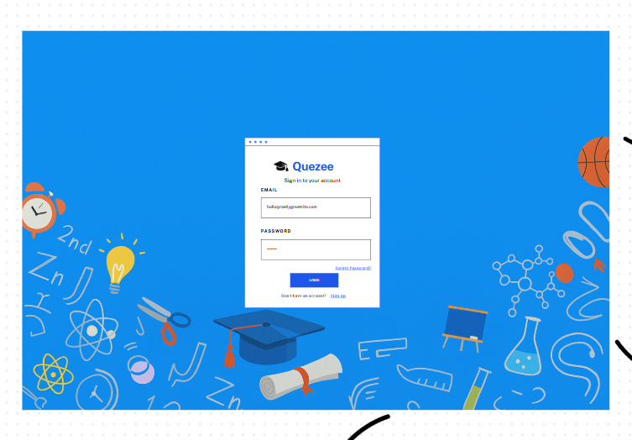

Field Name | Field Type | Description
Email | Text Box | This is for the user to input a valid email address for logging in. The input must follow standard email formatting rules, including the presence of the "@" symbol and a valid domain name (e.g., user@example.com).
Password | Password Box | This is for user to input password for logging in
Log in | Button | User clicks to authenticate him/herself into the system with provided email & password
Sign up | Hyperlink | User clicks to redirect to the User Register page for registering new user account to access the system
Forgot Password? | Hyperlink | User clicks to redirect to the Password Reset page for resetting his/her forgot password

Database Access
Table | CRUD | Description
account | R | Verify Email & Password information
setting, account | R | Specify the authorizations of the logged-in user

SQL Commands:
Verify Email information
SELECT * FROM account WHERE email = ?
Verify Email and Password information
SELECT * FROM account WHERE email = ? AND password = ?

b. User Registration
UI Design

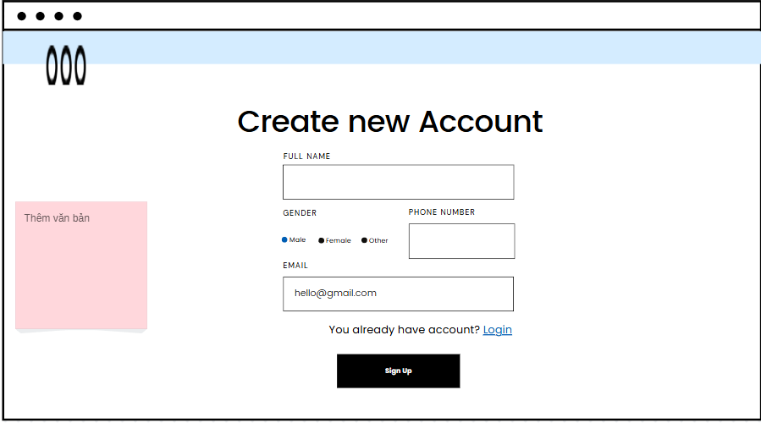

Field Name | Field Type | Description | Field Group Name
Full Name | Input/Text | Users input their full name. | Register
Gender | Input/Radio | User choose their gender | Register
Phone Number | Input/Text | User’s input their phone number | Register
Email | Input/Text | Input user’s email to register | Register
Agree conditions | Input/Checkbox | To confirm agree with tém and conditions | Register
Sign up | Button | Submit form register | Register
Login | Link | To direction to login page | Register

Database Access

Table Name | CRUD | Description
Account | Read, Create | Verify if an email address already exists, create a new account into the system.

Check email exists:

“SELECT * FROM account WHERE email = ?”

“INSERT INTO `swp391`.account (id, email, full_name, password,
dob, gender, created_date, status, phone, image_url, role_id)
VALUES (?, ?, ?, ?, ?, ?, ?, ?, ?, ?, ?)”

1.1 Reset Password
UI Design
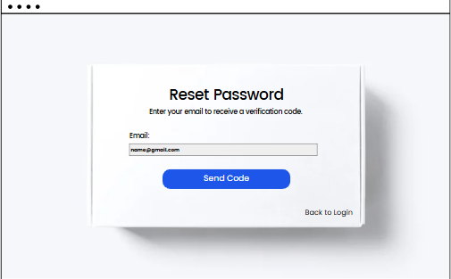
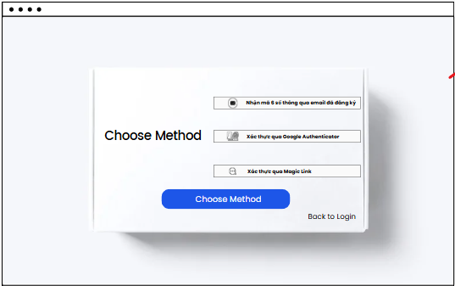
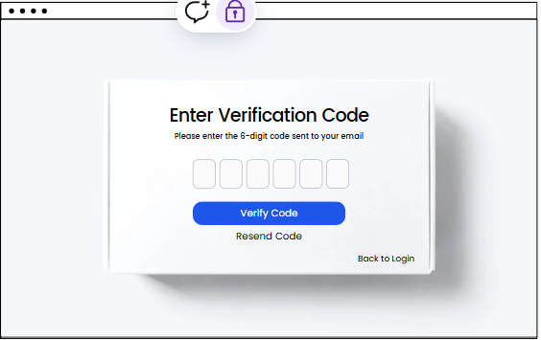
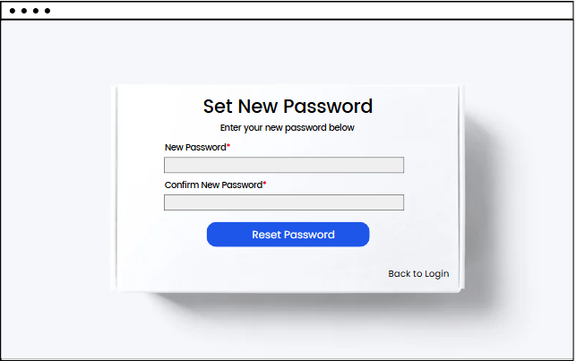

This page allows users to change their password if they forgot by one of 3 methods: OTP, TOTP (Google Authenticator), Magic link
Field Name | Field Type | Description | Field Group Name
Email | Input field | Allow users to enter their email, following the format <username>@<domain name>. Their email must be existing in the database | Verify email
Send Code | Button | Submit data to get permission to access next step | Verify email
Magic Link | Button | Users choose this method to receive a verify link sent with email | Authentication methods
Google Authenticator | Button | Users choose this method to authenticate by Google Authenticator app in their mobile device | Authentication methods
6-digit OTP | Button | Users choose this method to receive a 6 digits sent with email | Authentication methods
6-digit Code | Input fields | Enter 6 digits code that sent in the email | Verify code
Verify Code | Button | Send data to server to check code | Verify code
Resend Code | Button | Resend new code to users’ email | Verify code
New password | Input field | Allow users to enter a new password. New password must be not null, has at least 8 characters, contains uppercase letters, digits and special characters | Reset Password
Confirm new password | Input field | Allow users to enter a confirmation password. Confirmation password must is the same as the new password | Reset Password
Back to login | Button | Navigate to login page | Navigation

Database Access
The screen interacts with the database for both read (R) and update (U) operations:
Table | CRUD | Description
Account | R, U | Get account by email and update account’s password

SQL Commands
SELECT * FROM account WHERE email = ?
UPDATE account a SET a.password = ? WHERE a.email = ?

2 User Profile

a. User Profile
This screen allows users to change your
- UC02_Login System

UI Design

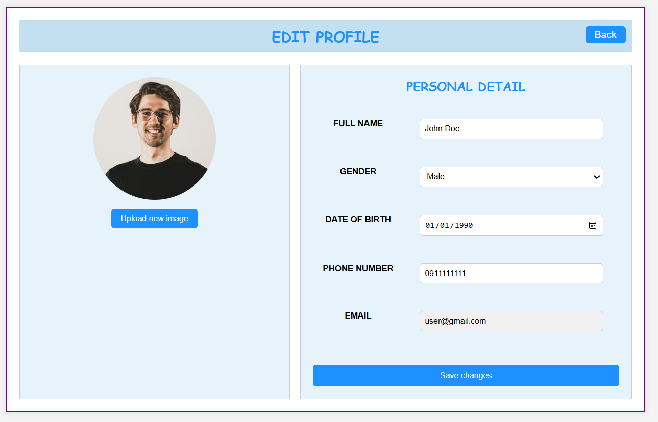
Field Name | Field Type | Description
Back | Button | Allows the user to navigate back to the previous screen.
User Profile Image | Image Display | Displays the current profile image of the user.
Upload new image | Button | Allows the user to upload a new image to update their profile picture.
FULL NAME | Input field | Displays and allows editing of the user's full name.
GENDER | Dropdown | Displays and allows selection of the user's gender.
DATE OF BIRTH | Date Picker | Displays and allows selection/editing of the user's date of birth.
PHONE NUMBER | Input field | Displays and allows editing of the user's phone number.
EMAIL | Input field (Read-only) | Displays the user's email address. This field appears to be read-only.
Save changes | Button | Saves all the modifications made to the user's profile information.

Database Access
Table | CRUD | Description
account | U | Update information for user

SQL Commands:
UPDATE `swp391`.account a
SET a.password = ?
WHERE a.email = ?
""";

2. Public

2.1 Blogs List
The blog list features a user-friendly interface with sorting options available for campaign themes and hot sales. Posts are displayed in a paginated format, showcasing the latest entries for easy navigation. Users can utilize the search box to quickly find specific content and can explore various categories along with the latest posts.

UI Design
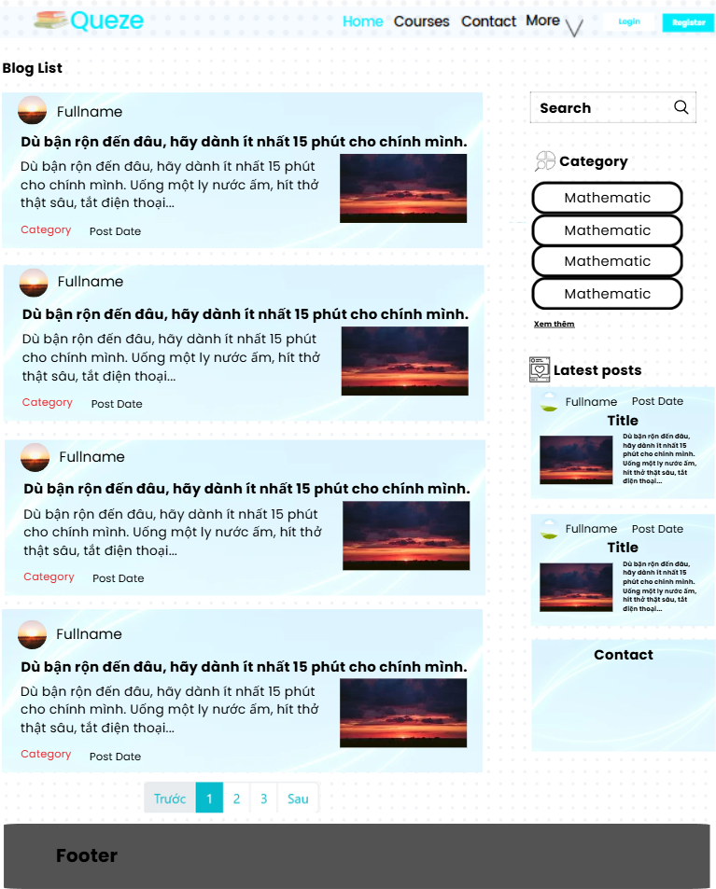
Each post is presented with essential information, including a thumbnail image, title, category, and a brief summary. Users can click on any post to be redirected to the detailed information page for further reading.

Below is the breakdown of the components:

Field Name | Field Type | Description | Field Group Name
Search bar | Input/Text | Search bar for Blog. | Sider
Icon Search | Button | Submit form to search blog | Sider
Category | Select/Link | Select to filter by category | Sider
Author Image | Image | Displays author image | Sider
Author name | Text | Displays author name | Sider
Blog Title | Text/Link | Displays the title of the blog. | Sider
Blog Image | Image | Displays the blog thumbnail image. | Sider
Blog Brief | Label/Text | Displays the brief info of each blog. | Sider
Blog Brief | Label/Text | Displays the brief info of each blog. | Blog List
Blog Category | Label/Text | Displays the categories of each blog. | Blog List
Blog Author | Text | Display author post blog | Blog List
Blog post date | Date | Displays the blog post date | Blog List
Blog Link | Anchor | Click to move to Blog Detail. | Blog List
Pagination | Text/Link | Click to switch to number page | Pagination
Previous | Button | Click to back to previous page | Pagination
Next | Button | Click to next page | Pagination
Database Access
The form collects data from the user and accesses table: blog.
It retrieves data from the Blog table to display.

Table | CRUD | Description
Blog | Read | Retrieves data for the blogs.
Blog Media | Read | Retrieves images
Account | Read | Retrieves full name, avatar.
Setting | Read | Retrieves setting type
SettingType | Read | Retrieves setting data

SQL Commands
Fetch Blog:
“””SELECT s.value
FROM `swp391`.settingtype st
JOIN `swp391`.setting s ON st.id = s.setting_type_id
JOIN `swp391`.blog b ON s.id = b.category
WHERE st.name = ? AND b.category = ?”””
“SELECT * FROM `swp391`.blog ORDER BY created_date DESC LIMIT ?”
“SELECT * FROM `swp391`.account WHERE id = ?”
“SELECT COUNT(*) FROM `swp391`.blog WHERE 1=1 AND status = ? AND (title LIKE ? OR brief_info LIKE ?) AND category = ?”
SELECT * FROM `swp391`.blogmedia WHERE blog_id = ? ORDER BY display_order

2.2 Blog Detail
Show post details (including title, author, updated date, category, and post details) + the sider with the post search box, posts categories, latest posts, static contacts/links

UI Design
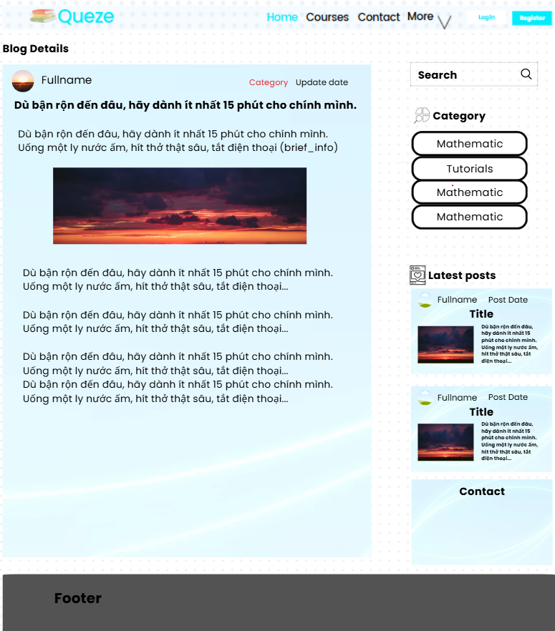

Below is the breakdown of the components:

Field Name | Field Type | Description | Field Group Name
Logo | Image/Link | Back to homepage | Header
Search bar | Input/Text | Search bar for Blog. | Sider
Category | Text/Link | Filter by category for blog. | Sider
Blog Author | Text | Displays the author of each blog. | Sider, Latest Posts
Post Date | Date | Displays post date. | Sider, Latest Posts
Blog Title | Text/Link | Displays the title of the blog | Sider, Latest Posts
Blog Brief | Label/Text | Displays the brief info of each blog. | Sider, Latest Posts
Blog thumbnail | Image | Display blog image | Sider, Latest Posts
Contact | Text | Display contact information | Sider, Latest Posts
Blog Title | Label/Text | Displays the title of the blog. | Blog Details
Blog Image | Image | Displays the blog thumbnail image. | Blog Details
Blog Brief | Label/Text | Displays the brief info of each blog. | Blog Details
Blog Category | Label/Text | Displays the categories of each blog. | Blog Details
Blog Link | Anchor | Click to move to Blog Detail. | Blog Details
Blog Author | Text | Displays the author of each blog. | Blog Details

Database Access
The form collects data from the user and accesses 2 tables: blog and user
It retrieves data from Blog and User tables to display.

Table | CRUD | Description
Blog | Read | Retrieves data for the blogs.
Account | Read | Retrieves data for the author name, avatar
SettingType | Read | Retrieves data
Setting | Read | Retrieves data type
BlogMedia | Read | Retrieves all blog images and videos

SQL Commands
Fetch Account:
“SELECT * FROM `swp391`.account WHERE id = ?”
Fetch Category:
""" SELECT s.value FROM `swp391`.settingtype st
JOIN `swp391`.setting s ON st.id = s.setting_type_id
JOIN `swp391`.blog b ON s.id = b.category
WHERE st.name = ? AND b.category = ? """;
Fetch Blog Media:
“SELECT * FROM `swp391`.blogmedia WHERE blog_id = ? ORDER BY display_order”
Fetch Blog:
“SELECT * FROM `swp391`.blog WHERE id = ?”
“SELECT * FROM `swp391`.blog ORDER BY created_date DESC LIMIT ?”

2.3 Home
UI Design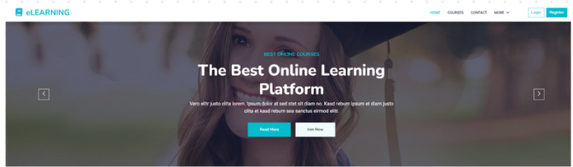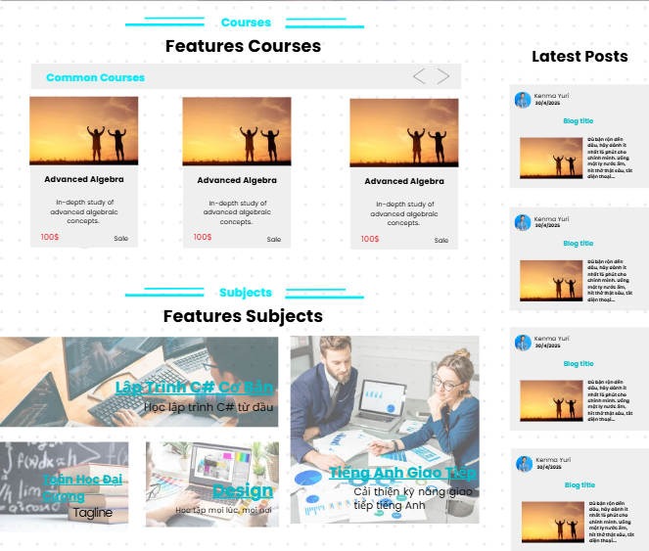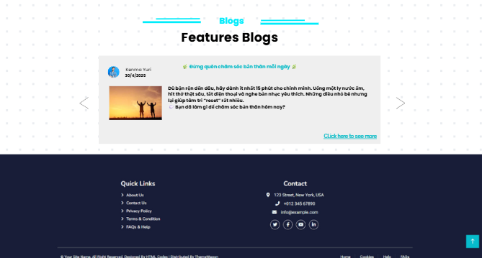

Below is the home components:

Field Name | Field Type | Description | Field Group Name
Quezee | Image/Link | Logo of the website | Header
Home | Link | Redirect to home page | Header
Courses | Link | Redirect to courses list | Header
Contact | Link | Scroll down to the footer (contact) | Header
More | Link | Scroll down to about us | Header
Slider | Image | Marketing | Slider
Read more | Button | Redirect to image location | Slider
Arrow left | Button | Show the image previous | Slider
Arrow right | Button | Show the image next | Slider
Courses Features | Text | Heading | Courses
Arrow left | Button | Display prev courses | Courses
Arrow right | Button | Display next courses | Courses
Courses image | Link | Display course image and redirect to course detail if user click on | Courses
Course title | Text | Display course title | Courses
Course description | Text | Display course description | Courses
Course price | Text | Display course price | Courses
Post title | Text/Link | Show title, redirect to post details | Hot Posts
User name | Text | User post content | Hot Posts
Date | Text | Posted date | Hot Posts
Thumbnail | Image | Show image of the post | Hot Posts
Content | Text | Show content | Hot Posts
Read more | Link | Redirect to post details | Hot Posts
Courses Title | Text | Show course title | Feature Subject
Tagline | Text | Show tagline of subject | Feature Subject
Subject Image | Image | Show image of subject, redirect to Subject topic | Feature Subject
Contact | Text | Contact, static information | Footer
Facebook icon | Icon/Link | Contact, link to facebook | Footer
Twitter icon | Icon/Link | Contact, link to twitter | Footer
Instagram icon | Icon/Link | Contact, link to instagram | Footer
Youtube | Icon/Link | Contact, link to youtube | Footer
Arrow up | Button | Scroll up to top | Home Page

Database Access
The form collects data from the user and accesses 2 tables: blog and user
It retrieves data from Blog and User tables to display.

Table Name | CRUD | Description
Blog | Read | Retrieves course details such as title, subtitle, description, and other info.
User | Read | Retrieves user’ information, user’s full name, avatar
Course | Read | Retrieves course
Slider | Read | Retrieves slider image-url, title,backlink-url
Price Package | Read | Get price for courses features
Subject | Read | Retrieves subject’ title, tagline, image
Tagline | Read | Retrieves tagline by subjectId

SQL Commands
Fetch Blog:
SELECT * FROM `swp391`.blog
WHERE status = true and flag_feature = true
ORDER BY views DESC LIMIT ?

SELECT * FROM blog
WHERE status = true
ORDER BY created_date DESC LIMIT ?

Fetch User:
SELECT * FROM account WHERE id = ?
Fetch Course:
SELECT course_id, COUNT(*) AS total_purchases
FROM swp391.personalcourse
WHERE status = 'PAID'
GROUP BY course_id
ORDER BY total_purchases DESC
LIMIT ?;

Fetch Price Package:
SELECT * FROM `swp391`.pricepackage
WHERE course_id = ?
Fetch Slider:
SELECT * FROM slider s WHERE s.status = ? ORDER BY RAND() LIMIT ?

Fetch Subject:
SELECT * FROM subject WHERE feature_flag = ? ORDER BY RAND() LIMIT ?

Fetch Tagline:
SELECT id, name FROM tagline t" + " JOIN subject_tagline s ON t.id = s.tagline_id" + " WHERE subject_id = ?

2.4 Subjects List

UI Design
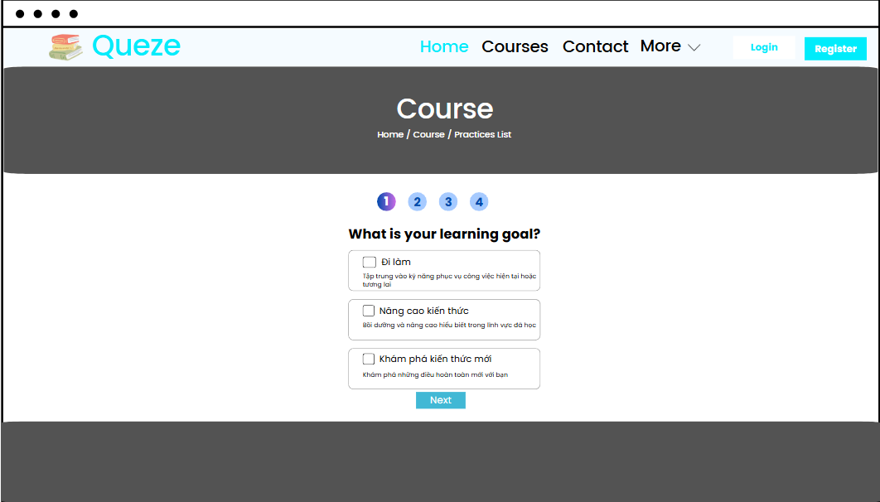

Below is the home components:

Field Name | Field Type | Description | Field Group Name
Step index | Label | Display the step that users is interacting with | Step elements
Question | Label | Display the question, which used to ask users | Step elements
Options | Checkbox | Allow users to choose options that are the best relevant to their goals | Step elements
Option description | Label | Describe about the options | Step elements
Next | Button | Allow users to move to the next step if they finish the current step | Step elements

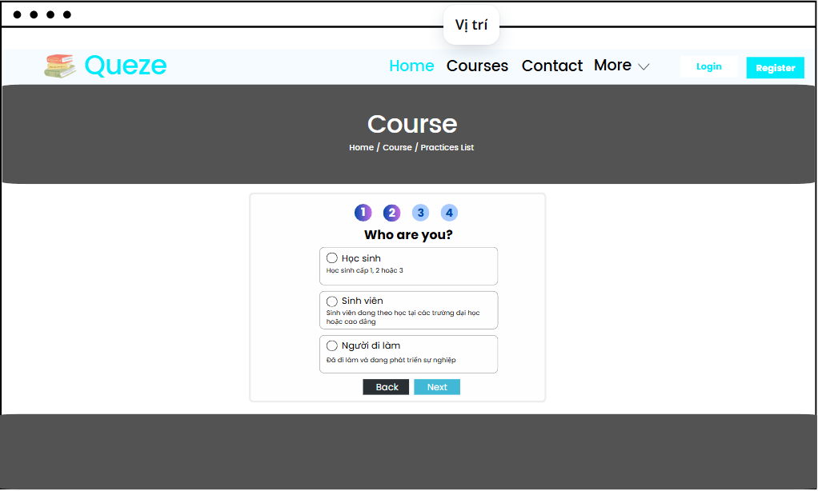
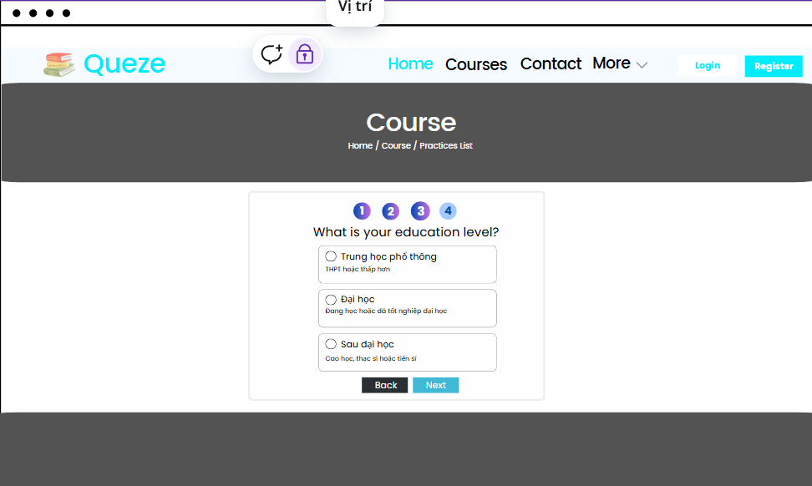

Below is the home components:

Field Name | Field Type | Description | Field Group Name
Step index | Label | Display the step that users is interacting with | Step elements
Question | Label | Display the question, which used to ask users | Step elements
Options | Checkbox | Allow users to choose options that are the best relevant to their goals | Step elements
Option description | Label | Describe about the options | Step elements
Next | Button | Allow users to move to the next step if they finish the current step | Step elements
Back | Button | Allow users to go back to the previous step | Step elements

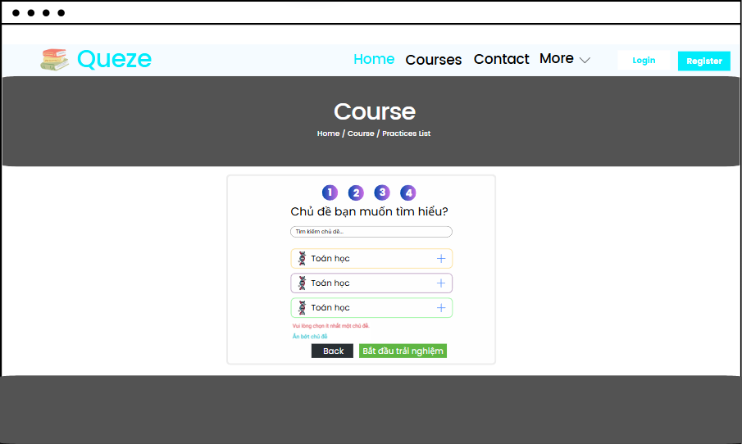

Below is the home components:

Field Name | Field Type | Description | Field Group Name
Step index | Label | Display the step that users is interacting with | Step elements
Question | Label | Display the question, which used to ask users | Step elements
Search field | Input box | Allow users to search topics by key words. | Step elements
Topics | Checkbox | Allow users to choose topics that are the best relevant to their goals | Step elements
Alert | Label | Notify that users must select at least one topic. This notify will disappear when users click a topic and re-render when users cancel all their topics | Step elements
Hide/Show topics | Button | Allow users to view more topics and hides the rest if needed | Step elements
Start the experience | Button | Send users’ customized configuration to server in order to find the best subjects list | Step elements
Back | Button | Allow users to go back to the previous step | Step elements
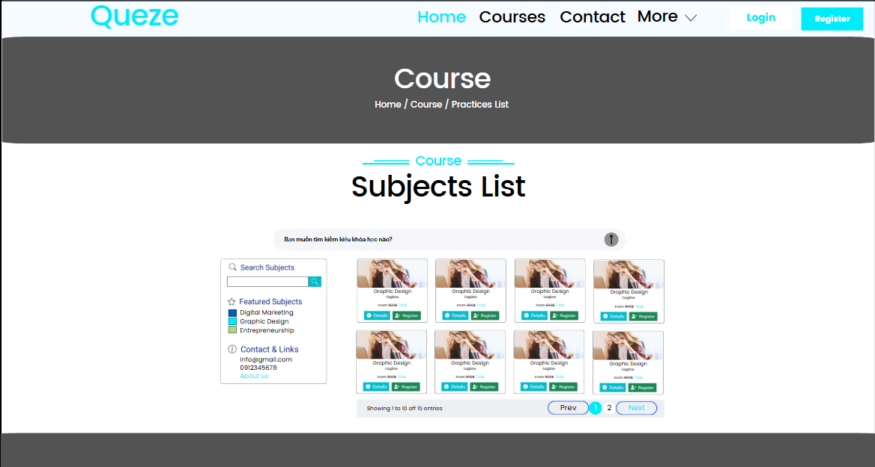

Below is the home components:

Field Name | Field Type | Description | Field Group Name
Prompt field | Input field | Allow users to get all subjects. If gemma finds keywords that are related to the category names, which is provided in the controller, it will find subjects by categories. Or else, it throws an error message “There is no subjects like your description” and ask users to prompt again | Prompt box
Submit prompt | Button | Allow users to submit their prompt to gemma | Prompt box
IMG | Image | Display the thumbnail image of the subject | Table content
Title | Label | Display the title of the subject | Table content
Tagline | Label | Display the subject’s tagline | Table content
From largest price to sale price | Label | Display the largest price of the subject and its sale price. Sale price must smaller than largest price | Table content
Details | Button | Allow users to view all information of subject in the “Subject details” screen | Table content
Register | Button | Allow users to register subjects by fulfilling all users’ information and price package in the “Subject Register” pop up screen. If users have logged in, they do not need to fill in their information | Table content
Showing 1 to 10 of 15 entries | Label | Show the current items of page with total elements | Pagination
Prev | Button | Navigate to previous page if the current page is different from 1 | Pagination
Page index | Button | Display the current page index (is marked) and the rest | Pagination
Next | Button | Navigate to previous page if the current page is smaller than total pages | Pagination
Search | Input field | Search for subjects by subject name | Left sidebar
Contact | Label | Display the organization’s information, who owns the system | Left sidebar
About us | Link | Navigate to the website’s introduction screen, which show all information about the website and organization owns it | Left sidebar
Featured Subjects | Label | Display all subject titles that are the top 3 trending | Left sidebar

Database Access
The page accesses multiple tables in the database to display detailed information about the course, chapters, lessons, price packages, and related courses.
Table Name | CRUD | Description
Subject | Read | Retrieves subject details such as id, name, thumbnail url, feature flag, author id and updated date.
Contact | Read | Retrieves contact details with id, name, link, email, phone and address
Topic | Read | Retrieves topic information such as id, name and subject id
Tagline | Read | Retrieves tagline information such as id and name

SQL Commands
- Get all categories:
SELECT DISTINCT s.value FROM setting_subject ss
JOIN setting s ON ss.setting_id = s.id
JOIN settingtype stt ON s.setting_type_id = stt.id
WHERE stt.name IN (‘Domain’, ‘Group’)
- Get subjects list by category:
SELECT * FROM subject s
JOIN setting_subject ss ON s.id = ss.subject_id
JOIN setting st ON ss.setting_id = st.id
JOIN settingtype stt ON st.setting_type_id = stt.id
WHERE st.value = ?
- Get subjects with pagination:
SELECT * FROM subject s ORDER BY id LIMIT ? OFFSET ?
- Get features subjects:
SELECT * FROM subject
WHERE feature_flag = ?
- Get lowest and sale price by subject id
SELECT pp.price AS ‘lowest_price’, pp.sale_price
FROM pricepackage pp
JOIN course c ON c.id = pp.course_id
JOIN topic t ON t.id = c.topic_id
JOIN subject s ON s.id = t.subject_id
WHERE s.id = ?
AND pp.price = (
SELECT MIN (pp2.price)
FROM pricepackage pp2
JOIN course c2 ON c2.id = pp2.subject_id
JOIN topic t2 ON t2.id = c2.topic_id
WHERE t2.subject_id = s.id
)
- Get number of courses per subject
SELECT COUNT(*)
FROM course c
LEFT JOIN topic t ON c.topic_id = t.id
LEFT JOIN subject s ON t.subject_id = s.id
WHERE s.id = ?
- Get total price of n courses of one subject
SELECT SUM(pp.price)
FROM course c
JOIN topic t ON c.topic_id = t.id
JOIN subject s ON t.subject_id = s.id
RIGHT JOIN pricepackage pp ON pp.course_id = c.id
WHERE s.id = ? AND pp.price > 0
ORDER BY pp.price
LIMIT ?
- Get top 3 featured subject
SELECT * FROM subject
WHERE feature_flag = ?
ORDER BY RAND() LIMIT ?
- Count subjects
SELECT COUNT(*) FROM subject;
- Get subject by id
SELECT * FROM subject WHERE id = ?
- Get contact by id
SELECT * FROM contact WHERE id = ?
- Get all topics
SELECT * FROM topic
- Get tagline by subject id
SELECT id, name FROM tagline t
JOIN subject_tagline s ON t.id = s.tagline_id
WHERE subject_id = ?
- Get all topics: SELECT * FROM topic

2.5 Subject Register
UI Design
a. Register popup modal
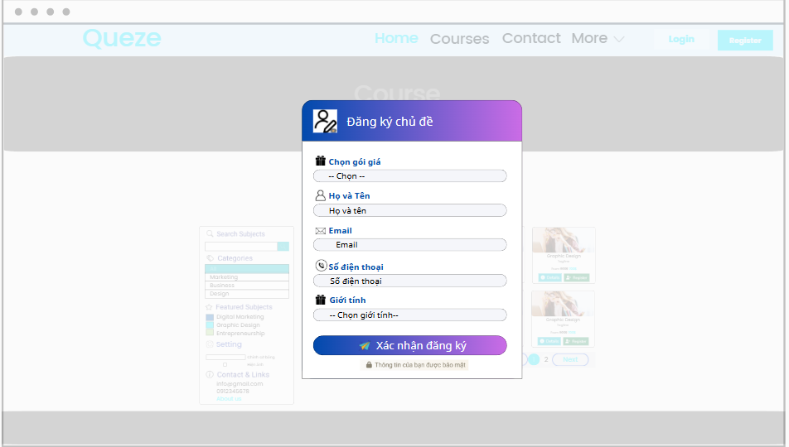
Below is the home components:

Field Name | Field Type | Description | Field Group Name
Header | Label | Display the content of popup modal | Header
Price package selection title | Label | Display the title of the selection field | Form group
Price package selection field | Select box | Allow users to choose one price package that fits to their need | Form group
Full name title | Label | Display the title of full name field | Form group
Full name input field | Input box | Allow users to enter their details if they have not signed in yet. If they are on session, information will be automatically fulfilled | Form group
Email title | Label | Display the title of email field | Form group
Email input field | Input box | Allow users to enter their details if they have not signed in yet. If they are on session, information will be automatically fulfilled | Form group
Phone number title | Label | Display the title of phone number field | Form group
Phone number input field | Input box | Allow users to enter their details if they have not signed in yet. If they are on session, information will be automatically fulfilled | Form group
Register confirmation | Button | Confirm the register information and send to server | Form group
Footer | Label | Display and notify users that their information will be secured | Footer

b. Payment screen
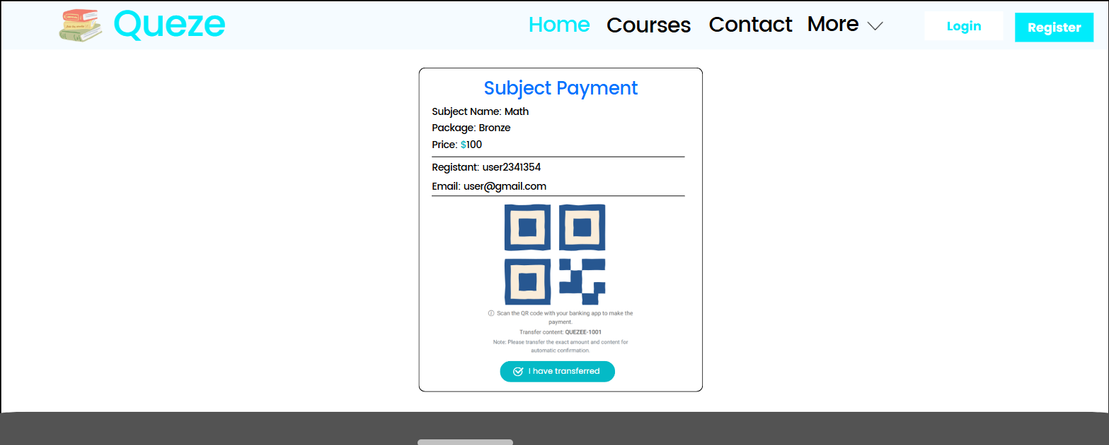
Below is the home components:

Field Name | Field Type | Description | Field Group Name
Subject Payment | Label | Display the header content of Payment screen | Payment elements
Subject Name | Label | Display the name of subject that current user has registered | Payment elements
Package | Label | Display the price package name of subject | Payment elements
Price | Label | Display the price of subject | Payment elements
Registant | Label | Display the full name of current user | Payment elements
Email | Label | Display the email of current user | Payment elements
QR code | Image | Display the QR code, allows users to scan it in order to make a bank transfer | Payment elements
Scan QR code guideline | Label | Guide users to scan the QR code | Payment elements
Note | Label | Display the note to users | Payment elements
Transferred | Button | Confirming that users have already transferred | Payment elements

Database Access
The page accesses multiple tables in the database to display detailed information about the course, chapters, lessons, price packages, and related courses.
Table Name | CRUD | Description
Account | Read, Create | - Retrieves account details.  - Create new account
PersonalSubject | Create, Read | - Create new personal subject with the information sent from request  - Check the existence of record
Subject | Read | Retrieves subject details such as id, name, thumbnail url, feature flag, author id and updated date.

SQL Commands
- Create new account
INSERT INTO account
VALUES (?, ?, ?, ?, ?, ?, ?, ?, ?, ?, ?)
- Get account by email and check email existing or not
SELECT * FROM account WHERE email = ?
- Check phone number existing or not
SELECT * FROM account WHERE phone = ?
- Get account by id
SELECT * FROM account WHERE id = ?
- Create new Personal Subject
INSERT INTO personalsubject
VALUES (?, ?, ?, ?, ?, ?, ?, ?)
- Update status of personal subject
UPDATE personalsubject SET status = ? WHERE subject_id = ? AND account_id = ?
- Get subject by id
SELECT * FROM subject WHERE id = ?
- Check if personal subject exists or not and get it
SELECT * FROM personalsubject WHERE subject_id = ? AND subject_id = ?

3. Marketing

3.1 Sliders List
UI Design
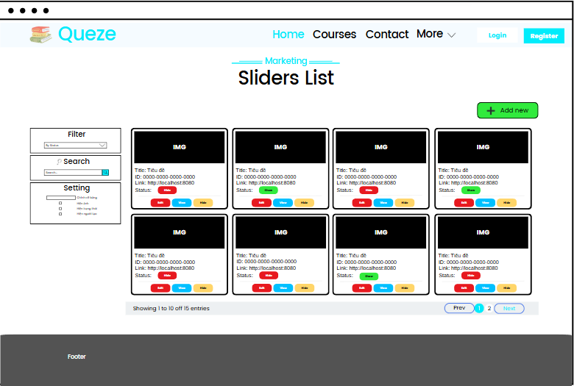

This section of the page is responsible for presenting the paginated list of sliders and activity’s options.
Below is the breakdown of the components:
Field Name | Field Type | Description | Field Group Name
By Status | Dropdown box | Filter sliders by their status | Left sidebar
Search | Input field | Search for sliders by keywords | Left sidebar
Change table’s size | Input field | Receive a number to change the number of items per page | Left sidebar
Show/Hide image | Checkbox | Show or hide the preview image if users want | Left sidebar
Show/Hide state | Checkbox | Show or hide the slider’s status if users want | Left sidebar
Show/Hide author name | Checkbox | Show or hide the slider’s author name if users want | Left sidebar
IMG | Image | Display the preview image of the slider | Table content
Title | Label | Display the title of the slider | Table content
ID | Label | Display the slider’s ID | Table content
Link | Label | Display the slider’s backlinkURL | Table content
Status | Button | Display the slider’s status, green box for active and red box for inactive | Table content
Edit | Button | Navigate users to the “Slider details” screen by clicking it | Table content
View | Button | Open the preview popup screen in order to see slider in the guest mode | Table content
Show/Hide | Button | Change sliders’ status if users want | Table content
Showing 1 to 10 of 15 entries | Label | Show the current items of page with total elements | Pagination
Prev | Button | Navigate to previous page if the current page is different from 1 | Pagination
Page index | Button | Display the current page index (is marked) and the rest | Pagination
Next | Button | Navigate to previous page if the current page is smaller than total pages | Pagination

Database Access
The page accesses multiple tables in the database to display detailed information about the course, chapters, lessons, price packages, and related courses.
Table Name | CRUD | Description
Slider | Read | Retrieves slider details such as title, id, imageUrl, backlinkUrl and status.
Account | Read | Retrieves author name by slider

SQL Commands
- SELECT * FROM slider
- SELECT * FROM account WHERE id = ?
- SELECT * FROM slider WHERE title LIKE ?
- SELECT * FROM slider WHERE status = ?
- UPDATE slider SET status = ? WHERE id = ?

3.2 Post Details
UI Design
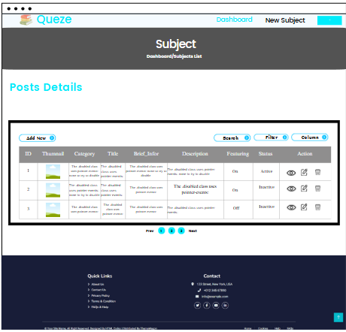
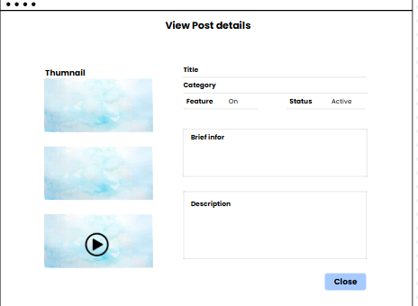
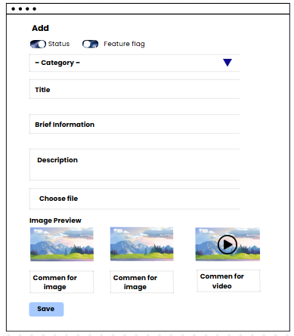
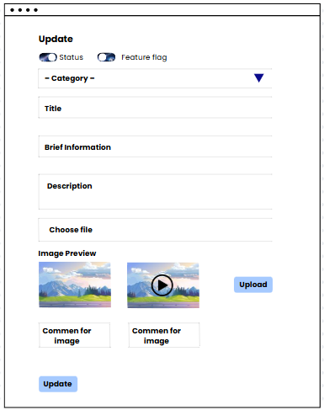
This screen allows marketers to manage blog posts. They can view, search, create, edit, and delete posts. Each post includes details like title, category, thumbnail, brief info, full description, featured flag, and status.
Field Name | Field Type | Description | Field Group Name
Add New | Button | Display pop-up to add new post | Post List
Search | Input/Text | Input keyword to search by title, content, brief content | Post List
Column | Checkbox | Display column is checked | Post List
ID | Text | Displayed number of post | Post List
Thumbnail | Image | Post image | Post List
Category | Text | Category of post | Post List
Brief_Infor | Text | Display post brief information | Post List
Description | Text | Display post description | Post List
Featuring | Text | Display feature status | Post List
Status | Text | Displayed post status | Post List
Action | Button | View, Edit, Delete post | Post List
Prev | Button | Back to previous page | Pagination
Next | Button | Display next page | Pagination
Title | Text | Display blog details title | View Post
Category | Text | Display post category | View Post
Feature | Text | Mark to common post in homepage | View Post
Brief Info | Text | Display post brief info | View Post
Description | Textfield | Display post description | View Post
Close | Button | Click to close pop-up | View Post
Title | Text | Display blog details title | Update Post
Category | Text | Display post category | Update Post
Feature | Text | Mark to common post in homepage | Update Post
Brief Info | Text | Display post brief info | Update Post
Description | Textfield | Display post description | Update Post
Upload | Input | Upload images and videos | Update Post
Update | Button | Submit form to update post | Update Post

Database Access
The page accesses multiple tables in the database to display detailed information about the post details.
Table Name | CRUD | Description
Blog | Read, Update, Create,  Delete | Retrieves course details such as title, subtitle, description, and other info. Insert, update, delete post details.
BlogMedia | Read, Create | Retrieves all blog images, videos, add videos, images
Setting | Read | Retrieves all category
Setting Type | Read | Fetches related setting based on setting type
Account | Read | Retries blog account id

SQL Commands

Fetch, Insert BlogMedia:
"SELECT * FROM `swp391`.blogmedia WHERE blog_id = ? ORDER BY display_order";
INSERT INTO `swp391`.blogmedia (
id, blog_id, media_type, file_path,
caption, display_order
) VALUES (?, ?, ?, ?, ?, ?)
INSERT INTO `swp391`.blogmedia (
id, blog_id, media_type, file_path,
caption, display_order
) VALUES (?, ?, ?, ?, ?, ?)

Fetch Blog:
“””SELECT COUNT(*) FROM `swp391`.blog
WHERE 1=1
AND status = ?
AND (title LIKE ? OR brief_info LIKE ? OR content LIKE ?)
AND category = ?”””
""" INSERT INTO `swp391`.blog (
id, account_id, title, content, views,
category, thumbnail_url, brief_info,
status, updated_date, created_date, flag_feature )
VALUES (?, ?, ?, ?, ?, ?, ?, ?, ?, ?, ?, ?) """
"""SELECT * FROM `swp391`.blog
WHERE 1=1 AND status = ? AND (title LIKE ? OR brief_info LIKE ? OR content LIKE ?) AND category = ?
ORDER BY created_date
DESC LIMIT ? OFFSET ?"""
Fetch setting and settingtype:
""" SELECT DISTINCT s.id, s.value
FROM `swp391`.settingtype st
JOIN `swp391`.setting s ON st.id = s.setting_type_id
JOIN `swp391`.blog b ON s.id = b.category WHERE st.name = ? """
Fetch AccountId:
“SELECT * FROM `swp391`.account WHERE id = ?”

3.3 Slider Details
UI Design
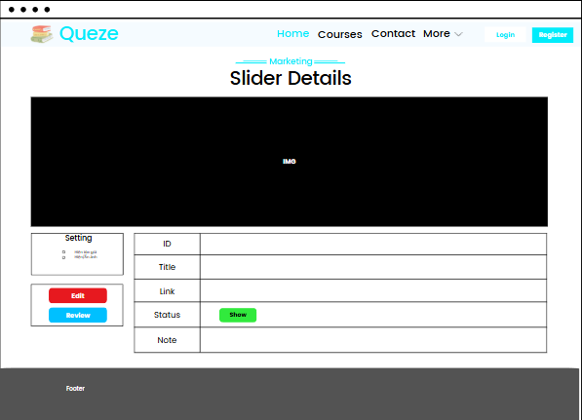

This section of the page is responsible for presenting the paginated list of sliders and activity’s options.
Below is the breakdown of the components:
Field Name | Field Type | Description | Field Group Name
IMG | Image | Display the preview image of the slider | Image
Show/Hide image | Checkbox | Show or hide the preview image if users want | Left sidebar
Show/Hide author name | Checkbox | Show or hide the slider’s author name if users want | Left sidebar
Edit | Button | Allow users to save all changes in the slider’s details | Left sidebar
Review | Button | Open the preview popup screen in order to see slider in the guest mode | Left sidebar
Title | Label | Display the title of the slider | Table content
ID | Label | Display the slider’s ID | Table content
Link | Label | Display the slider’s backlinkURL | Table content
Status | Button | Display the slider’s status, green box for active and red box for inactive | Table content
Note | Label | Display the note of slider’s author | Table content
Author | Label | Display author’s name, who create this slider | Table content

Database Access
The page accesses multiple tables in the database to display detailed information about the course, chapters, lessons, price packages, and related courses.
Table Name | CRUD | Description
Slider | Read, Update | - Retrieves slider details such as title, id, imageUrl, backlinkUrl and status.  - Update slider information
Account | Read | Retrieves author name by slider

SQL Commands
- SELECT * FROM slider WHERE id = ?
- SELECT * FROM account WHERE id = ?
- UPDATE slider SET status = ?, title = ?, image_url = ?,
backlink_url = ?, status = ?
WHERE id = ?

3.4 Dashboard
UI Design
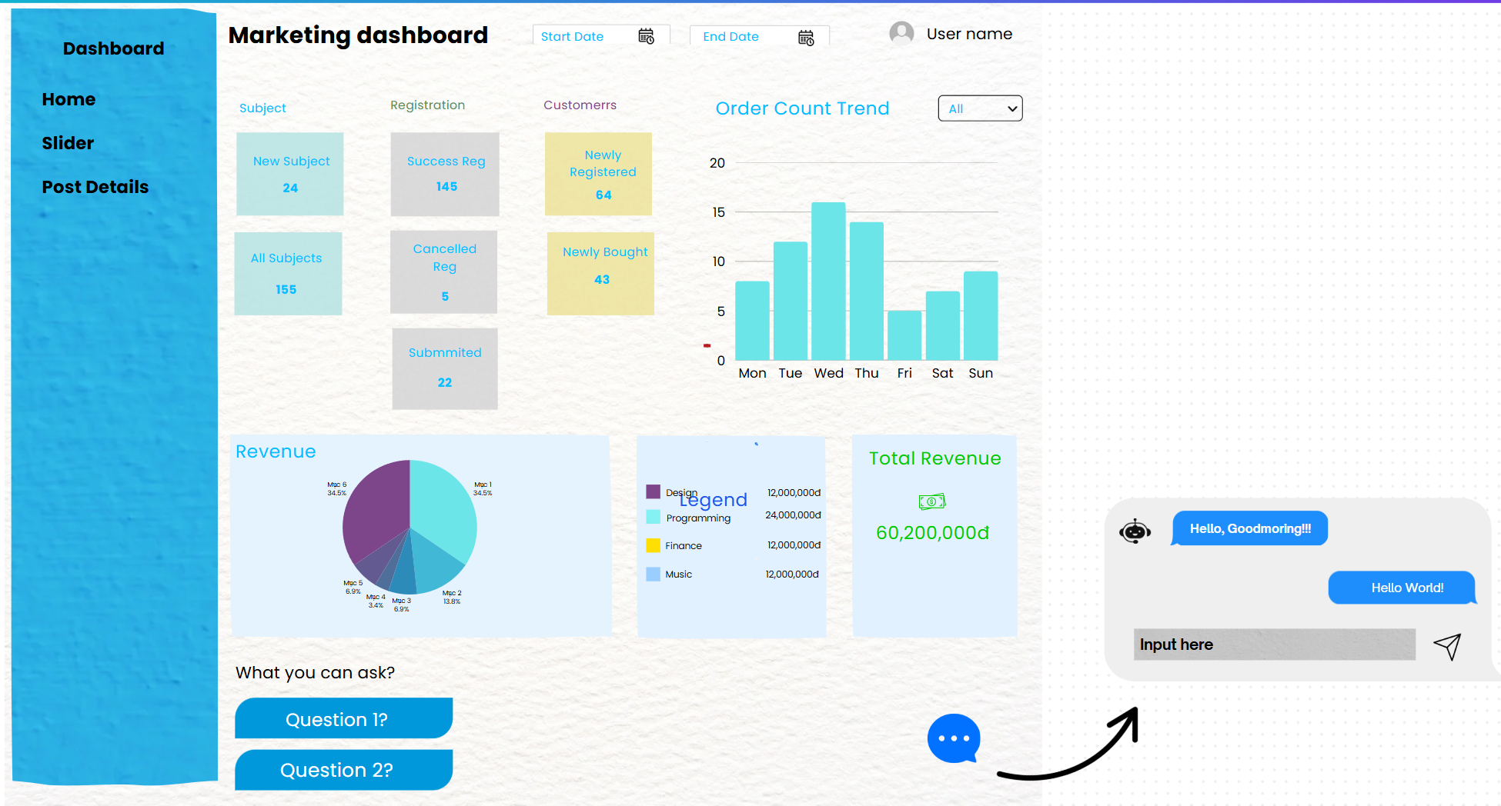

This section of the page is responsible for statistics of subject, customer, revenue, registration.
Below is the breakdown of the components:

Field Group Name | Field Name | Field Type | Description
Sidebar | Post Details | Link | Redirect to the Post Details page (Marketer role)
Sidebar | Home | Link | Redirect to the Homepage
Sidebar | Slider | Link | Redirect to the Slider page
Sidebar | Registration List | Link | Redirect to the Registration List (Sale role)
Dashboard | Marketing dashboard | Text | Title page
Dashboard | Start Date | Input/Date | Start date for statistics
Dashboard | End Date | Input/Date | End date for statistics
Subject | Subject | Text | Title
Subject | New Subject | Text | Display total new subject in start date to end date
Subject | All Subject | Text | Display all subject
Registration | Registration | Text | Title
Registration | Success Reg | Text | DIsplay number of registration success
Registration | Canceled Reg | Text | Display number of registration canceled
Registration | Submitted | Text | Display number of Registration submitted
Customers | Customers | Text | Title
Customers | Newly Registered | Text | Number of newly user register
Customers | Newly Bought | Text | A number of new courses are bought.
Order Trend | Order Count Trend | Text | Title
Order Trend | All / Success Only | Selected | Choose order by condition (All or success)
Order Trend | Y-assis (e.g., 0, 5,...) | Text | Number of orders
Order Trend | X-assis (e.g., Mon, Tue,...) | Text | Days of week
Revenue | Pie Chart | Chart | Statistic revenue by categories
Revenue | Legend | Text | Description for chart
Revenue | Total Revenue | Text | Total revenue
Chatbot | Message Icon | Text field | Input prompt to ask AI chatbot
What you can ask? | Question Suggestion | Text | Label
Question 1? | Question Suggestion | Button | Button click to send question to AI
Question 2? | Question Suggestion | Button | Button click to send question to AI

Database Access
The page accesses multiple tables in the database to display detailed information about the course, chapters, lessons, price packages, and related courses.
Table Name | CRUD | Description
Subject | Read | Retrieves new subject in date range,all subject, revenue by subject category.
Course | Read | Retrieves course by status (success, cancel, sent)
Account | Read | Retrieves new account in date range and new user buy new course
Personal Course | Read | Retrieves courses, which users join success, all.
Price package | Read | Retrieves course price.
Topic | Read | Join table

SQL Commands
- “SELECT COUNT(*) FROM `swp391`.subject”
- “SELECT COUNT(*) FROM `swp391`.subject WHERE created_date BETWEEN ? AND ?”
- “SELECT COUNT(*) FROM personalcourse WHERE status = ? AND enroll_date BETWEEN ? AND ?”
- “SELECT COUNT(*) FROM `swp391`.account WHERE created_date BETWEEN ? AND ?”
- “SELECT COUNT(*) FROM personalcourse ps
JOIN account a ON ps.account_id = a.id
WHERE ps.enroll_date BETWEEN ? AND ?
AND a.created_date BETWEEN ? AND ?”
- “SELECT s.name AS category, SUM(pp.sale_price) AS total_revenue
FROM `swp391`.subject s
JOIN `swp391`.topic t ON t.subject_id = s.id
JOIN `swp391`.course c ON c.topic_id = t.id
JOIN `swp391`.pricepackage pp ON pp.course_id = c.id
JOIN `swp391`.personalcourse ps ON ps.course_id = c.id
WHERE ps.enroll_date BETWEEN ? AND ?
GROUP BY s.name
ORDER BY total_revenue DESC;”
- “SELECT COUNT(*) FROM personalcourse WHERE status = ? AND enroll_date BETWEEN ? AND ?”

4. Customer

4.1 Practices List
UI Design
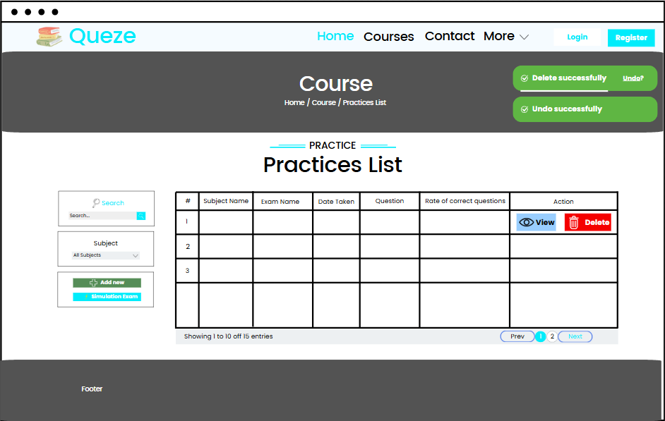

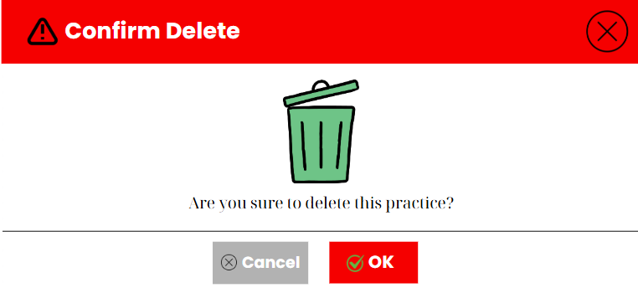

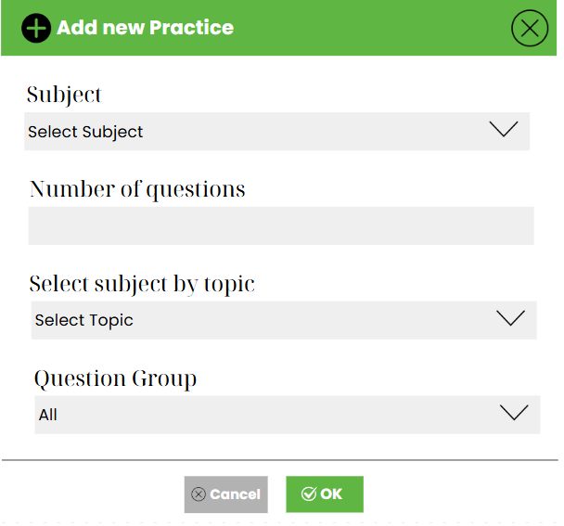
This section is responsible for learning of user, listing and display all the resources of their registered course to the screen:

Field Name | Field Type | Description | Field Group Name
Search… | Input box | Contains the keywords in order to search for exams | Left sidebar
Search Button | Button | Allows users to search by keywords | Left sidebar
All Subjects | Dropdown box | Users select one subject to get all exams that this subject has | Left sidebar
Add new | Button | Allows users to add a new exam | Left sidebar
Simulation Exam | Button | Allows users to start an exam | Left sidebar
# | Table column | Displays the order of an exam | Exam table
Subject Name | Table column | Displays the subject of an exam | Exam table
Exam name | Table column | Displays the name of an exam | Exam table
Taken Date | Table column | Displays the date when this exam has created or enrolled | Exam table
Question | Table column | Displays the number of questions and the number of correct questions | Exam table
Rate of correct questions | Table column | Displays the percentage of correct questions | Exam table
View | Button | Allows users to view the exam details | Action button
Delete | Button | Allows users to delete a specific exam | Action button
Notification | Label | Displays the page’s notifications | Notification
Undo link | Button | Rollback the deletion of an exam | Action button
Prev | Button | Used to move to the previous page if the page index is larger than 1 | Pagination button
Page Index | Button | Show all the available pages, used to navigate to random pages | Pagination button
Next | Button | Used to navigate to the next page if the page index is smaller than the total pages number. | Pagination button
Select topic | Dropdown box | Filter question by topic or dimension | Popup screen element
Question Group | Dropdown box | Contains all the topic or dimension | Popup screen element
Number of questions | Input box | Allows users to input the number of question in the exam | Popup screen element
Select Subject | Dropdown box | Contains the list of subjects | Popup screen element
Cancel | Button | Leaves out the delete popup screen | Popup screen element
OK | Button | Accepts the deletion | Popup screen element

Database Access

Table Name | CRUD | Description
Subject | Read | Retrieves subject name of an exam
PersonalQuiz | Read, Delete | Retrieves quizzes list, which belongs to recent user  Delete quiz by their id
Quiz | Read | Retrieves quizzes list
Topic | Read | Retrieves topic name of an exam
Setting | Read | Retrieves domain of an exam
Setting_Subject | Read | Retrieves id of setting by subject’s id

SQL Commands:

“SELECT * FROM quiz WHERE id = ?”
“SELECT * FROM topic WHERE id = ?”
“SELECT * FROM subject WHERE id = ?”
“SELECT setting_id FROM setting_subject WHERE subject_id = ?”
“SELECT value FROM setting WHERE id = ?”
“DELETE FROM personalquiz WHERE id = ?”

4.2 My Registration
UI Design
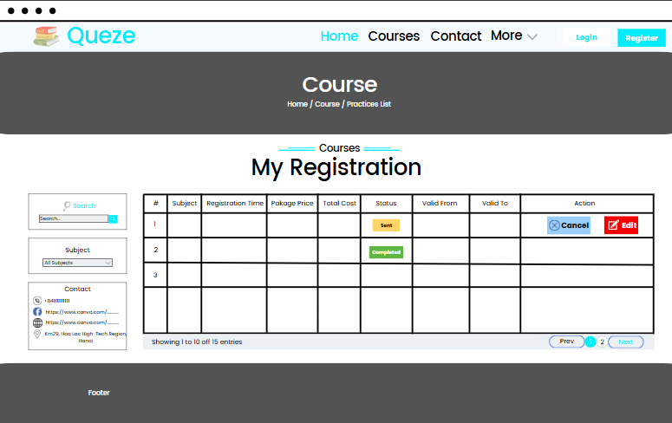
This section is responsible for showing all the registered courses of recent users. Users can search, filter by subjects, view course’s contact information, and cancel-edit registration:

Field Name | Field Type | Description | Field Group Name
Search | Input box | Used to input keywords | Left sidebar
Search Button | Button | Allows users search courses by keywords | Left sidebar
Subject | Dropdown box | Used to filter exams by their subjects name | Left sidebar
Contact | Label | Display the organization’s information, who owns the course | Left sidebar
# | Table column | Display the order of courses | Courses table
Subject | Table column | Displays the time of Quiz | Courses table
Registration Time | Table column | Display the time when users register a course | Courses table
Package | Table column | Display the packages name | Courses table
Total Cost | Table column | Display the cost of a course | Courses table
Status | Table column | Display the status of a course | Courses table
Valid from | Table column | Display the start date of validity period | Courses table
Valid to | Table column | Display the end date of validity period | Courses table
Cancel | Button | Used to cancel the registration if course’s status is “sent” | Action button
Edit | Button | Used to edit one specific registration if course’s status is “sent” | Action button
Prev | Button | Used to move to the previous page if the page index is larger than 1 | Pagination button
Page Index | Button | Show all the available pages, used to navigate to random pages | Pagination button
Next | Button | Used to navigate to the next page if the page index is smaller than the total pages number. | Pagination button

Database Access

Table Name | CRUD | Description
PersonalCourse | Read, Delete | Get all the courses that recent user has registered  Delete course, which is enrolled by the recent user, by it’s id and user’s id
PricePackage | Read | Get price packages by course
Course | Read | Get courses that recent user has registered
Topic | Read | Get topic of courses
Subject | Read | Get subject of course
Contact | Reac | Get contact of course

SQL Commands:
"SELECT * FROM personalcourse p WHERE p.account_id= ?"
"SELECT * FROM pricepackage p WHERE p.course_id= ?"
"SELECT * FROM course s WHERE s.id = ?"
"SELECT * FROM topic s WHERE s.id= ?"
"SELECT * FROM subject s WHERE s.id = ?"
“SELECT * FROM contact”
“SELECT * FROM contact WHERE id = ?”
“DELETE FROM personalsubject WHERE subject_id = ? AND account_id = ?”

4.3 Simulation Exam

UI Design

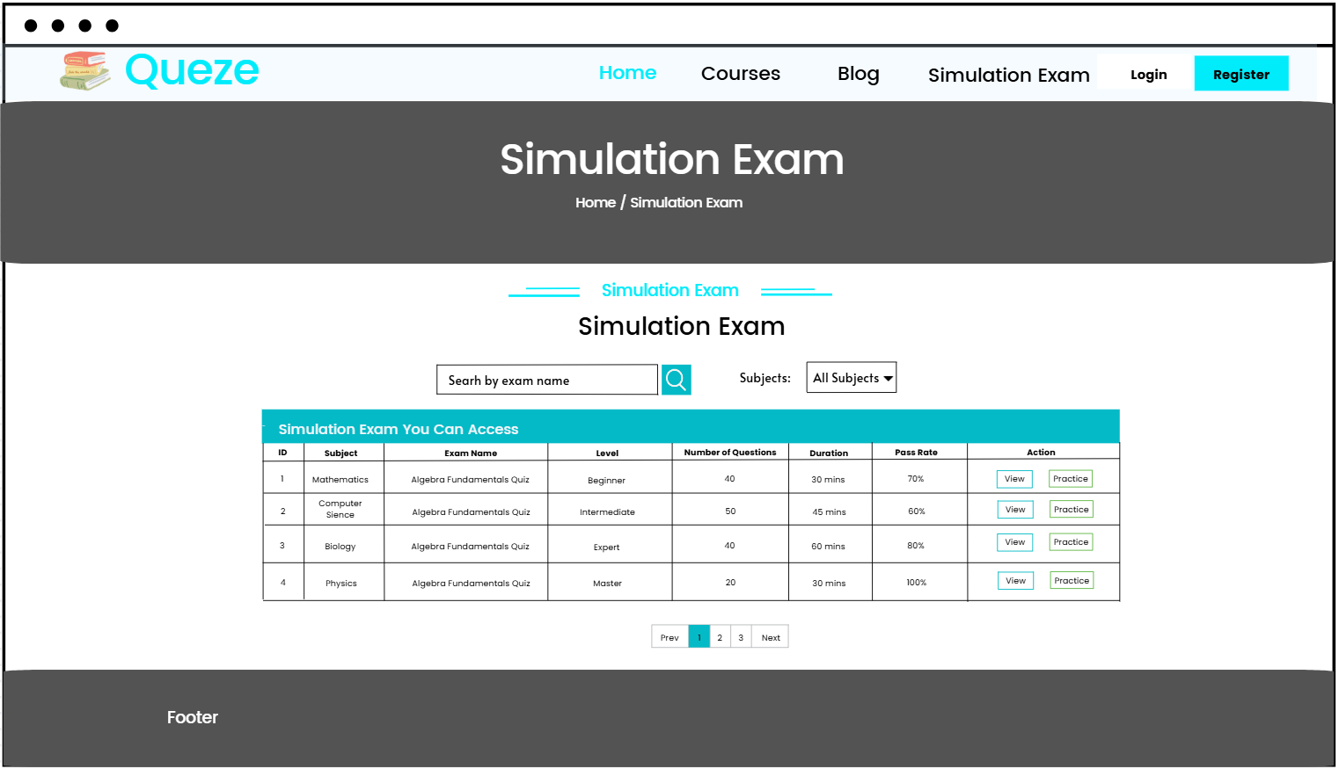
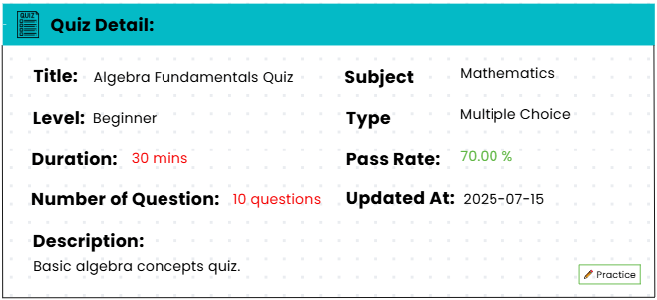

Field Name | Field Type | Description | Field Group Name
Quezee | Link | Redirect to homepage | Navbar
Home | Link | Redirect to homepage | Navbar
Courses | Link | Redirect to Courses page | Navbar
Blog | Link | Redirect to Blog page | Navbar
Simulation Exam | Link | Redirect to Simulation Exam page | Navbar
Login | Link | Redirect to Login page | Navbar
Register | Link | Redirect to Register page | Navbar
Simulation Exam | Text | Header | Content
Search | Input | Search simulation exam by name | Content
Search Icon | Button | Submit search form | Content
Subjects | Label/Text | Label for select subjects | Content
All Subjects | Select | Display all subjects user can filter | Content
Simulation exam you can access | Text | Heading for table content | Table
ID | Text | Display subjects id | Table
Subject | Text | Display Subject name | Table
Exam Name | Text | Display exam name | Table
Level | Text | Display level of exam | Table
Number of Questions | Text | Display number of questions | Table
Duration | Text | Display time of examinations | Table
Pass Rate | Text | Display pass rate of exam | Table
Action (View, Practice) | Button | Click to view to display pop-up exam detail, Click to practice to redirect to do exam page | Table
Prev | Button | Click to return one page before if (current page > 1) | Pagination
Number(1, 2, 3,...) | Link | Current page. Click to redirect that page number | Pagination
Next | Button | Click to next one page (if current page not max page) | Pagination
Footer | Static Link | Display information of website and contact | Footer
Quiz Detail | Text | Display Heading for quiz detail | Quiz Detail
Title | Text | Display title for quiz detail | Quiz Detail
Level | Text | Display level for quiz detail | Quiz Detail
Duration | Text | Display time exam for quiz detail | Quiz Detail
Number of Questions | Text | Display number of questions for quiz detail | Quiz Detail
Description | Text | Display description for quiz detail | Quiz Detail
Subject | Text | Display subject for quiz detail | Quiz Detail
Type | Text | Display type for quiz detail | Quiz Detail
Pass Rate | Text | Display pass rate for quiz detail | Quiz Detail
Updated At | Text | Display updated at for quiz detail | Quiz Detail
Practice | Link | Redirect to do exam | Quiz Detail

Database Access

Table Name | CRUD | Description
Subjects | Read | Get all Subject to filter
Quiz | Read | Get quiz details (id, title, duration, pass rate, level,...)
QuizType | Read | Get type of quiz

SQL Commands:

"""
SELECT
q.id, q.duration, q.status, q.pass_rate, q.updated_date,
q.number_of_question, q.description, q.title, q.subject_id,
s.name AS subject_name,
qt.name as type, q.level
FROM quiz q
JOIN subject s ON q.subject_id = s.id
JOIN quiztype qt ON q.type = qt.id
WHERE q.id = ?
"""

"SELECT COUNT(*)
FROM quiz q
WHERE 1=1 q.status = ? AND q.subject_id = ? AND q.type = ? AND q.title LIKE ?
"

"""SELECT q.id, q.duration, q.status, q.pass_rate, q.updated_date, q.number_of_question, q.description, q.title, q.subject_id,
s.name as subject_name,
q.type, q.level
FROM quiz q
JOIN subject s ON q.subject_id = s.id
WHERE 1=1 AND q.status = ? AND q.subject_id = ? AND q.type = ? AND q.title LIKE ?
ORDER BY q.id LIMIT ? OFFSET ?
"""

5. Course Content

5.1 Subject Lesson
UI Design

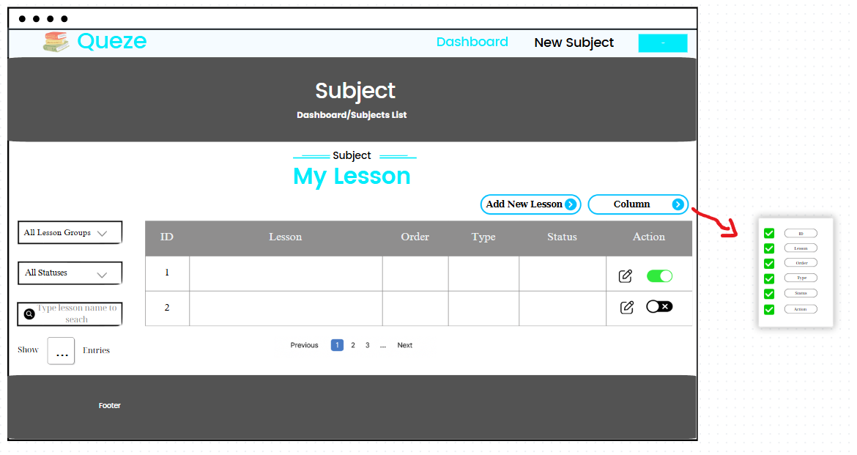

Below is the breakdown of the components:

Field Name | Field Type | Description
ID | Label/Text | Id of the lesson
Lesson | Label/Text | Displays the title of the lesson.
Status | Dot + Label/Text | Displays the status of the lesson.
Type | Label/Text | Displays the type of the lesson.
Order | Label/Text | Displays the order of the lesson.
Action button | Button | Change status/Edit Lesson.
Lesson Groups Filter | Dropdown | Filters lessons by lesson group.
Status Filter | Dropdown | Filters lessons by active/inactive status.
Search Box | Input/Text | Allows keyword-based search by lesson title.
Pagination Dropdown | Dropdown Select | Sets number of rows per page.
Pagination Controls | Navigation Buttons | Navigate across multiple pages.
Add new Lesson | Button | User clicks to redirect to the Lesson Details page for registering new lesson
Column | Button | User clicks to column can design format table, choose column want to show.

Database Access

Table | CRUD | Description
lesson | Read | Retrieves data for the lessons.
setting | Read | Retrieves data for the lesson.type.

SQL Commands
SELECT * FROM `swp391`.lesson WHERE course_id = ?
SELECT id, value FROM setting WHERE setting_type_id = ?

5.2 Lesson Details
UI Design

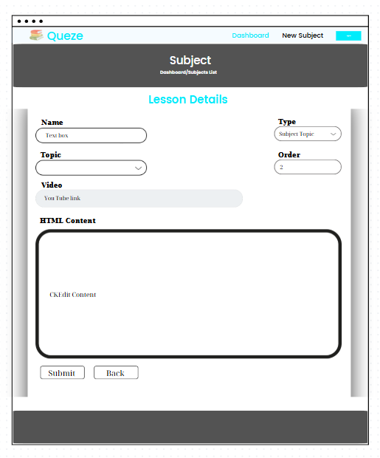

Below is the breakdown of the components:

Field Name | Field Type | Description
Name | Text Field | The title of the lesson. Required field.
Subject Topic | Dropdown | List of existing subject topics. Used to categorize the lesson.
Topic | Dropdown | Secondary grouping inside the subject.
Order | Number Input | Defines the sequence number of the lesson within the subject.
Video | Text Field | Optional YouTube video link. Only visible if lesson type is Lesson.
HTML Content | Rich Text Editor (CKEditor) | Optional content block for entering lesson material.
Submit | Button | Saves the lesson information.
Back | Button | Returns to the previous screen (usually lesson list).

SQL Commands

Table | CRUD | Description
lesson | Read, Create, Update | Retrieves data for the lessons and add data for the lesson.
setting | Read | Retrieves data for the lesson.type.
topic | Read | Retrieves data for the topic .
learning material | Read, Create, Update | Retrieves data for the learning material  and add data for the learning material, update data for the learning material  .
course | Read, Update | Retrieves data for the course, update data for course

- SELECT * FROM `swp391`.lesson WHERE id = ?

- SELECT * FROM `swp391`.course s WHERE s.id = ?

- SELECT * FROM `swp391`.topic s WHERE s.id = ?

- SELECT value FROM `swp391`.setting WHERE id = ?

- SELECT * FROM `swp391`.learningmaterial WHERE id = ?

- SELECT COUNT(*) FROM `swp391`.lesson WHERE course_id = ?

- SELECT * FROM topic

- INSERT INTO `swp391`.lesson (id, status, name, course_id, lesson_type_id)
VALUES (?, ?, ?, ?, ?)
- UPDATE `swp391`.course SET topic_id = ? WHERE id = ?

- INSERT INTO `swp391`.learningmaterial
(id, title, updated_date, duration, video_content_url, html_content)
VALUES (?, ?, ?, ?, ?, ?)
- UPDATE `swp391`.course SET topic_id = ? WHERE id = ?

5.3 Subject List

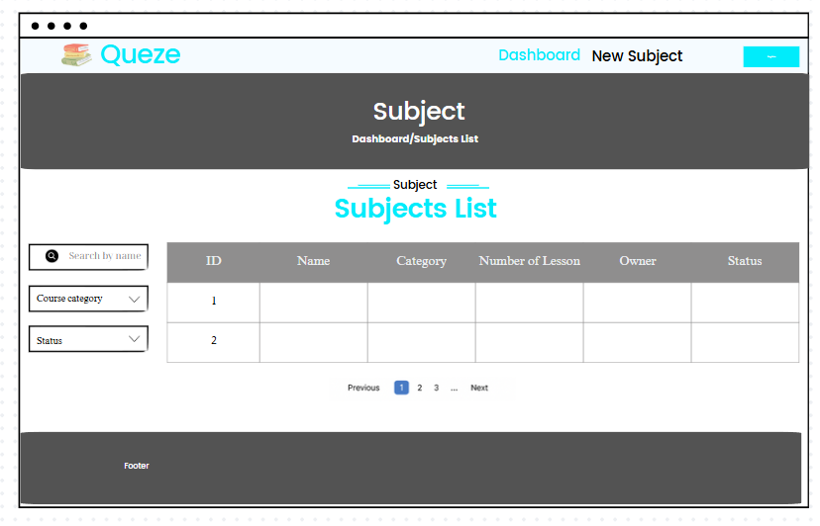

UI Design

Field Name | Field Type | Description | Field Group Name
ID | Table Column | Displays the unique identifier for each subject | Course List Table
Name | Table Column | Displays the title of each subject | Course List Table
Category | Table Column | Displays the course category the subject belongs to | Course List Table
Number of Lesson | Table Column | Displays how many lessons are associated with the subject | Course List Table
Owner | Table Column | Displays the user (typically expert or admin) who created or owns the subject | Course List Table
Status | Table Column | Displays whether the subject is currently active or inactive | Course List Table
Pagination Controls | Buttons | Navigates between different pages of the subject list (1, 2, 3, Next…) | Pagination Section
Header Title | Static Label/Text | Page title that helps users understand they are on the Subject section | Header
Breadcrumb | Static Text | Shows the user's current location in the navigation hierarchy | Header
Search by name | Text Input + Icon | Allows users to search subjects by entering a keyword in the subject's name | Filter Section
Course category | Dropdown | Dropdown filter to display subjects based on their course category | Sidebar
Status | Dropdown | Dropdown filter to display subjects based on their current status | Sidebar

Database Access

Table | CRUD | Description
Course | R | Reads data to display subjects in the list, including details such as title, subtitle, and status
Category | R | Reads category information for filtering purposes
User | R | Reads user information to display the owner/creator of each course
Course_Enrollment | R | Reads data to display the number of learners enrolled in each course

SQL Commands

1.SELECT * FROM `swp391`.topic s
WHERE s.id = ?

2. SELECT * FROM `swp391`.subject s WHERE s.id = ?

3. SELECT COUNT(*) FROM lesson WHERE course_id = ?

4. SELECT * FROM `swp391`.account WHERE id = ?

5. SELECT s.value
FROM `swp391`.setting_subject ss
JOIN `swp391`.setting s ON ss.setting_id = s.id
JOIN `swp391`.settingtype stt ON s.setting_type_id = stt.id
WHERE ss.subject_id = ? AND stt.name = 'Blog Category'

5.4 New Subject
UI Design

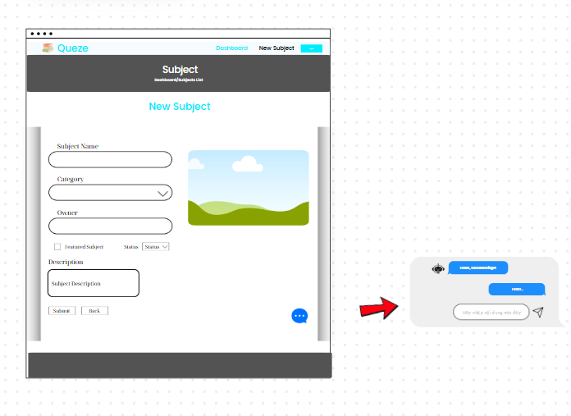

Field Name | Field Type | Description
Subject Name | Text Field | Title of the subject. This is a required field.
Owner | Text Field (or dropdown in implementation) | The name/ID of the expert assigned to this subject.
Category | Dropdown | The subject category. Loaded from pre-configured category list.
Image Upload | Image Selector | Optional. Allows user to upload or choose a preview image for the subject.
Featured Subject | Checkbox | If checked, the subject will be highlighted as "featured" on the homepage or subject list.
Status | Dropdown | Status of the subject: options may include Draft, Published, Inactive, etc.
Description | Textarea | A brief description of the subject content. Optional but recommended.
Submit | Button | Saves the new subject to the system.
Back | Button | Cancels the operation and returns to the Subjects List screen.
Chat Bot | Text | User types a message to send to chatbot, asking questions related how to register new subject.

Database Access

Table | CRUD | Description
Course | R | Reads data to display subjects in the list, including details such as title, subtitle, and status
Category | R | Reads category information for filtering purposes
User | R | Reads user information to display the owner/creator of each course
Course_Enrollment | R | Reads data to display the number of learners enrolled in each course

SQL

- SELECT * FROM topic
- SELECT * FROM `swp391`.account
WHERE role_id = (
SELECT id FROM `swp391`.setting
WHERE value = 'Expert'
LIMIT 1
)
- SELECT * FROM `swp391`.contact
- INSERT INTO `swp391`.course (
id, title, duration, status, description, created_date, updated_date,
thumbnail_url, number_of_lessons, topic_id, contact, expert_id
) VALUES (?, ?, ?, ?, ?, ?, ?, ?, ?, ?, ?, ?)

SQL Commands

5.5 Subject Dimension
UI Design

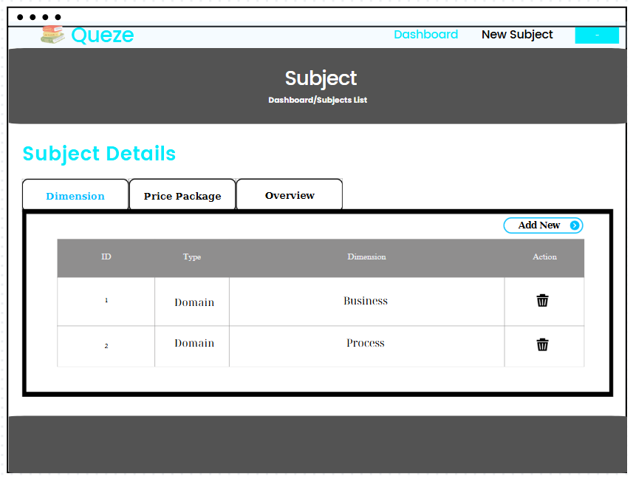

Field Name | Field Type | Description
ID | Label/Text | Unique identifier of the dimension entry.
Type | Label/Text | The dimension type (e.g., Domain, Group).
Dimension | Label/Text | The actual dimension value (e.g., Business, Process).
Action | Button | Contains Delete icons for removing the entry.
Tabs (Dimension, Price Package, Overview | Tab Navigation | Switch between detail sections of the subject.
Add New | Button | Open form to add a new dimension.

Database Access

Table | CRUD | Description
lesson | Read | Retrieves data for the lessons.
setting | Read | Retrieves data for the lesson.type.

SQL Commands:

DELETE FROM setting_subject WHERE setting_id = ? AND subject_id = ? AND setting_id IN (SELECT id FROM setting WHERE description = ?)

INSERT INTO setting (id, value, status, description, updated_date, setting_type_id)
VALUES (?, ?, ?, ?, ?, ?);

INSERT INTO setting_subject (setting_id, subject_id)
VALUES (?, ?)

5.6 Price Package

UI Design
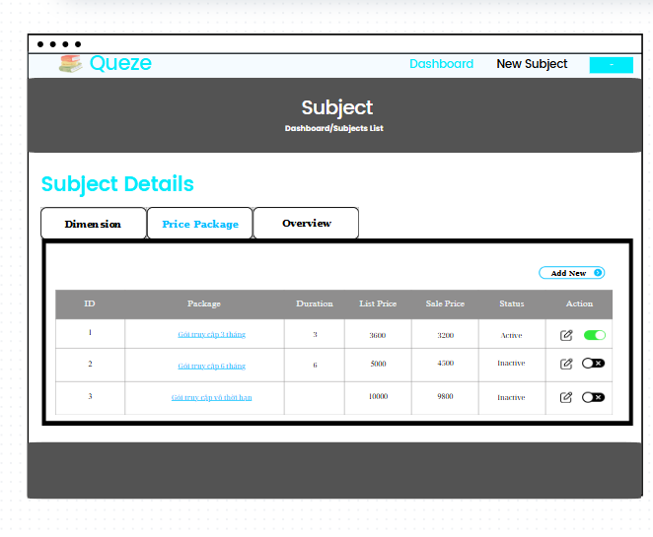

Field Name | Field Type | Description
ID | Label/Text | Unique identifier of the dimension entry.
Package | Hyperlink | Title of the package (clickable, likely to open Subject Lesson).
Duration | Label/Text | Access duration of the package (in months).
List Price | Label/Text | Original price of the package.
Sale Price | Label/Text | Discounted selling price.
Status | Label/Text | Indicates if the package is Active or Inactive.
Action | Button | Edit icon to modify the package; toggle switch to activate/deactivate.
Tabs (Dimension, Price Package, Overview | Tab Navigation | Navigate among detail sections.
Add New | Button | Open form to add a new price package.

Database Access

Table | CRUD | Description
lesson | Read | Retrieves data for the lessons.
setting | Read | Retrieves data for the lesson.type.

SQL Commands:

- UPDATE pricepackage
SET title = ?, price = ?, sale_price = ?, access_duration = ?, status = ?
WHERE id = ?

- DELETE FROM `swp391`.pricepackage p
WHERE p.id=?

- INSERT INTO `swp391`.pricepackage (id, course_id, title, price, sale_price, access_duration, status, description)
VALUES (?,?,?,?,?,?,?,?)

5.7 Overview
UI Design
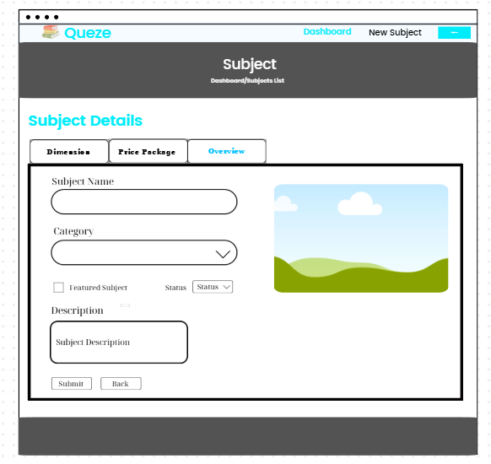

Field Name | Field Type | Description
Subject Name | Text Input | Input field to enter the name of the subject.
Category | Dropdown List | Dropdown to select the subject category from predefined values.
Featured Subject | Checkbox | Checkbox to mark the subject as a featured one.
Status | Dropdown List | Dropdown to select the subject's status (e.g., Active, Inactive).
Description | Text Area | Multi-line input for entering subject description.
Owner (Expert) | Dropdown List | Allows Admin to assign or change the subject owner.
Thumbnail Image | Image Display | Displays the avatar/photo of the assigned expert.
Submit | Button | Button to save all entered/edited subject information.
Back | Button | Button to navigate back to the previous screen (Subject List)
Tabs (Overview, Dimension, Price Package) | Tab Navigation | Allows users to navigate between different subject details sections.

Database Access

Table | CRUD | Description
Account | Read | Retrieves data for the lessons.
setting | Read | Retrieves data for the lesson.type.
subject | Read | Retrieves data for the subject
course | Read | Retrieves data for the course by id
contact | Read | Retrieves data for the contact by id

SQL Commands:

- SELECT * FROM `swp391`.subject s WHERE s.id = ?

- SELECT id, name, subject_id FROM `swp391`.topic WHERE subject_id = ?

- SELECT * FROM `swp391`.course s WHERE s.topic_id = ?

- SELECT * FROM `swp391`.contact WHERE id = ?

- SELECT * FROM `swp391`.account WHERE email = ?

- SELECT s.value
FROM `swp391`.setting_subject ss
JOIN `swp391`.setting s ON ss.setting_id = s.id
JOIN `swp391`.settingtype stt ON s.setting_type_id = stt.id
WHERE ss.subject_id = ? AND stt.name = 'Blog Category'

- SELECT s.id, s.value, s.description
FROM `swp391`.setting_subject ss
JOIN `swp391`.setting s ON ss.setting_id = s.id
WHERE ss.subject_id = ?

6. Sale

6.1 Registrations List
UI Design

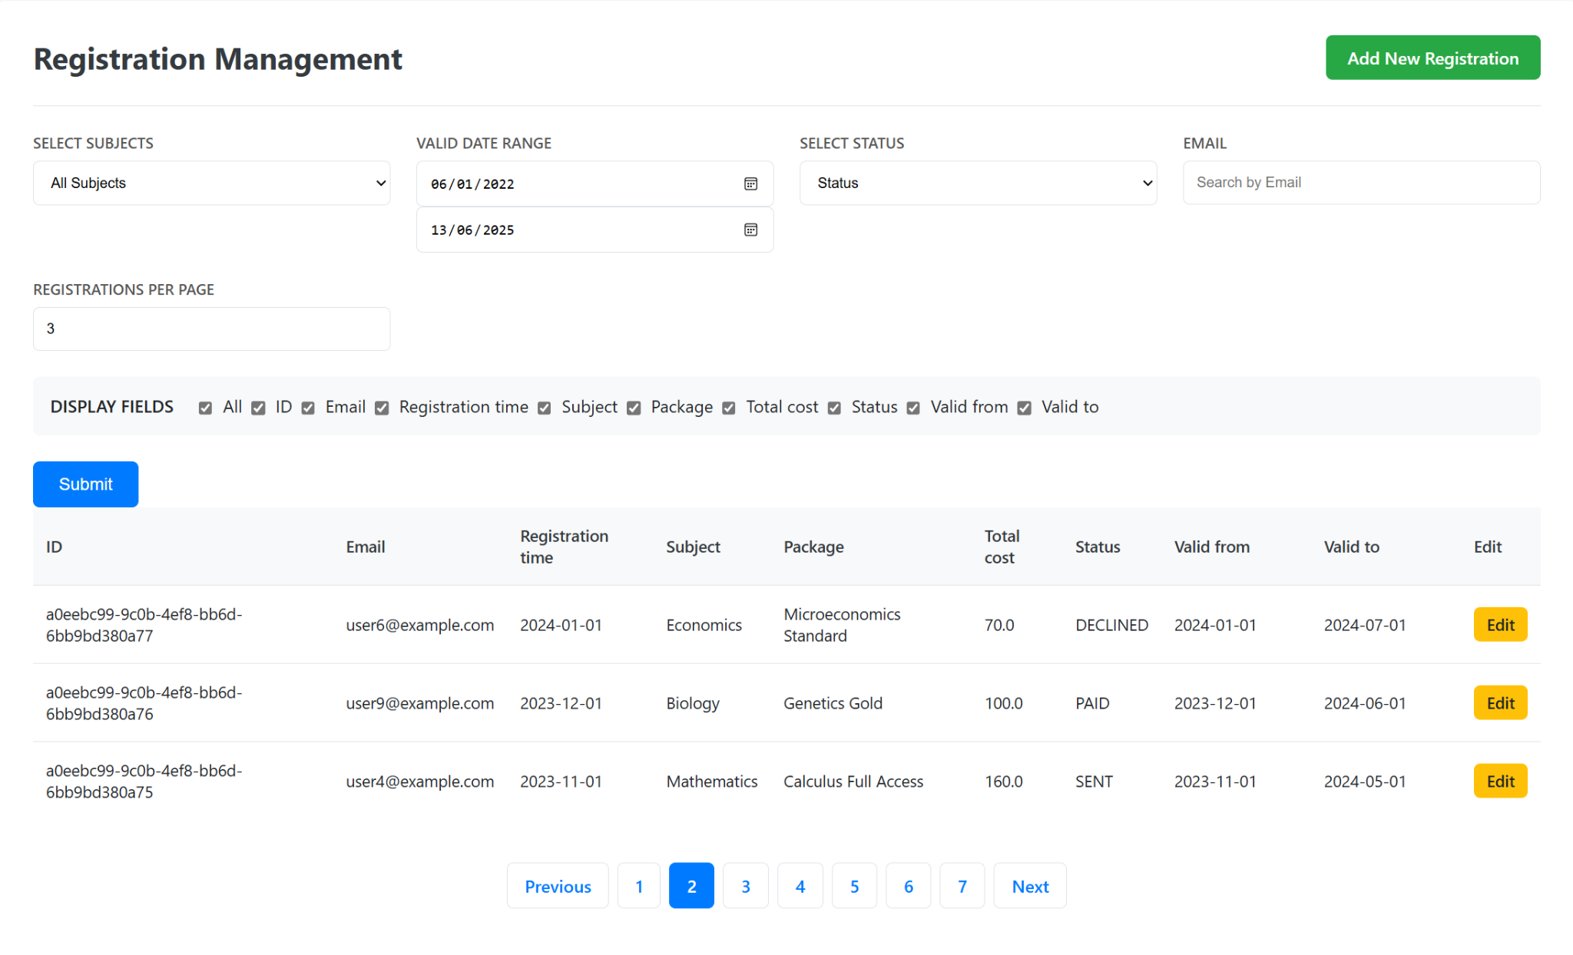
The screen allows the seller to search and filter the list of courses that the user has registered for. The user can click the edit button to go to another page to edit and can click the add new button.

Field Name | Field Type | Description
ID | String | Unique identifier for each registration record (UUID format).
Email | Email Field | User's email address used during registration.
Registration Time | Date | Date when the registration was submitted.
Subject | String | Subject area linked with the registration (e.g., Economics, Biology).
Package | String | Name of the registration package selected.
Total Cost | Float | Monetary amount for the selected package.
Status | String | Current status of the registration (e.g., SENT, PAID, DECLINED).
Valid From | Date | Date when the registration becomes valid.
Valid To | Date | Expiry date of the registration validity.
Edit Button | Button | Yellow button to edit the specific registration record.
Select Subjects | Dropdown (Select) | Filter dropdown to select and view registrations by subject.
Valid Date Range - From | Date Picker | Start date of the desired registration validity period.
Valid Date Range - To | Date Picker | End date of the desired registration validity period.
Select Status | Dropdown (Select) | Filter to show registrations by their status.
Email Search | Text Input | Input box for filtering registrations by email address.
Registrations Per Page | Numeric Input | Number of records to show per page (e.g., 3).
Display Fields | Checkbox Group | Toggle visibility of columns like ID, Email, Status, etc.
Submit Button | Button | Blue button to apply selected filters and column visibility settings.
Add New Registration | Button | Green button to create a new registration.
Previous Button | Button | Navigate to the previous page in the registration list.
Page Number Buttons | Button Group | Buttons labeled (1, 2, 3, ...) to jump to a specific page.
Next Button | Button | Navigate to the next page in the registration list.

Database Access

Table Name | CRUD Operations | Description
PersonalCourse | Read | Retrieves registration info with filters (subject, email, status, dates, etc).
Account | Read | Retrieves account details (email).
Course | Read | Retrieves course info to map to subject/topic.
Topic | Read | Maps course to subject.
Subject | Read | Retrieves all subjects from the system.
PricePackage | Read | Retrieves associated price package (if any) using LEFT JOIN.

SQL Commands:

- Retrieve Paginated Registration Info
SELECT
pc.id,
acc.email,
pc.enroll_date AS registration_time,
s.name AS subject_name,
MIN(pp.title) AS package_name,
MIN(pp.sale_price) AS total_cost,
pc.status,
pc.enroll_date AS valid_from,
pc.expire_date AS valid_to
FROM personalcourse pc
JOIN account acc ON pc.account_id = acc.id
JOIN course c ON pc.course_id = c.id
JOIN topic t ON c.topic_id = t.id
JOIN subject s ON t.subject_id = s.id
LEFT JOIN pricepackage pp ON pc.course_id = pp.course_id
WHERE 1=1
[AND s.id = ?]
[AND pc.status = ?]
[AND pc.enroll_date >= ?]
[AND pc.expire_date <= ?]
[AND acc.email LIKE ?]
GROUP BY pc.id, acc.email, pc.enroll_date, s.name, pc.status, pc.expire_date
ORDER BY pc.enroll_date DESC
LIMIT ? OFFSET ?;
- Parameters: subject (optional): Subject ID
- status (optional): Registration status
- validFrom (optional): Start date
- validTo (optional): End date
- email (optional): Email (partial match)
- LIMIT, OFFSET: for paging

- Retrieve All Subjects
SELECT * FROM swp391.subject;

- Retrieve Distinct Statuses from PersonalCourse
SELECT DISTINCT status FROM personalcourse WHERE status IS NOT NULL;

7. Component

7.1 Back To Top
UI Design


Below is the back to top components:

Field Name | Field Type | Description
Back to Top | Button | Move from bottom of page to top of page

7.2 Navbar
UI Design

Field Name | Field Type | Description
Queze | Logo/Link | Back to homepage
Home | Link | Redirect to homepage
Blog | Link | Redirect to blog page
Simulation Exam | Link | Redirect to Simulation Exam page
Login | Link | Redirect to login page
Register | Link | Redirect to register page

7.3 Spinner
UI Design


Field Name | Field Type | Description
Spinner | Label | A circular animated indicator shown while the system is loading or processing data. It informs the user that a background task is ongoing.

7.4 Notification
UI Design
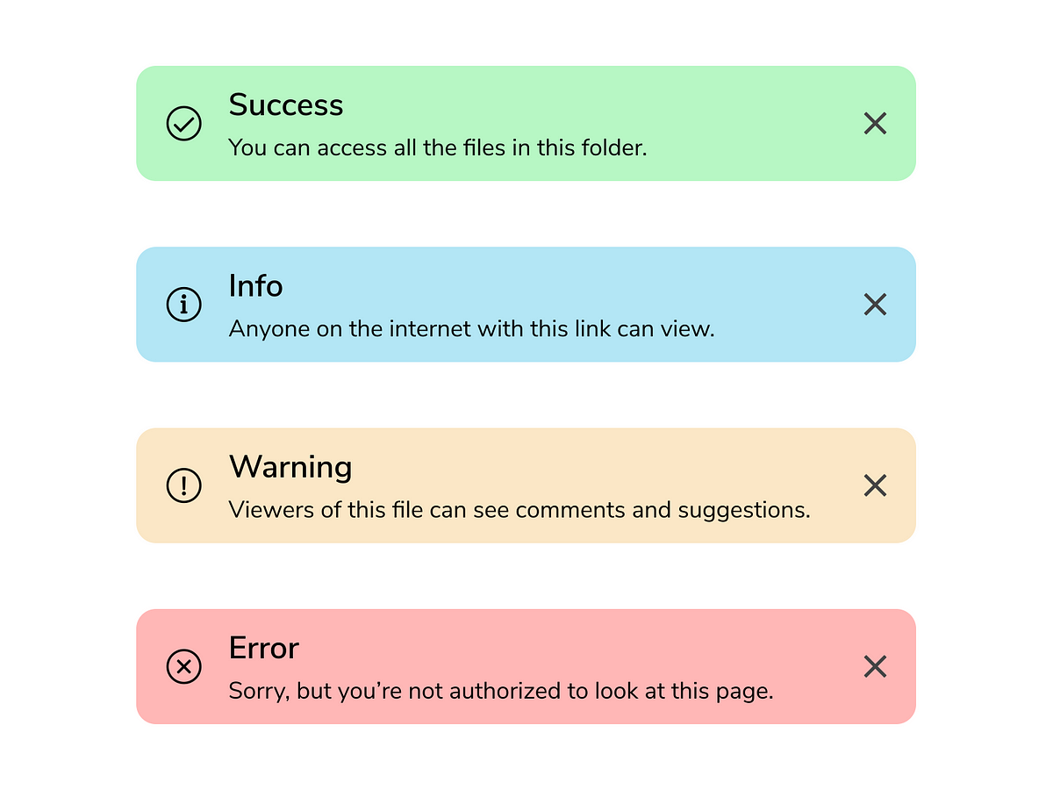

Field Name | Field Type | Description
Type | Enum (Success, Info, Warning, Error) | The alert type determines its purpose, styling, and color.
Icon | Image/Icon | Visually represents the alert type. Helps users quickly identify the message's purpose.
Title | Text | Short title describing the alert type (e.g., “Success”, “Error”).
Message | Text | The detailed message displayed inside the alert.
Close Button | Button | Allows the user to dismiss the alert. Located at the top-right corner.

7.5 Header

The site header is a fixed navigation bar at the top, allowing users to quickly access sections such as Home, Courses, Blog, Simulation Exam and Practice. This bar also includes a login/registration section for unauthenticated users and displays user information with an account menu when logged in.

UI Design

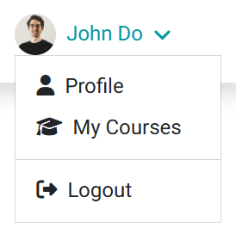


Below is the home components:

Field Name | Field Type | Description | Field Group Name
Logo + Brand Name | Link + Icon + Text | Logo and title linking to homepage | Navbar - Branding
Home | Link | Link to the homepage | Navbar - Navigation Links
Courses | Link | Redirect to courses listLink to the course list page | Navbar - Navigation Links
Blog | Link | Link to the blog page | Navbar - Navigation Links
More | Dropdown Toggle | Opens additional links | Navbar - Navigation Links
About Us | Dropdown Item | Link to the Our Team page | Navbar - Dropdown (More)
Our Team | Dropdown Item | Redirect to image location | Navbar - Dropdown (More)
Testimonials | Dropdown Item | Link to the Testimonials page | Navbar - Dropdown (More)
Login Button | Button | Button for user login | User Authentication (Guest)
Register Button | Button | Button for user registration | User Authentication (Guest)
User Avatar | Image | Displays user's profile image | User Authentication (Logged In)
User Full Name | Text | Displays the user's name | User Authentication (Logged In)
User Menu Toggle | Dropdown Toggle | Opens user account menu | User Authentication (Logged In)
Profile | Dropdown Item | Link to user profile | User Dropdown Menu
My Courses | Dropdown Item | Link to user's courses | User Dropdown Menu
Divider | Divider | Visual separation line | User Dropdown Menu
Logout | Dropdown Item | Link to log out | User Dropdown Menu

7.6 Footer

The Footer screen is an area that provides information about the platform, contact information, social media, and support links. It helps users learn more about the platform, connect with the support team, and easily access other parts of the site.

UI Design
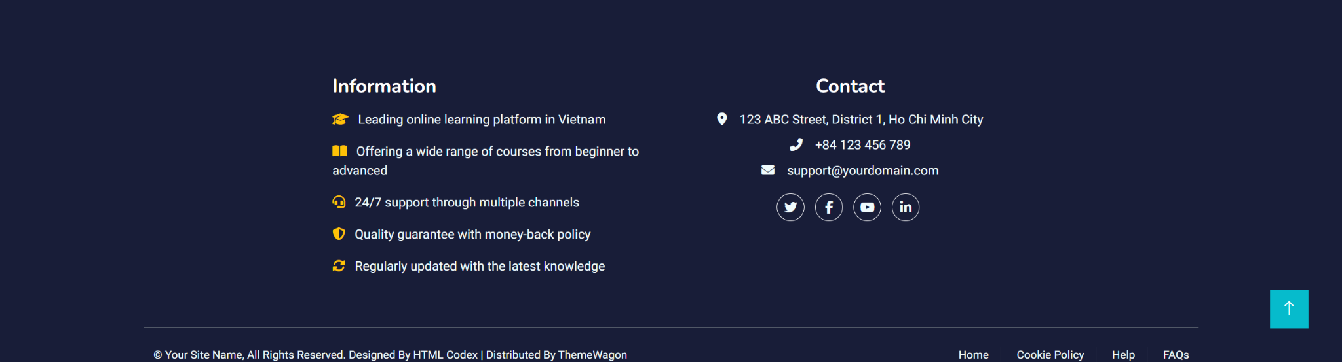

Below is the home components:

Field Name | Field Type | Description | Field Group Name
Footer Section | Container (Div) | Wrapper for the entire footer | Footer
Home | Link | Link to the homepage | Footer - Information
Information Heading | Text | Title "Information" for the left column | Footer - Information
Info Item 1 | Icon + Text | General feature: online learning in Vietnam | Footer - Information
Info Item 2 | Icon + Text | Opens additional links | Footer - Information
Info Item 3 | Icon + Text | 24/7 support availability | Footer - Information
Info Item 4 | Icon + Text | Quality and refund policy | Footer - Information
Info Item 5 | Icon + Text | Knowledge regularly updated | Footer - Information
Contact Heading | Text | Title "Contact" for the right column | Footer - Contact Info
Address | Icon + Text | Physical address info | Footer - Contact Info
Phone | Icon + Text | Phone number info | Footer - Contact Info
Email | Icon + Text | Contact email | Footer - Contact Info
Social Icons (Twitter) | Button + Icon | Social media link icon | Footer - Social Links
Social Icons (Facebook) | Button + Icon | Social media link icon | Footer - Social Links
Social Icons (YouTube) | Button + Icon | Social media link icon | Footer - Social Links
Social Icons (LinkedIn) | Button + Icon | Social media link icon | Footer - Social Links
Copyright Text | Text | Copyright notice and credit | Footer - Bottom Row
HTML Codex Link | Link | Design credit link to HTML Codex | Footer - Bottom Row
ThemeWagon Link | Link | Distribution credit link | Footer - Bottom Row
Bottom Menu - Home | Link | Footer navigation link to Home | Footer - Navigation Links
Bottom Menu - Cookie Policy | Link | Footer navigation link to Cookie Policy | Footer - Navigation Links
Bottom Menu - Help | Link | Footer navigation link to Help | Footer - Navigation Links
Bottom Menu - FAQs | Link | Footer navigation link to FAQs | Footer - Navigation Links
Back to Top Button | Button (Fixed) | Scrolls back to the top of the page | Footer - Utility Button

8. Test Content

8.1 Quizzes List

The screen allows the expert to manage the quizzes including viewing the list of ID Title, Subject, Description, Level, Number of Questions, Duration (minutes), Pass Rate (%), Quiz Type
The screen provides conditional fields so that the expert can filter and search the list of quizzes

UI Design
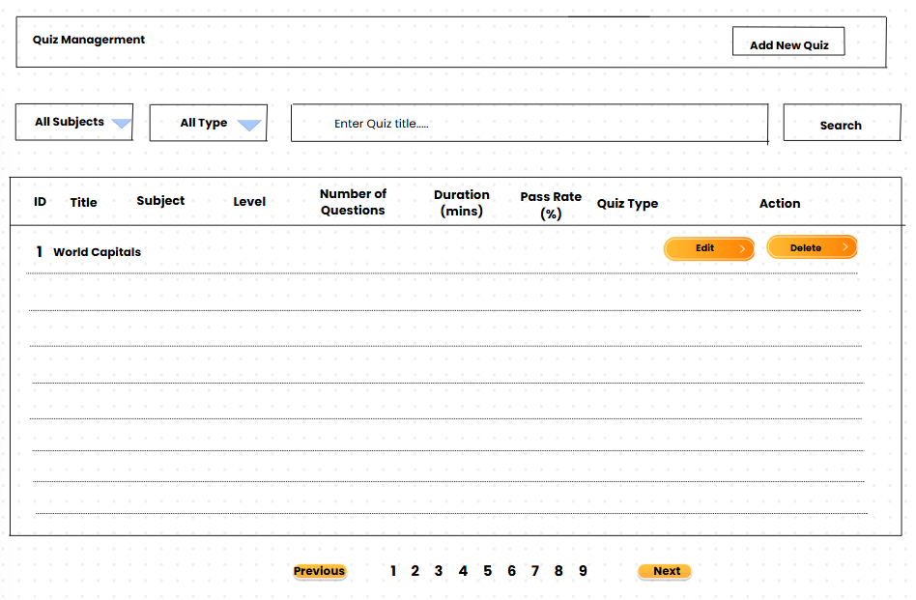
.
Field Name | Field Type | Description (English)
Title | Text Input | The name of the quiz (e.g., World Capitals).
Description | Text Area | A brief overview or purpose of the quiz.
Duration (minutes) | Number Input | Time allowed to complete the quiz, in minutes.
Pass Rate (%) | Number Input (0–100) | Minimum percentage required to pass the quiz.
Number of Questions | Number Input | Total number of questions included in the quiz.
Subject | Dropdown | Select the subject the quiz belongs to.
Topic | Dropdown (dependent) | Select a topic based on the selected subject.
Level | Dropdown | The difficulty level of the quiz (e.g., Easy, Medium, Hard).
Type | Dropdown | The type of quiz (e.g., Practice Test, Final Exam).
Status (Public?) | Checkbox or Dropdown | Set whether the quiz is visible to others (Published or Private).
Submit Button | Button | Confirms and creates the new quiz.
Cancel Button | Button | Cancels the creation and redirects to the quiz list page.
Edit Button | Button | Opens the selected quiz for editing.
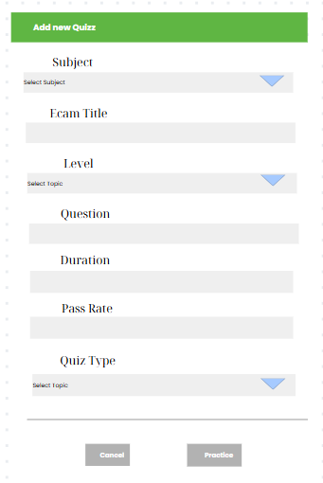

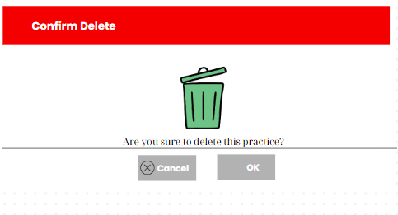

Field Name | Field Type | Description
Subject | Dropdown | Select the subject the quiz belongs to.
Exam Title | Text Input | The name/title of the quiz.
Level | Dropdown | Choose the difficulty level of the quiz.
Question | Number Input | Enter the number of questions in the quiz.
Duration | Number Input | Time limit to complete the quiz (in minutes).
Pass Rate | Number Input | Minimum percentage required to pass.
Quiz Type | Dropdown | Select the type of quiz (e.g., practice, final).
Topic | Dropdown | Select a topic based on the chosen subject.
Cancel | Button | Abort the quiz creation and return to the list.
Practice | Button | Submit the form and save the new quiz.

Database Access

Table Name | CRUD Operations | Description
Subject | Read | Get a list of Subjects to drop down.
QuizTitle | Read | Get a list of Title to drop down.
Quiz | Read | Get a list of Quizzes with conditions to display on the screen
QuizLevel | Read | Get a list of Title to drop down.
Quiz | Create | Create a new quiz from the form.
Quiz | Delete | Delete a requested quiz.

SQL Commands:
Insert Quiz
"INSERT INTO quiz (id, duration, status, pass_rate, updated_date, number_of_question, description, title, subject_id, type, level) "
+ "VALUES (?, ?, ?, ?, ?, ?, ?, ?, ?, ?, ?)"

- Parameters: id, duration, status, pass_rate, updated_date, number_of_question, description,title, subject_id, type, level
Retrieve Subject
SELECT * FROM subject;

Retrieve QuizLevel
SELECT * FROM quizlevel;

Retrieve QuizTitle
SELECT * FROM quiztype;

Delete Quiz
DELETE FROM quiz WHERE id = ?;

Retrieve Quiz
"SELECT " +
"q.id, q.duration, q.status, q.pass_rate, q.updated_date, " +
"q.number_of_question, q.description, q.title, q.subject_id, " +
"q.type, q.level " +
"FROM quiz q " +
"WHERE 1=1 "

AND q.subject_id = ?
AND q.type = ?
AND q.title LIKE ?
RDER BY q.id LIMIT 5 OFFSET ?

8.2 Quiz Details

The screen provides information fields of an untaken test for experts to edit and add information including Title, Subject, Exam Level, Duration (minutes), Pass Rate (%), Quiz Type, Description, Total number of questions, Question allocation

UI Design
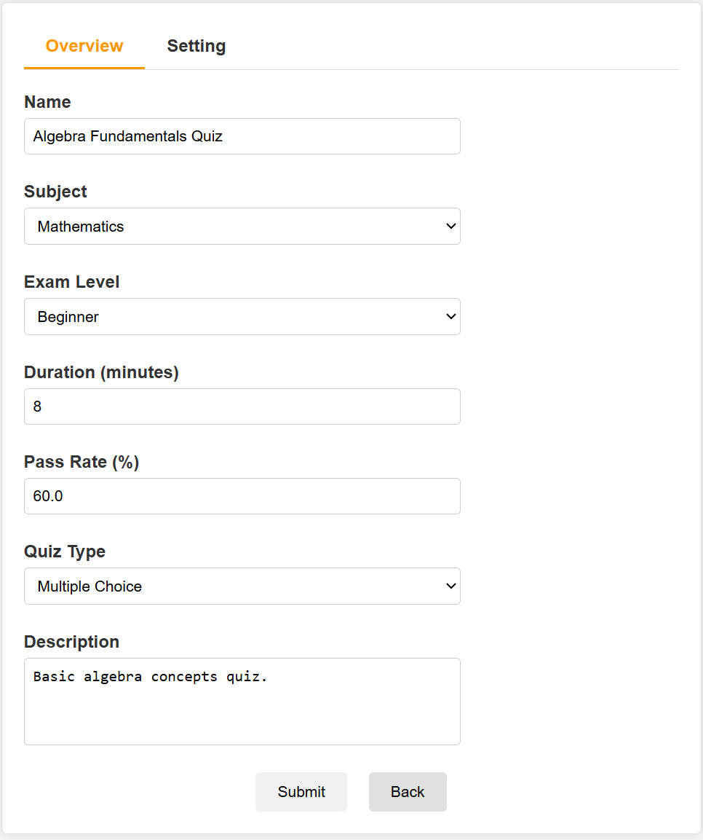
.
Field Name | Field Type | Description (English)
Name | Text Input | The name of the quiz (e.g., Algebra Fundamentals Quiz)..
Exam Level | Dropdown | Select the difficulty level of the quiz (e.g., Beginner).
Subject | Dropdown | Select the subject the quiz belongs to.
Duration (minutes) | Number Input | Time allowed to complete the quiz, in minutes.
Pass Rate (%) | Number Input | Minimum percentage required to pass the quiz.
Quiz Type | Dropdown | Select the format of the quiz questions (e.g., Multiple Choice).
Description | Text Area | A brief description of the content or purpose of the quiz.
Submit | Button | Submits and saves the information entered or edited in the form.
Back | Button | Returns to the previous page without saving any changes.
Setting | Button | Go to the setting page to continue editing

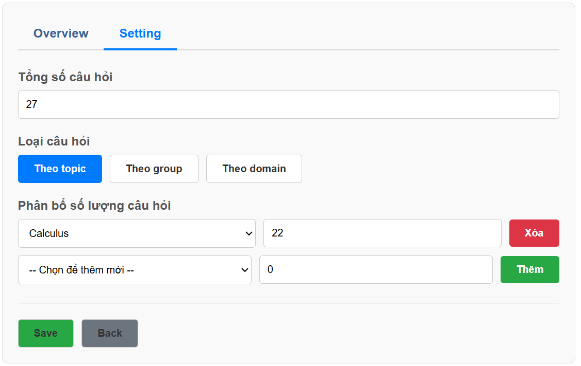

Field Name | Field Type | Description
Overview / Setting Tabs | Navigation Tabs | Allows switching between the "Overview" and "Setting" sections. "Setting" is currently selected.
Tổng số câu hỏi (Total number of questions) | Number Input | A field to set or display the total number of questions for the quiz. The value is 27.
Loại câu hỏi (Question Sourcing) | Button Group | A set of toggle buttons to select how questions are categorized. Options are "By topic", "By group", "By domain".
Phân bổ số lượng câu hỏi (Question Quantity Allocation) | Dynamic List | A section to assign a specific number of questions from different categories.
Topic Selector | Dropdown | A dropdown within the allocation list to select a topic. Example: Calculus.
Number of Questions | Number Input | Specifies the number of questions to take from the selected topic. Example: 22.
Xóa (Delete) Button | Button | Removes the corresponding topic allocation row from the list.
Thêm (Add) Button | Button | Adds the new topic allocation row to the list.
-- Chọn để thêm mới -- (Add New Dropdown) | Dropdown | Selects a new topic to add to the allocation list.
Save | Button | Saves the current settings for the quiz.
Back | Button | Returns to the previous page without saving changes.

Database Access

Table Name | CRUD Operations | Description
Quiz | Update | Update a quiz from form
Topic | Read | Get a list of Topics by SubjectId to drop down.
Setting | Read | Get a list of Setting with SettingName = ‘domain’ or group’to drop down
QuizQuestionSourceConfig | Read | Get the list of QuizQuestionSourceConfig according to sourceType condition on the screen
QuizQuestionSourceConfig | Create | Create new QuizQuestionSourceConfig from list
QuizQuestionSourceConfig | Delete | Delete a QuizQuestionSourceConfig from the list.

SQL Commands:

Insert QuizQuestionSourceConfig
"INSERT INTO quiz_question_source_config (id, quiz_id, source_type, source_id, number_of_questions) "

ID | Category | Rule Definition
BR-01 | Constraints | Payment for courses must be made online through the integrated VietQR payment gateway.
BR-02 | Constraints | Courses must have at least one thumbnail and a valid price package to be displayed in the course list.
BR-03 | Facts | A user can only enroll in a course after successfully completing the payment process.
BR-04 | Constraints | Only users with a valid login session can access the course dashboard.
BR-05 | Facts | Users can update their profile information, but changes will not affect past transactions.
BR-06 | Constraints | If a payment fails, users must retry or contact support before enrolling in the desired course.
BR-07 | Computations | Discounts are calculated as sale price = price - (discount percentage * price).
BR-08 | Constraints | Each user account must have a unique email address.
BR-09 | Facts | Users can unenroll from a course, but the payment is non-refundable.
BR-10 | Computations | Pagination for course lists is set to a default of 15 courses per page, configurable by the user.
+ "VALUES (?, ?, ?, ?, ?)";

- Parameters: id, quiz_id, source_type, source_id, number_of_questions,
Update Quiz
SELECT * FROM subject;
"UPDATE quiz SET duration = ?, status = ?, pass_rate = ?, updated_date = ?, "
+ "number_of_question = ?, description = ?, title = ?, subject_id = ?, type = ?, level = ? "
+ "WHERE id = ?";

Retrieve Topic
"SELECT id, name, subject_id FROM topic WHERE subject_id = ?"

Retrieve Setting
"SELECT s.* "
+ "FROM setting s "
+ "JOIN settingtype st ON s.setting_type_id = st.id "
+ "JOIN setting_subject ss ON ss.setting_id = s.id "
+ "WHERE ss.subject_id = ? AND st.name = ?"
;

Retrieve QuizQuestionSourceConfig
"SELECT * FROM quiz_question_source_config WHERE quiz_id = ?";

Delete QuizQuestionSourceConfig
"DELETE FROM quiz_question_source_config WHERE quiz_id = ?";

8.3 Question Details

The "Question Details" screen is where users can edit the specifics of a question. This screen includes fields for entering information about the subject, lesson, dimension(s), status, question content, notes, and answer options along with an explanation.

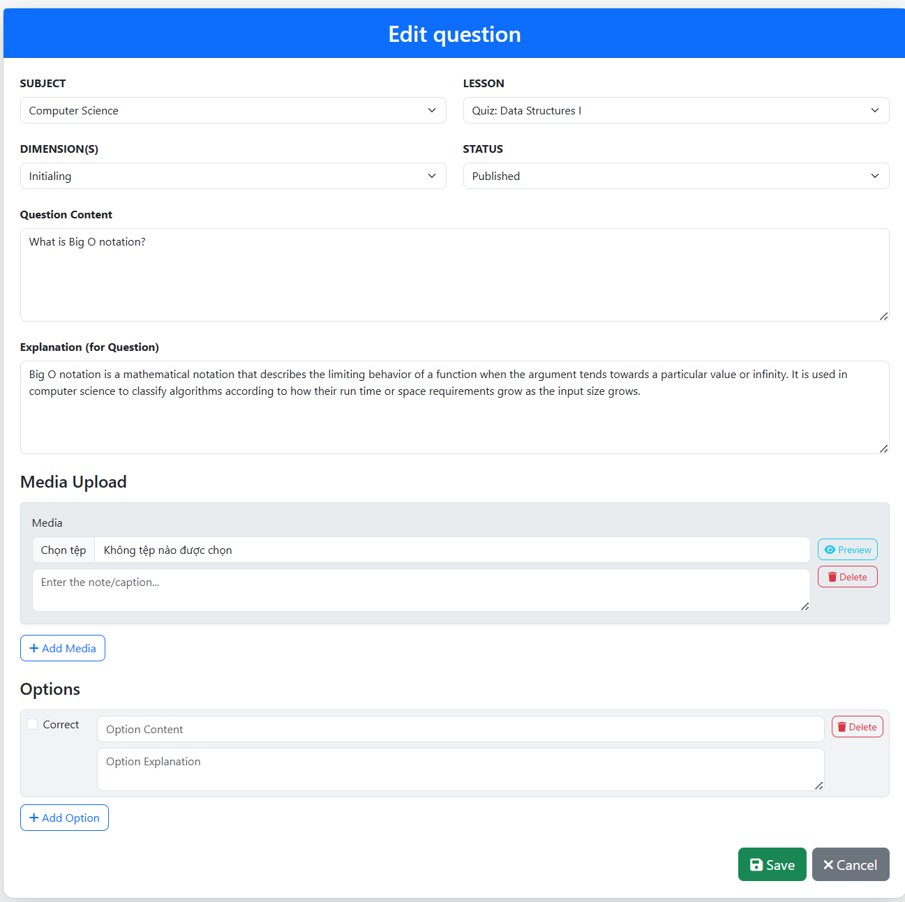
UI Design

Field Name | Field Type | Description | Field Group Name
Lesson | Dropdown box | Used to select the lesson related to the question. | Question Details
Subject | Dropdown box | Used to select the subject related to the question. | Question Details
Dimension(s) | Dropdown box | Used to select the aspects/topics of the question. | Question Details
Status | Dropdown box | Used to select the status of the question (e.g., Published, Draft). | Question Details
Question Content | Text area | Used to enter the main content of the question. | Question Content
Upload | Button | Used to upload media files (images, videos) for the question. | Media Upload
Preview | Button | Used to preview the uploaded media files. | Media Upload
Note | Text area | Used to enter additional notes for the question. | Note
Add Media | Icon/Button | Used to add other media elements (e.g., images, videos). | Option
Option | Input field | Used to enter the content of answer option | Option
Delete | Button | Used to delete the answer option. | Option
Add Option | Icon/Button | Used to add more answer options (C, D, etc.). | Option
Explanation | Text area | Used to enter the explanation for the correct answer or for the question. | Explanation
Save | Button | Used to save all entered changes for the question. | Action Buttons
Cancel | Button | Used to discard changes and return to the previous screen. | Action Buttons

Database Access

Table Name | CRUD Operations | Description
Question | Read, Update | Creates, retrieves, updates, and deletes question details including content, topic, quiz, and level.
Option | Create, Read, Update, Delete | Manages answer options for each question, including content, correctness, and explanation.
Subject | Read | Retrieves a list of corresponding subjects.
Setting | Read | Retrieves various settings like question levels and dimensions.
Setting_Question | Create, Read, Delete | Associates questions with specific setting dimensions (e.g., difficulty levels).
Question_Media | Create, Read, Update, Delete | Manage response options for each image, video, including file selection, content, delete.
Lesson | Read | Retrieve the list of corresponding lessons

SQL Commands
Retrieve Subject SELECT * FROM subject;
Retrieve Lesson SELECT * FROM lesson;
Retrieve Setting SELECT s.* FROM setting s JOIN setting_type st ON s.setting_type_id = st.id WHERE st.name = ?; Parameters: setting_type_name
Retrieve Question SELECT q.id, q.content, q.level, q.subject_id, sub.name AS subject_name, q.lesson_id, les.name AS lesson_name, q.status, q.explanation, s.id AS dimension_id, s.value AS dimension_name FROM question q JOIN subject sub ON q.subject_id = sub.id LEFT JOIN lesson les ON q.lesson_id = les.id LEFT JOIN setting_question sq ON q.id = sq.question_id LEFT JOIN setting s ON sq.setting_id = s.id WHERE q.id = ?; Parameters: id
Update Question UPDATE question SET content = ?, topic_id = ?, quiz_id = ?, level = ?, subject_id = ?, lesson_id = ?, status = ?, explanation = ? WHERE id = ?; Parameters: content, topic_id, quiz_id, level, subject_id, lesson_id, status, explanation, id
Retrieve Options for Question SELECT * FROM option WHERE question_id = ?; Parameters: question_id
Insert Option INSERT INTO option (id, content, is_true, explanation, question_id) VALUES (?, ?, ?, ?, ?); Parameters: id, content, is_true, explanation, question_id
Update Option UPDATE option SET content = ?, is_true = ?, explanation = ? WHERE id = ?; Parameters: content, is_true, explanation, id
Delete Option DELETE FROM option WHERE id = ?; Parameters: id
Retrieve Media for Question SELECT * FROM question_media WHERE question_id = ? ORDER BY display_order ASC; Parameters: question_id
Insert Media INSERT INTO question_media (id, question_id, media_type, file_path, caption, display_order) VALUES (?, ?, ?, ?, ?, ?); Parameters: id, question_id, media_type, file_path, caption, display_order
Update Media UPDATE question_media SET file_path = ?, caption = ?, display_order = ? WHERE id = ?; Parameters: file_path, caption, display_order, id
Delete Media DELETE FROM question_media WHERE id = ?; Parameters: id
Retrieve Setting for Question SELECT s.* FROM setting s JOIN setting_question sq ON s.id = sq.setting_id WHERE sq.question_id = ?; Parameters: question_id
Insert Setting_Question Link INSERT INTO setting_question (setting_id, question_id) VALUES (?, ?); Parameters: setting_id, question_id
Delete Setting_Question Link DELETE FROM setting_question WHERE question_id = ?; Parameters: question_id

8.4 Question List
UI Design
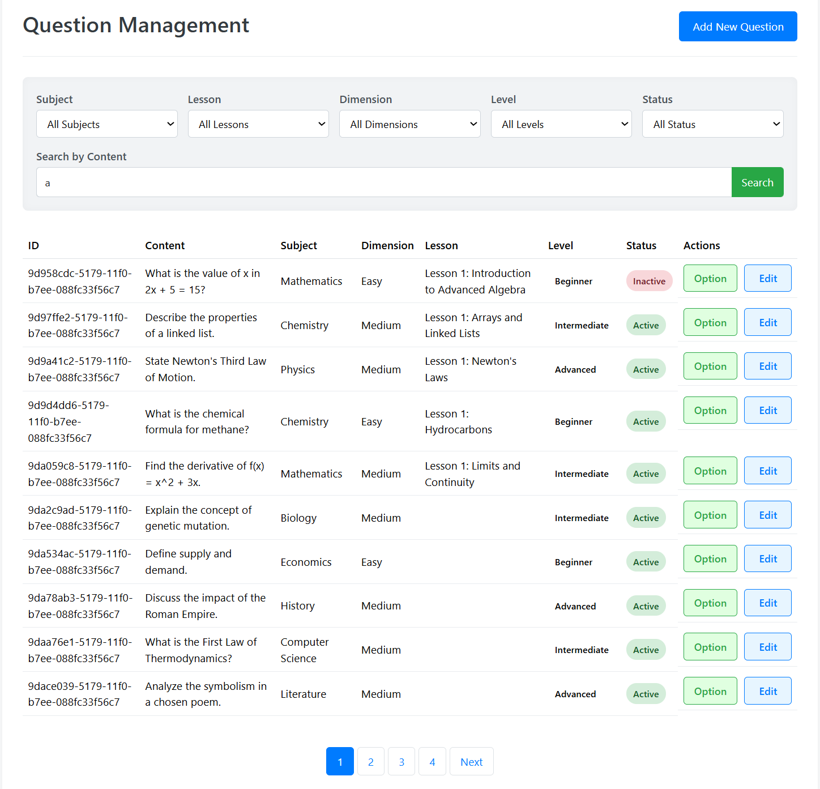
This screen displays questions that users can search by subject, lesson, status, level, content, dimension fields. And users can optionally change the hidden, show status. Users can click Edit to edit the question fields or can add new questions.

Field Name | Field Type | Description | Field Group Name
Subject | Dropdown box | Used to filter questions by their subject. | Filters
Lesson | Dropdown box | Used to filter questions by the lesson they belong to. | Filters
Dimension | Dropdown box | Used to filter questions by specific dimensions. | Filters
Level | Dropdown box | Used to filter questions by their difficulty level. | Filters
Status | Dropdown box | Used to filter questions by their current status (e.g., Active, Inactive). | Filters
Search by Content | Input box | Used to input keywords to search for questions by their content. | Search
Search Button | Button | Initiates the search for questions based on the entered keywords and selected filters. | Search
Add New Question | Button | Allows users to navigate to a new screen to create a new question. | Actions
ID | Table column | Displays the unique identifier for each question. | Question List
Content | Table column | Displays the text content of the question. | Question List
Subject | Table column | Displays the subject associated with the question. | Question List
Dimension | Table column | Displays the dimension of the question. | Question List
Lesson | Table column | Displays the lesson associated with the question. | Question List
Level | Table column | Displays the current status of the question. | Question List
Status | Table column | Displays the current status of the question. | Question List
Option | Button | Allows users to view and manage the answer options for a specific question. | Actions
Edit | Button | Used to edit the details of a specific question. | Actions
Pagination Numbers | Button | Navigates through different pages of question results. | Pagination
Next | Button | Navigates to the next page of question results. | Pagination

Database Access

Table Name | CRUD Operations | Description
Subject | Read | Get a list of Subjects to drop down.
Lesson | Read | Get a list of Lesson to drop down.
Setting | Read | Get a list of Setting(belongs to SettingType named Group and Domain belongs to Dimension and Question Level) to drop down.
Question | Read | Get the Question list with the required properties
Question | Update | Update status for Question..

SQL Commands:

Insert Question
"INSERT INTO quiz (id, duration, status, pass_rate, updated_date, number_of_question, description, title, subject_id, type, level) "
+ "VALUES (?, ?, ?, ?, ?, ?, ?, ?, ?, ?, ?)"

- Parameters: id, duration, status, pass_rate, updated_date, number_of_question, description,title, subject_id, type, level
Retrieve Subject
SELECT * FROM subject;

Retrieve Lesson
SELECT * FROM lesson;

Retrieve Setting
SELECT s.*
FROM setting s
JOIN settingtype st ON s.setting_type_id = st.id
WHERE st.name = ?
;

Update Question
UPDATE question SET status = ? WHERE id = ?

Retrieve Question
SELECT
q.id,
q.content,
q.level,
q.subject_id,
sub.name AS subject_name,
q.lesson_id,
les.name AS lesson_name,
q.status,
q.explanation,
s.id AS dimension_id,
s.value AS dimension_name
FROM question q
JOIN subject sub ON q.subject_id = sub.id
LEFT JOIN lesson les ON q.lesson_id = les.id
LEFT JOIN setting_question sq ON q.id = sq.question_id
LEFT JOIN setting s ON sq.setting_id = s.id
WHERE 1=1

IV. Appendix

1. Assumptions & Dependencies
Assumptions:
- AS-1: Users will have access to a stable internet connection to browse courses, make payments, and interact with the system.
- AS-2: The payment gateway API (VietQR) will remain operational and provide consistent service for transaction processing.
- AS-3: Course creators and administrators will upload course content and necessary information (such as price, taglines, thumbnails) in the correct format.
- AS-4: User credentials will be stored securely in compliance with data protection laws.
Dependencies:
- DE-1: The system depends on third-party payment gateway services (e.g., VietQR) to generate QR codes and verify transactions.
- DE-2: The system relies on Java EE and Tomcat for backend operations, with MySQL for database management.
- DE-3: Email notifications for profile updates, payments, and course enrollments depend on third-party email services (e.g., Gmail SMTP).
- DE-4: Cross-browser compatibility assumes that users access the system via modern web browsers (Chrome, Firefox, Edge).

2. Limitations & Exclusions
- Limitations:
  - LE-1: The system does not support offline payments (e.g., cash on delivery).
  - LE-2: The course content is limited to formats compatible with the current file upload system (e.g., PDF, video files).
  - LE-3: User sessions will automatically expire after 30 minutes of inactivity for security reasons.
  - LE-4: Course progress tracking is available only for video and quiz content.
- Exclusions:
  - EX-1: The platform does not include advanced analytics for course performance (e.g., completion rates, dropout analysis) in this version.
  - EX-2: Courses will not be auto-translated or localized for multilingual support in the initial release.
  - EX-3: Integration with external Learning Management Systems (LMS) is not included in this version.

3. Business Rules

ID | Constraint | Rule Definition
BR-CMF-1 | Structural | The email address provided during registration must be in a valid format
BR-CMF-2 | Constraint | The email address must not already exist in the system’s user database.
BR-CMF-3 | Computation | Token used in magic link should be expired after 5 minutes
BR-CMF-4 | Behavioral | Magic link can be only used for one time
BR-CMF-5 | Computation | Magic link should be stored in the email that sent to users
BR-CMF-6 | Triggering | Secret key is created only when users trigger TOTP
BR-CMF-7 | Temporal | TOTP expires after 30 second
BR-CMF-8 | Behavioral | Each code is only used for one time
BR-CMF-9 | Structural | Contains 6 digits
BR-CMF-10 | Computation | OTP should be stored in the email that sent to users
BR-CMF-11 | Temporal | OTP expires after 5 minutes
BR-PL-1 | Constraint | Only active sliders are displayed.
BR-PL-2 | Constraint | Only blogs with the status = true are displayed.
BR-PL-3 | Fact | Search includes title, brief, and description.
BR-PL-4 | Constraint | Only subjects with the feature flag = true are displayed.
BR-PL-5 | Constraint | Prompt-based engines (Gemma 3 4b) must semantically compare prompt text with all available subject categories in the system and return the closest match.
BR-PL-6 | Constraint | - If gemma deduces the category name, the name will be returned.  - If gemma does not find any categories, it will return “none”  - If gemma find all categories, it will return “all”
BR-PL-7 | Structural | Prompt language must be English
BR-PL-8 | Behavioral | If users do not sign in, they must fill in all fields manually. Otherwise, their information that gotten from their account details will be automatically rendered
BR-MF-1 | Structural | Media files (images/videos) must follow format and size restrictions defined by the system.
BR-MF-2 | Constraint | Only media files with the following extensions are accepted:  Images: .jpg, .jpeg, .png, .gif, .webp  Videos: .mp4, .mov, .avi, .mkv
BR-MF-3 | Constraint | Image files are saved to the /img/ directory; video files are saved to the /video/ directory.
BR-MF-4 | Structural | Each uploaded file must not exceed 30MB in size.
BR-MF-5 | Structural | Pagination options include: 10, 20, 50 rows per page.
BR-MF-6 | Computation | Search filters posts by title, description, or brief content using partial match.
BR-MF-7 | Constraint | The chatbot only uses data visible on the dashboard (e.g., total revenue, order trend, new accounts) to provide insights.
BR-MF-8 | Structural | The default date range for all metrics and charts is the last 7 days upon dashboard load.
BR-MF-9 | Validation | The selected date range must be valid: startDate ≤ endDate. If not, an error is shown.
BR-MF-10 | Computation | Each metric is calculated based on the currently selected date range.
BR-CSF-1 | Constraint | Only the quiz has status = true are displayed.
BR-CF-1 | Constraint | Admin can view all subjects, while experts can only view the subjects they own.
BR-CF-2 | Structural | Subjects must have a valid category assigned; otherwise, they will not be shown.
BR-CF-3 | Behavioral | Subject list is paginated, showing 10 records per page.
BR-CF-4 | Structural | Only users with the Admin role are allowed to access the New Subject screen.
BR-CF-5 | Behavioral | All required fields (name, category, owner, and status) must be filled before submission.
BR-CF-6 | Structural | Subject name must be unique within the system.
BR-CF-7 | Structural | Each subject must be assigned to a valid expert who exists in the system.
BR-CF-8 | Behavioral | Only Admin can change the subject's status or edit price packages.
BR-CF-9 | Structural | Each subject must be assigned to exactly one expert.
BR-CF-10 | Behavioral | Each dimension must have a type, name, and description.
BR-CF-11 | Behavioral | Only Admin or assigned Expert of the subject can add/edit dimensions.
BR-CF-12 | Structural | Each subject can have one or more price packages.
BR-CF-13 | Constraint | Price package name must be unique within the same subject.
BR-CF-14 | Behavioral | Only Admin users can add or edit price packages; Experts have view-only access.
BR-CF-15 | Computation | Final payable amount = Sale Price (if available), otherwise List Price.
BR-CF-16 | Structural | Each lesson must belong to a specific price package
BR-CF-17 | Behavioral | Only assigned users (Admin/Expert) can manage lessons
BR-CF-18 | Constraint | Lessons must have unique names within the same package
BR-CF-19 | Behavioral | Only users with Admin or assigned Expert role can add or edit lessons.
BR-CF-20 | Behavioral | Lesson name and type fields are mandatory.

4. Additional Notes
- Notifications:
  - Users will receive email notifications for payment success, enrollment confirmation, and profile updates.
- Security:
  - All sensitive user data (e.g., passwords, payment details) is encrypted during storage and transmission.
- Data Retention:
  - User course enrollment data will be retained for up to five years after account inactivity.
- Error Handling:
  - All server errors will redirect users to a user-friendly error page with an option to report the issue.

